5]0

**1**

**GENETICS**

**Chapter coverage**

1.1 *Introduction of Genetics*

1.2 *Heredity*

1.3 *Variation*

* 1. **INTRODUCTION OF GENETICS**

Have you ever wondered why you “*have your father’s nose*“? Or, *why you look* *a lot like your sister or brother*? All of us have noticed that the same families tend to look alike. Children seen to get some traits, or characteristics, from their parents. The ability of living organisms to transmit their traits from one generation to the next is referred to as **heredity** or **inheritance**. **Genes** are the genetic information which are transmitted from one generation to another in a living organism. **Geneticists** investigate how these genes are transmitted from one generation to the next, what their structure is and how they function in a living organism. The differences between organisms of the same species is called **variation**. The study of heredity and variation is called **genetics**.

* 1. **HEREDITY**

In this part the following aspects should be discussed:

* Hereditary materials
* DNA replication and Genetic code
* Protein synthesis
* Mendelian principles of inheritance
* Test cross and back cross
* Non mendelian principle of inheritance
* Linkage
* Pedigree analysis
* Genetic engineering
  + 1. **HEREDITARY MATERIALS**

**Hereditary materials** are the chemical structures or units in the chromosomes which are responsible for the passage of genetic information or genes from one generation to another. They are also referred to as genetic materials. There are two types of genetic materials in the cell, these are deoxyribonucleic acid (DNA) and ribonucleic acid (RNA).

***Properties of genetic materials***

The genetic materials have the following main properties which make them suitable as materials for heredity, among them, include the following:

1. **Constancy**

The amount of hereditary materials remain constant within each somatic cell of a healthy individual to ensure genetic stability.

1. **Linearity**

The hereditary materials are linear structurally, so that the genetic information can be carried out in linear array.

1. **Metabolic stability**

The hereditary materials are metabolically stable and chemical inert so as to store the genetic information.

1. **Self-replication**

In the presence of appropriate enzymes, the hereditary materials are capable of undergoing self-replication to produce their own copies for the inheritance.

1. **Mutation**

In the presence of mutagens, the hereditary materials are capable of undergoing mutation. The tendency is very important for evolution.

***SAQ 1.1***

***DAR MOCK 2017***

* State the properties of DNA molecule which make it suitable as a material of heredity**.**

***Location of hereditary materials in the cell***

In eukaryotic cells, there are two locations of hereditary materials, which are – location of hereditary materials in the nucleus and location of hereditary materials in the chromosomes.

**Location of hereditary materials in the nucleus**

The location of hereditary materials in the nucleus is supported by the following evidences:

1. **Universal occurrence:** Nucleus controls all activities of the cell including heredity; thus nucleus is the carrier of hereditary materials.
2. **Evidence from fertilization:** During fertilisation, the nucleus of a male gamete fuses with that of a female gamete to form a zygote, the later develops into an individual organism with various characteristics that are derived from parents. This shows that the fused nuclei had hereditary materials from the parents.
3. **Evidences from nuclear division:** Nuclear division may cause variation, since variation is controlled by hereditary materials, hence nucleus is the carrier of hereditary materials.

***SAQ 1.2***

***DAR MOCK 2019***

* Explain the evidences that prove the location of hereditary materials are in the cell and also found in the nucleus of the cell.

**Location of hereditary materials in the chromosomes**

The location of hereditary materials in the chromosomes is supported by the following evidences:

1. **Chromosomal analysis:** Chromosomal analysis has revealed the presence of protein and DNA. However experiment has revealed that it is the DNA portion of the chromosome which is involved in heredity. Thus the chromosomes are the carrier of hereditary materials.
2. **Evidences from fertilization:** During fertilisation process, if a sperm carrying an **X** chromosome fuses with an egg carrying an **X** chromosome, the resulting zygote will ultimately develop into a female offspring with **XX** sex chromosomes. On the contrary, if a sperm carrying a **Y** chromosome fuses with an egg carrying an **X** chromosome, the resulting zygote will develop into a male offspring with **XY** sex chromosomes. Since sex is a genetically determined characteristic, then the fused chromosomes had hereditary materials.
3. **Evidence from nuclear division**: During diplotene of prophase I, there is a crossing over among the homologous chromosomes the consequence of which is variation, since variation is usual controlled genetically, thus chromosomes are the carrier of hereditary materials.
4. **Evidence from mutation:** Mutation of the chromosomes lead to sudden change in the genetic makeup of an individual organism the consequence of which is variation, since variation is controlled hereditary materials, then, chromosomes are the carrier of hereditary materials from one generation to the next.

***SAQ 1.3***

***COAST MOCK 1998***

* What are the hereditary materials?
* Suggest the specific location of the hereditary materials in the cell and give the evidence to back up your suggestion.

***Types of genetic materials***

There are two types of genetic materials found in the body of living organism. These are deoxyribonucleic acid (DNA) and Ribonucleic acid (RNA). They contain different chemical components, and hence different properties:

**Deoxyribonucleic acid (DNA)**

Deoxyribonucleic acid (DNA) is a type of nucleic acid which is found in the nucleus of the cell. It is also found in the chloroplast and mitochondria of the eukaryotic cell.

**Roles of deoxyribonucleic acid (DNA)**

1. It controls all activities and life processes of the cell.
2. It carriers the genetic information from one generation to another.
3. It synthesizes RNA in a process called transcription.
4. It controls protein synthesis in the cell.

***SAQ 1.4***

***DAR MOCK 2019***

* Explain two roles of deoxyribonucleic acid (DNA) in the cell.

**The structure of DNA**

* Structurally, According to **James Watson** and **Francis Crick** in **1950s**, DNA is a double – stranded molecule that contains polynucleotide chains wrapped around each other to form a double helix chains.
* The chains run in opposite directions, that is anti – parallel as one strand is 3‘ - 5‘ direction and the other is 5‘ - 3‘ direction.
* Each chain has a sugar phosphate backbone with bases which project at right angles and hydrogen bonds with bases of the opposite chain across the double helix. The sugar phosphate backbone plays a structural role and genetic information is carried in the organic bases.There are four (4) types of nitrogenous bases in DNA structure. These are Adenine (A), Guanine (G), Cytosine (C) and Thymine (T).

**The chemical nature of DNA**

The DNA is made up of three main components include; A pentose sugar, phosphate group and nitrogenous bases.

1. **Pentose sugar**

This is the five carbon compound. The pentose sugar in a DNA is called **deoxyribose**; because it lacks oxygen atom on carbon 2 of the sugar ring as shown in Figure 1.1.

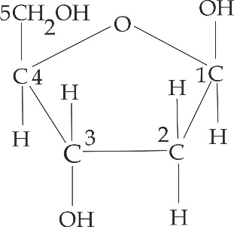

**Figure 1.1** structure of deoxyribose

1. **Phosphate group**

This is derived from phosphoric acid as shown in Figure 1.2; and it is this group that makes DNA to be acidic in nature. It is linked to the 5 carbon of the pentose sugar by a phosphodiester bond.

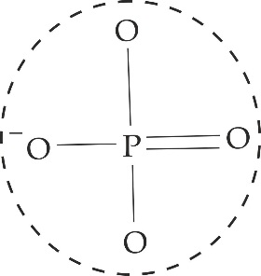

***Figure 1.2*** *structure of phosphate group*

1. **Nitrogenous bases**

These are simply nitrogen containing molecules, which have the same chemical properties as bases.They are divided into two (2) main classes, namely: the purines and pyrimidine as shown in Table 1.1.

1. **Purines**

These are bases with two nitrogen containing rings; consists of a pyridine ring joined together with an imidazole ring to form a double ring structure. The purines are comprised of Adenine (A) and Guanine (G) shown in Figure 1.3.

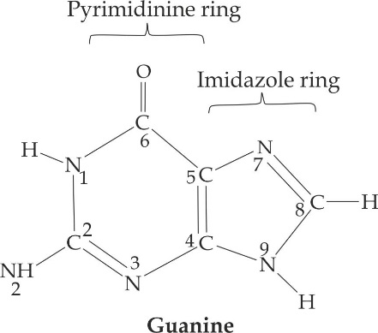

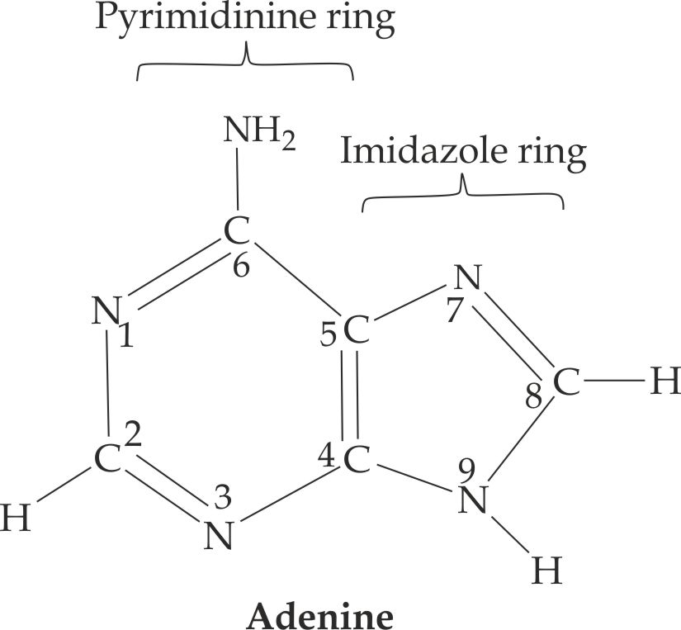

***Figure 1.3*** *Chemical structure of purines*

1. **Pyrimidine**

These are bases with only one nitrogen containing ring; consists of a pyridine ring only. The pyrimidine are comprised of Thymine (T) and Cytosine (C).

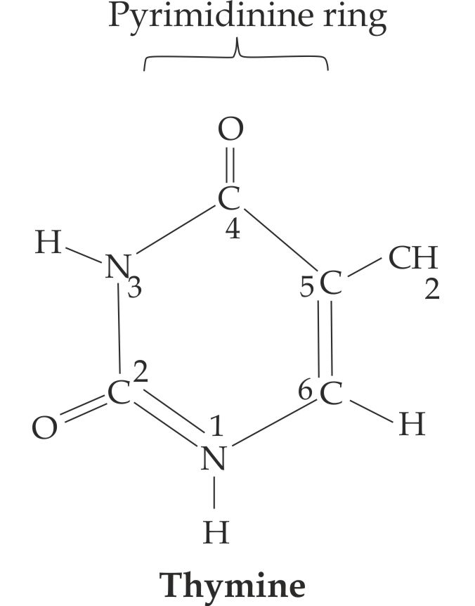

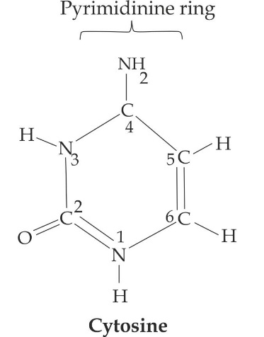

**Figure 1.4** Chemical structures of pyrimidine

***Chargaff’s rule*:**

**″**purine always paired with pyrimidine”; i.e. **Adenine** being always paired with **thymine** (A »T), and **guanine** with **cytosine** (G » C).

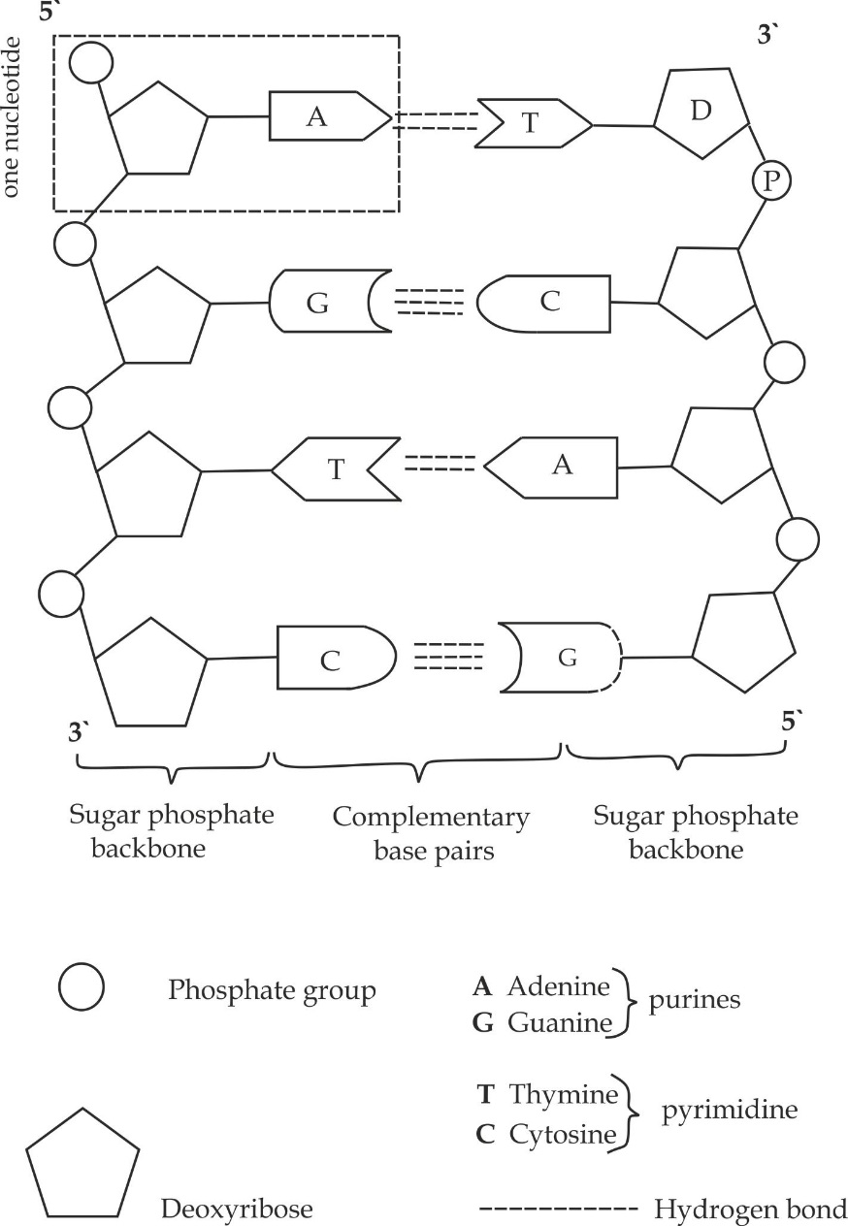

***Figure 1.5*** *Chemical structure of DNA*

***SAQ 1.5***

***DAR MOCK 2017***

* Describe the structure and chemical composition of deoxyribose nucleic acid (DNA) molecule.
* Biochemical analysis of a sample of DNA showed that, 33% of the nitrogenous bases were guanine. Calculate the percentage of the bases in the sample which should be adenine. Explain how you arrived at your answer.

**Ribonucleic acid (RNA)**

Ribonucleic acid (RNA) is a type of nucleic acid which is mainly found in the cytoplasm of the cell. It is synthesized by the DNA strand, a process known as **transcription**.

**The structure of RNA**

* Structurally, RNA is a single stranded polynucleotide chain with 5‘end to 3’ end direction.
* The chain has sugar phosphate backbone which plays a structural role with bases at right angles for the storage of genetic information.
* The phosphate group of the next nucleotide in the sequence is linked to the hydroxyl group on carbon number 3 of the preceding nucleotide. This arrangement repeats itself several times to make RNA a long structure.
* For tRNA the nucleotide sequences is folded into a clove life structure by the hydrogen bonds.

**The chemical nature of RNA**

Like DNA.The RNA is made up of three main components include; a pentose sugar, phosphate group and nitrogenous bases.

1. **Pentose sugar**

This is the five carbon compound. The pentose sugar in a RNA is called **ribose**; because it contains oxygen atom on carbon 2 of the sugar ring as shown in Figure 1.6.

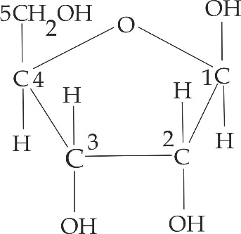

***Figure 1.6*** *ribose sugar*

1. **Phosphate group**

This is derived from phosphoric acid as shown in Figure 1.7; and it is this group that makes DNA to be acidic in nature. It is linked to the 5 carbon of the pentose sugar by a phosphodiester bond. It has to be noted that, the positioning of the hydroxyl group in carbon 2 of the sugar gives the molecule an electrostatic negative charge. It is because of this charge that, the OH group repels negatively with the negatively charged phosphate group attached to the carbon 1 of the ribose sugar. Furthermore, the presence of reactive hydroxyl group (OH) attached to carbon 2 of its sugar makes the whole RNA molecule prone to hydrolysis, this is the reason why RNA is unstable, and hence, unsuitable molecule for storing genetic information.



***Figure 1.7*** *structure of phosphate group*

1. **Nitrogenous bases**

They are similar in structure and function to that of DNA, except that RNA contains uracil pyrimidine base instead of thymine as shown in Figure 1.8.

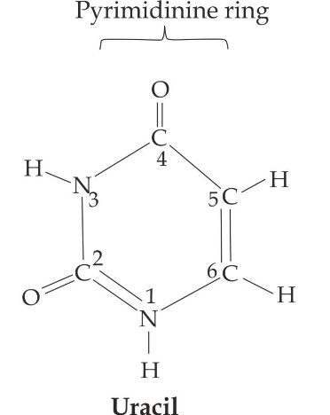

***Figure 1.8*** *chemical structure of uracil pyrimidine*

***SAQ 1.6***

***DAR MOCK 2017***

* Describe the structure and chemical composition of RNA.

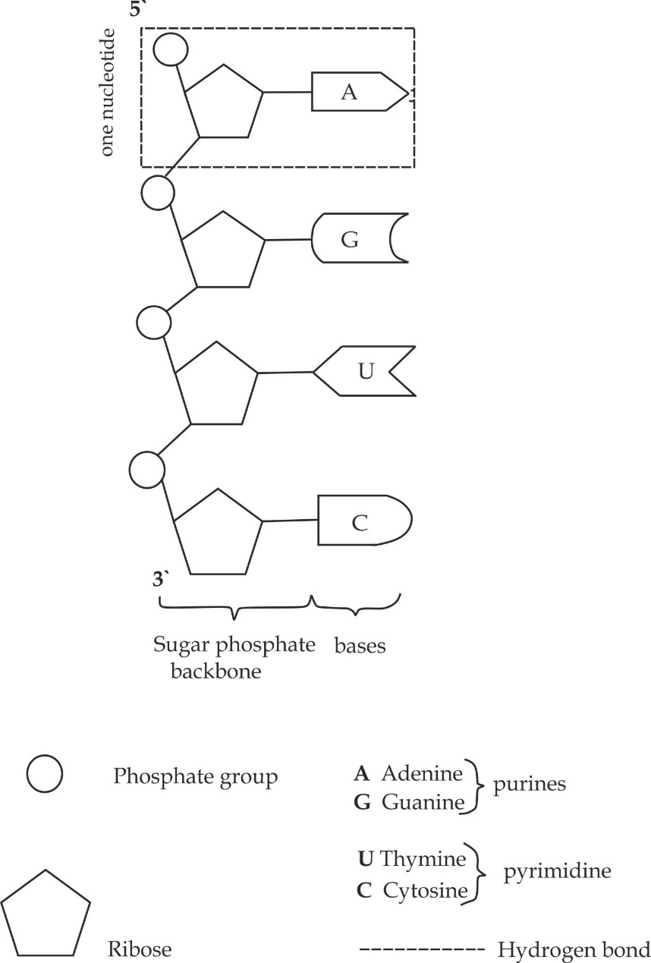

***Figure 1.9*** *Chemical structure of RNA*

**Types of Ribonucleic acid (RNA)**

There are three types of ribonucleic acids (RNA), namely: messenger RNA (mRNA), ribosomal RNA (rRNA) and transfer RNA (tRNA).

1. **Messenger RNA (mRNA)**

This constitutes about 3 - 5% of the total RNA in the cell. It is a single stranded molecule made from one of the strands of DNA in the process called **transcription** as shown in Figure 1.10.

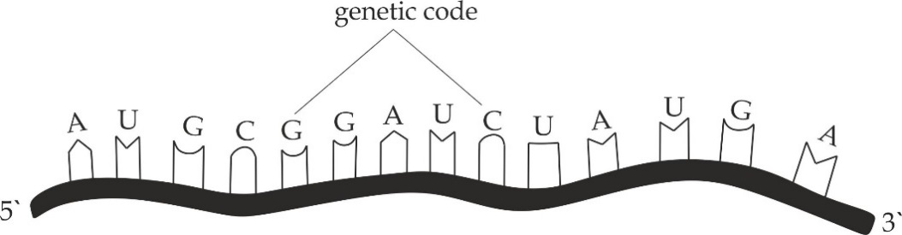

***Figure 1.10*** *The structure of messenger RNA*

**Role of messenger RNA (mRNA)**

It carriers the genetic code from a DNA in the nucleus to the ribosome for protein synthesis. This genetic code contains the information about the type of amino acids that should be joined together to form a protein molecule (polypeptide chain).

1. **Ribosomal RNA (rRNA)**

This constitutes about 80% of the total RNA of the cell. Ribosomal RNA associates with protein molecule to form ribosome. More than half of the mass of the ribosome is made up of rRNA. It is composed of complex molecules in two sections, the large subunit (LSU) for attachment of tRNA and the small subunit (SSU) for attachment of mRNA as shown in Figure 1.11.

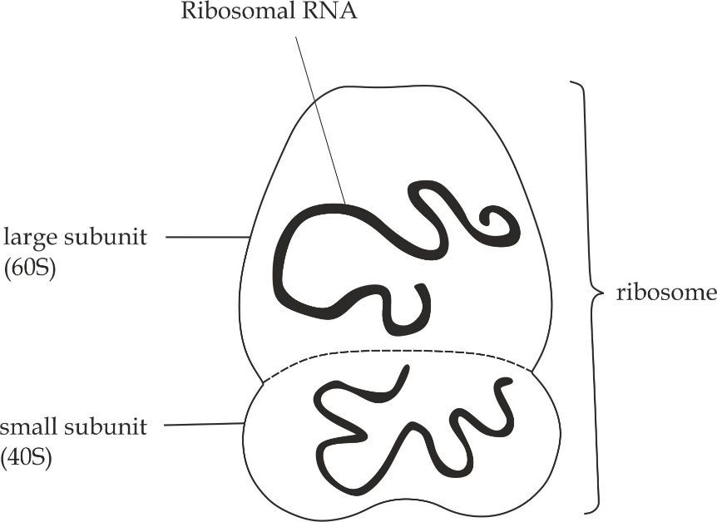

***Figure 1.11*** *The structure of ribosomal RNA (rRNA)*

**Role of ribosomal RNA (rRNA)**

It attracts different types of tRNA – amino acids toward the ribosome during protein synthesis.

1. **Transfer RNA (tRNA)**

This constitutes about 15% of the total RNA in the cell and it is also known as **soluble RNA** (sRNA).Structurally as illustrated in Figure 1.12, all tRNA molecules have very similar secondary structure in which a single – stranded chain is folded in a “clover leaf “structure. The tRNA molecule has four active or recognition sites. The upper site (3’ end) recognises the amino acid whereas the lower anticodon site recognises the mRNA. The T – loop recognises the ribosome whereas the D- loop recognises an enzyme called amino acyl –tRNA synthetase. This enzyme catalyses the binding of tRNA to a specific amino acid. This catalytic process produces an amino acid tRNA complex called amino acyl – tRNA.

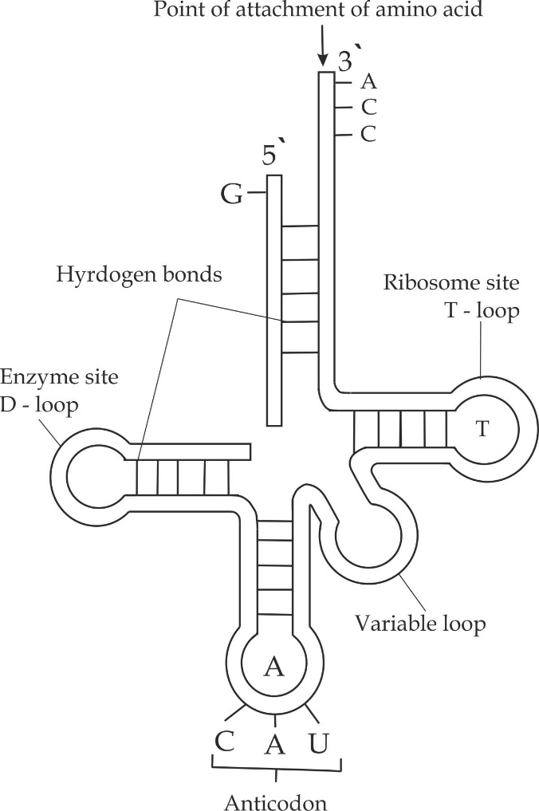

***Figure 1.12*** *The structure of transfer RNA (tRNA)*

**Role of transfer RNA (t RNA)**

It carriers the activated amino acid from the cytoplasm to the mRNA on the ribosome for protein synthesis.

***SAQ 1.7***

***NECTA 2018***

* Identify three types of ribonucleic acids.
* Describe the structure and location of the type of ribonucleic acids identified in 6(b) (i). (Diagram are not required).

**Table 1.1 differences between DNA and RNA**

|  |  |
| --- | --- |
| **DNA** | **RNA** |
| It is a single helix polynucleotide | It is a double helix polynucleotide |
| It is found in the nucleus | It is found in the cytoplasm |
| Pentose sugar is deoxyribose | Pentose sugar is ribose |
| It contains thymine as pyrimidine | It contains uracil as pyrimidine |
| It can undergoes self-replication | It cannot undergo self-replication |
| It has larger molecular weight | It has smaller molecular weight |
| It is more stable | It is less stable |

* + 1. **DNA REPLICATION AND GENETIC CODE**

***DNA replication***

DNA replication is the process by which DNA molecule makes its own exact copies .This biological process occurs in all living organisms and is the basis for biological inheritance. The process of DNA replication takes place during an interphase stage in the nuclear division. For each cell to divide, it must first replicates its DNA so that each daughter cell receives an exact copy of DNA.

**Significances of DNA replication**

1. **It maintains the genetic stability of an individual**

It ensures that each newly formed daughter cell in the body receives the correct number of chromosomes.

1. **It is a means of synthesizing RNA**

For example; if attracts “**U**″ instead of ″**T**“; the resulting strand with “**U** ″becomes RNA instead of DNA.

1. **It may lead to mutation**

For example; if mistakes occur in the arrangement of base sequence which result into mutations. These are the sources of genetic variations.

**Table 1.2 the roles of enzymes in DNA replication process**

|  |  |
| --- | --- |
| **Enzyme** | **Function in replication process** |
| **Topoisomerase** | * It relaxes the DNA from its super – coiled nature. |
| **DNA helicase** | * It unwinds the DNA double helix at the replication fork. |
| **Primase** | * It provides an RNA primer for DNA polymerase to begin synthesis of the new DNA strand |
| **DNA polymerase III** | * It builds a new double strand of DNA by adding nucleotides in the 5’ to 3’ direction. * It performs the proof reading and error correction |
| **DNA ligase** | * It joins the Okazaki fragments of the lagging strand. |

**Mechanism of DNA replication**

The mechanism of DNA replication is divided into three phases, namely:

* Unwinding of double stranded DNA molecule
* Replication of the parental stranded DNA
* Sealing the gaps

1. **Unwinding of double stranded DNA molecule**

* DNA replication starts with the unwinding or unzipping of the two intertwined antiparallel strands of DNA by the **helicase enzyme**. This enzymes untwists the helices at locations known as replication origin by breaking down the weak hydrogen bonds between the complementary strands base pairs of DNA molecule resulting into the formation of Y – shaped structure called a **replication fork**.
* Each of the separated strands acts as a template to which sets of the nucleotides would attach by base pairing for making the new strands of DNA.
* A single strand binding protein (SSB) stabilises each of the unwound parental DNA strands. This prevents the winding up or zipping up of the two strands before the replication of new strands is complete as indicated in Figure 1.13.

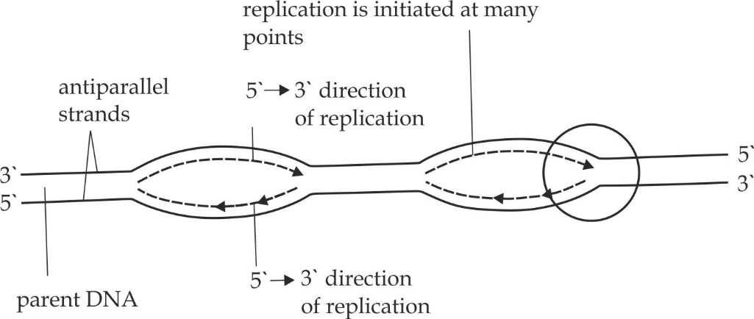

***Figure 1.13*** *Unwinding of a double stranded DNA molecule*

1. **Replication of the parental strands**

AS a result of their different orientations or anti – parallelism, the one of the strands is oriented in the 3’ to 5’ direction towards the replication fork. The 3’ to 5’ is the **leading strand** whereas the other strand oriented in the 5’ to 3’ direction away from the replication fork is called the **lagging strand**. The enzyme DNA polymerase III can work only in a 5’ end to 3’ end direction.

1. **Replication of the leading strand**

* A short piece of RNA known as a primer that is produced by an RNA polymerase enzyme called Primase, comes along and bind to the end of the leading strand. This is necessary because the enzyme DNA polymerase III cannot initiate the synthesis of initiate the synthesis of new DNA strands without a primer. The primer acts as a starting point for a new strand synthesis.
* The enzyme DNA polymerase III then binds to the leading strand and moves along it while adding free nucleotides by complementary base pairing.
* Adding of nucleotide is done to the new strand of DNA in the 5’ - 3’ direction without interruption manner along the entire length of the leading strand, hence, it is called a continuous replication.

1. **Replication of the lagging strand**

* On the lagging strand, DNA synthesis is interrupted because the DNA polymerase must as well move in the 5’ - 3’ direction.
* The relatively short lengths of replicated DNA are formed by this process, known as ***Okazaki fragment*** of the lagging, hence, it is called a discontinuous replication.

1. **Sealing the gaps**

* Once all the bases are matched up, an enzyme called RNA polymerase I, strips away the primers and fill the gaps which occupied by the primers by complimentary nucleotides.
* The DNA polymerase III and I proofread the newly synthesized strand to make sure there are no mistakes in the new DNA sequence.
* At the end of the DNA replication process, the enzyme called DNA ligase joins or stretches the sugar – phosphate backbones of the Okazaki fragments to create a continuous strand of DNA. It also seals up the sequence of DNA into two continuous double strands by catalysing the construction of hydrogen bonds between the bases pairs of DNA strands. Each of the constructed DNA molecule has one old strand and one new strand. This sort of DNA replication is called a semi – conservative replication as shown in Figure 1.14.

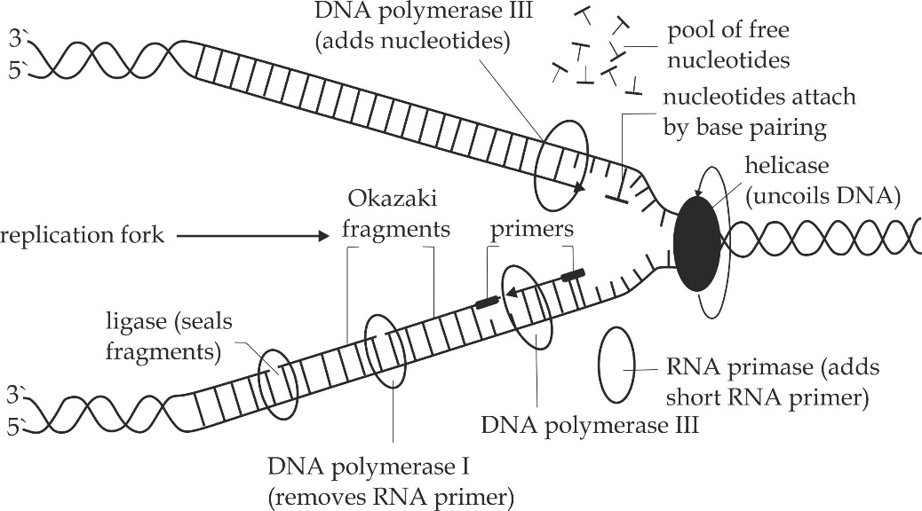

***Figure 1.14*** *The main steps of DNA replication*

***SAQ 1.8***

***DAR MOCK 2014***

* Describe the mechanism of DNA replication.
* Explain the significances of DNA replication.
* Why DNA replication is termened as semi – conservative?

***Genetic code***

**Genetic code** is a translation relationship between base sequence of DNA and amino acids that make up proteins. The base sequence of DNA and amino acids that make up proteins. The base sequence coded on the DNA determines the types of protein to be produced. Each protein can be made from only twenty amino acids and each amino acid has its own code on the DNA, this twenty amino acids are manufactured out of sixty four codes formed by what is called the triplet codes. Each triplet code is known as a codon and encodes information for a single amino acid. The full set of codons is known as a genetic code shown in Figure 1.15.

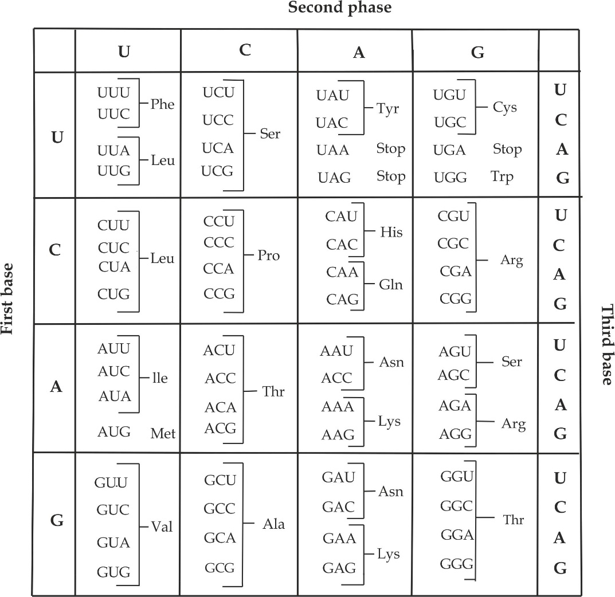

***Table 1.3*** *the genetic dictionary. The messenger RNA codons corresponding to the 20 amino acids made in cells are shown in this genetic dictionary. Three triplet acts as stop codons, and under certain conditions the codon AUG initiates protein synthesis.*

**Characteristics of genetic code**

The features which characterize the genetic code include the following:

1. **The genetic code is triplet:** Three nitrogenous bases specifying one amino acid. The codons are formed using the bases which are available in the mRNA.The four nucleotide bases (A, G, C and U) in the mRNA are used to produce three base codons (43 = 64 three base groups).Therefore, there are 64 codons, which code for the 20 amino acids and since each codon codes for only one amino acid, this means that, one amino acid can be coded by more than one codon.
2. **The genetic code is degenerate:** All amino acids except methionine (AUG) and tryptophan (UGG) are coded by more than one codon. For example, threonine is coded by four codons ACU, ACC, ACA and ACG. In this case, there are more codons than there are amino acids.
3. **The genetic code is punctuated:** Genetic code is punctuated, that means, it has the start and stop signals. The codon AUG (methionine) acts as a start signal for the initiation of polypeptide chain and the codons UAG, UAA and UGA are stop signal, which determine the end of polypeptide chain synthesis.
4. **The genetic code is universal:** Genetic code is universal, that means, the same codon for the same amino acid in all living organisms and viruses, however, a few exceptions are found in mitochondria. For example, UGA is one of the termination codons, which code for tryptophan in yeast mitochondria.
5. **The genetic code is non-overlapping:** The genetic code is sequentially read in groups of three without overlapping except in some viruses. For example, mRNA with base sequence AUGUCUCCA can be read as AUG/ UCU/ CCA and not AUG/ GUC/ CUC/CCA.

***SAQ 1.9***

***DAR MOCK 2021***

* With examples explain properties of genetic code.
* Using different pairs of the nitrogenous bases A, G, T and C list the 16 possible combinations of bases that can be produced.
* If four bases used singly would code for four amino acids, pairs of bases codes for 16 amino acids and triplet of bases code for 64 amino acids deduce a mathematical expression to explain this.

**1.2.3 PROTEIN SYNTHESIS**

Protein synthesis is the process whereby amino acids are joined up together by the peptide bonds to form a polypeptide chain.

**Mechanism of protein synthesis**

The mechanism of protein synthesis is divided into two main stages, namely: transcription and translation.

**Transcription**

Transcription is a process by which the base sequence in a DNA is converted into a complementary base sequence of mRNA.The occurs in the nucleus of the cell and proceeds by the following steps:

1. **Removal of histone protein**

The protein histone that protecting the DNA double helix is removed to expose the polypeptide sequence of the DNA molecule.

1. **Unwinding of a DNA molecule**

The double helix by breaking down the relatively week hydrogen bonds between the complementary base pairs and exposes the bases of the DNA strands. This process is controlled by the enzyme called RNA helicase.

1. **Synthesis of mRNA**

One of the two strands of DNA is selected as a template for the formation of a complementary single strand of mRNA.The, each of the exposed bases on the transcribing strand attracts a free nucleotide in the cytoplasm according to the base pairing rules between DNA and RNA. The base pairing rules are such that. Adenine pairs with uracil and Guanine pairs with cytosine in producing a molecule of mRNA from DNA.The molecule of mRNA is then synthesized by joining the nucleotides.

1. **Leaving of the mRNA**

The synthesized mRNA then leaves the nucleus through the nuclear pore carrying the genetic code with it to the ribosome in the cytoplasm. Along the messenger RNA strand is a sequence of triplet codes, which has been determined by the DNA.

1. **Winding of a DNA molecule**

When sufficient amount of mRNA has been synthesized, the RNA polymerase leaves the DNA and the two strands of DNA zip – up again reforming the double helix as indicated in Figure 1.15.

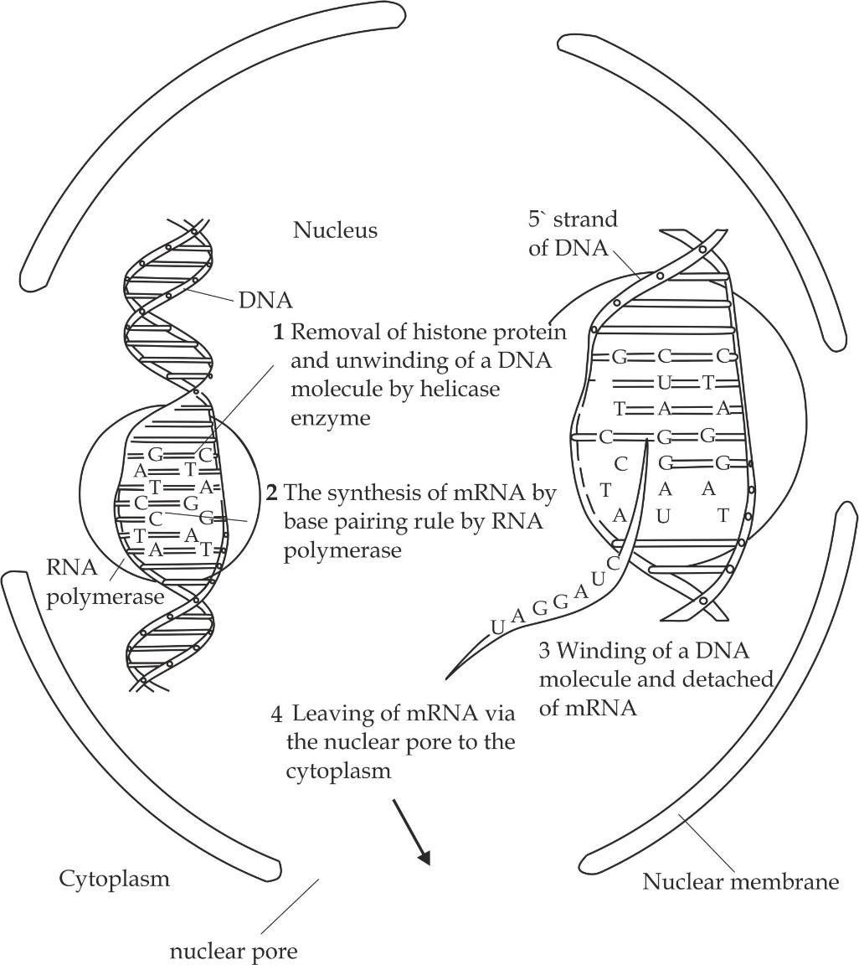

***Figure 1.15*** *Summary of the main steps of transcription*

**Translation**

Translation is a process whereby triplet base sequence of the mRNA molecule

Is converted into a sequence of amino acids in a polypeptide chain (protein). The process of translation occurs on the ribosomes and proceeds by the following main steps:

1. **Binding the mRNA to the ribosome**

The synthesized mRNA from the nucleus attaches itself on the small subunit of the ribosome in the presence of magnesium ion (mg2+) as cofactor as shown in Figure 1.16.

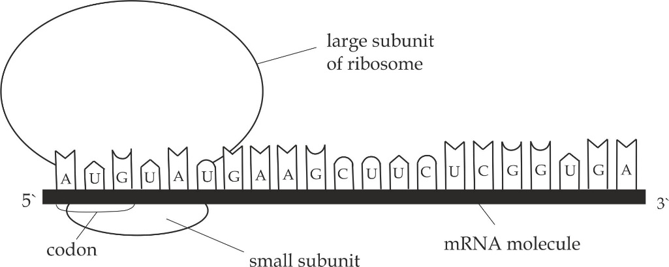

***Figure 1.16*** *Binding the mRNA to the ribosome*

1. **Amino acid activation and attachment to tRNA**

The amino acids in the cytoplasm becomes activated by ATP energy and complex with their specific tRNA under the influence of the aminoacyl tRNA synthetase enzyme, The formed products are called amino acid – tRNA complexes as shown in Figure 1.17.

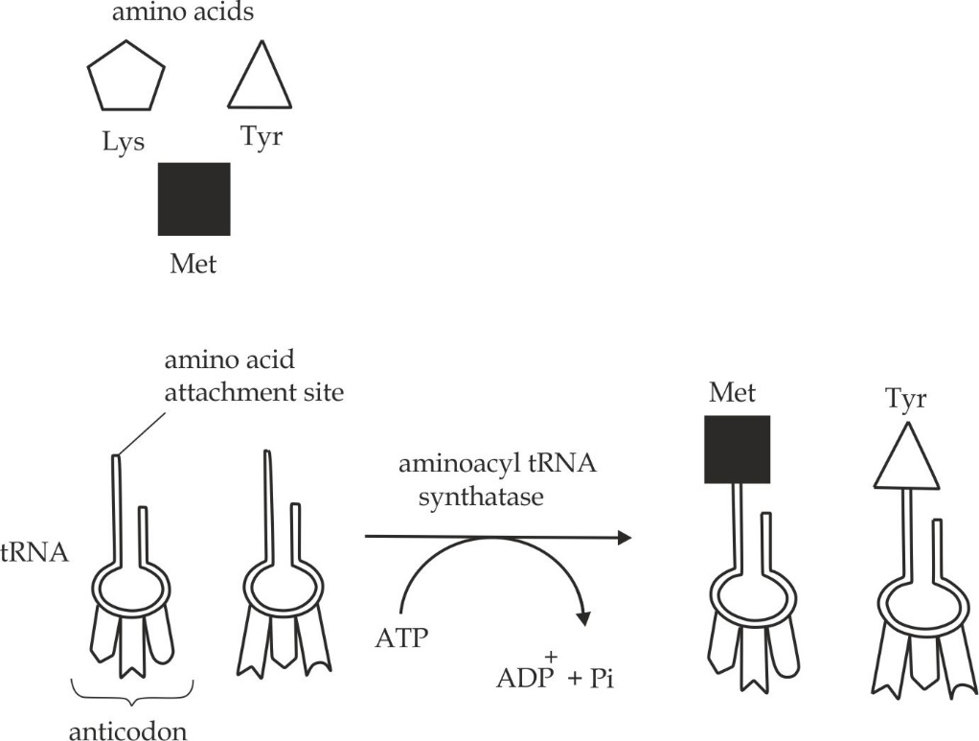

***Figure 1.17*** *Amino acid activation and attachment to tRNA*

1. **Polypeptide chain initiation**

The first codon attracts an amino acid – tRNA complex showing the complementary anticodon whereby the polypeptide chain initiation starts. The first codon is usually AUG which attracts methionine as shown in Figure 1.18.

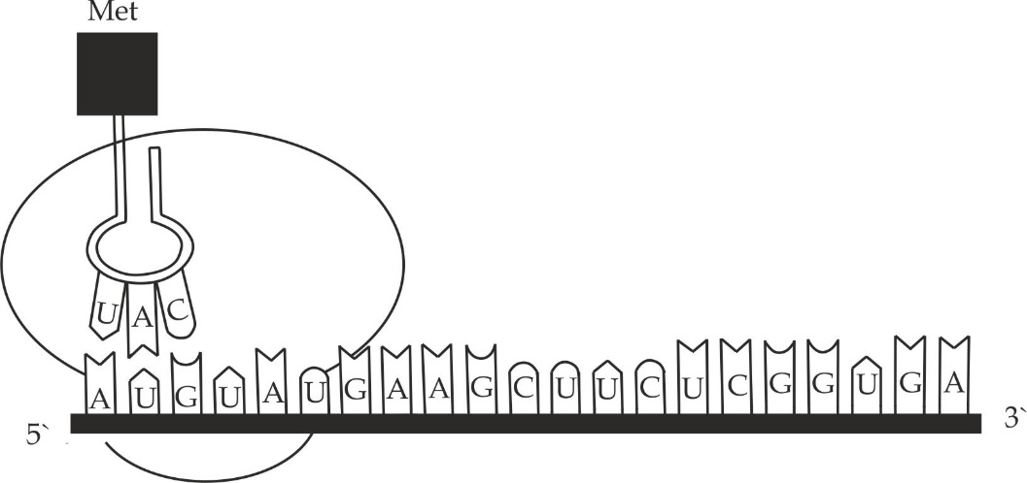

***Figure 1.18*** *Polypeptide chain initiation*

1. **Polypeptide chain elongation**

Elongation of the chain begins when the ribosome moves and read the second codon on the mRNA molecule. Consequently this movement also attract amino acid –tRNA complex showing the complementary anticodon. These two first amino acids are then joined together by the peptide bonds shown in Figure 1.19a.

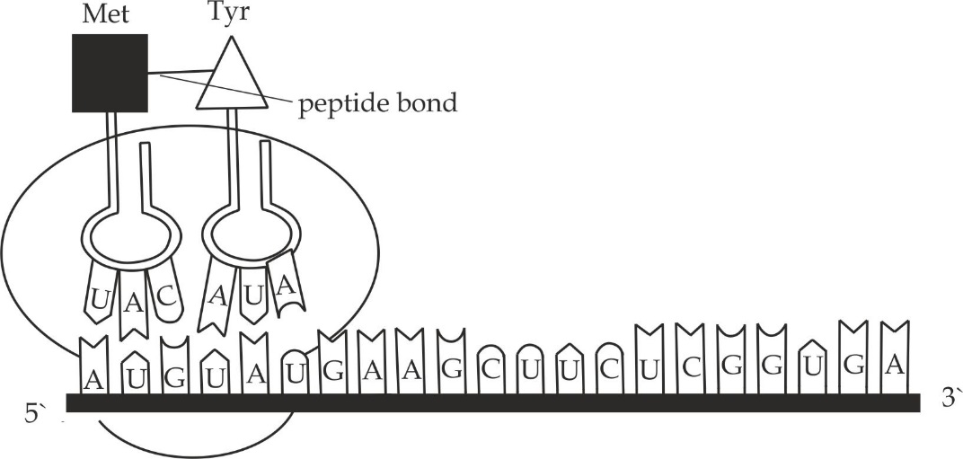

***Figure 1.19a*** *the first phase of polypeptide chain elongation*

Once amino acid is added into a growing peptide chain, the ribosome moves and read along the mRNA to enclose a new codon, consequently this movement attracts another amino acid –t RNA molecule showing the complementary anticodon. This newly brought amino acid is also joined to the previous amino acid by a peptide bond. The tRNA that was carrying the previous amino acid now is released and returns to the cytoplasm to pick up another amino acid as shown in Figure 1.19b.

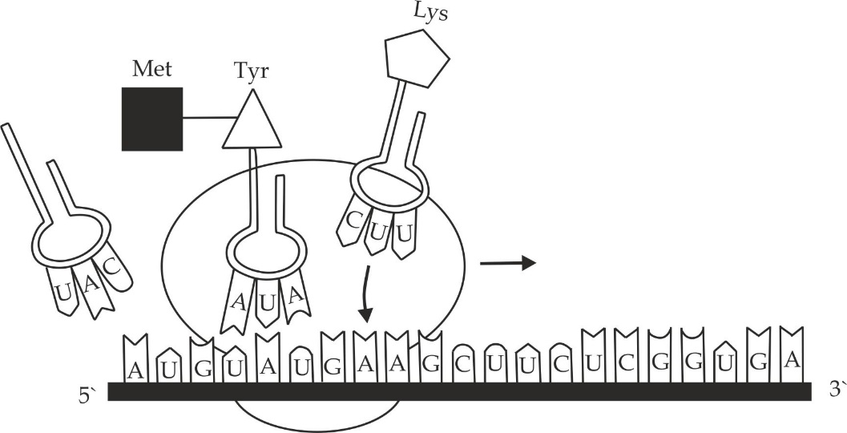

***Figure 1.19b*** *the second phase of polypeptide chain elongation*

1. **Polypeptide chain termination**

The sequence of ribosomes reading and translating the codes on the mRNA continues until it comes to a nonsense stop codon. The stop codons are **UAG**, **UGA** and **UAA** at this point, the polypeptide chain is formed as shown in Figure 1.20. At this point the polypeptide chain leaves the ribosome and completes the translation.

**Table 1.4 some inhibitors of bacterial protein synthesis**

|  |  |
| --- | --- |
| **antibiotic** | **effect** |
| Tetracycline | Inhibits binding of amino – acyl tRNA to ribosome |
| Streptomycin | Inhibits initiation of translation and causes misreading |
| Chloramphenicol | Inhibits the formation of peptide bonds |
| Erythromycin | Inhibits translation of mRNA along ribosome |
| Neomycin | Inhibits interaction between tRNA and mRNA |

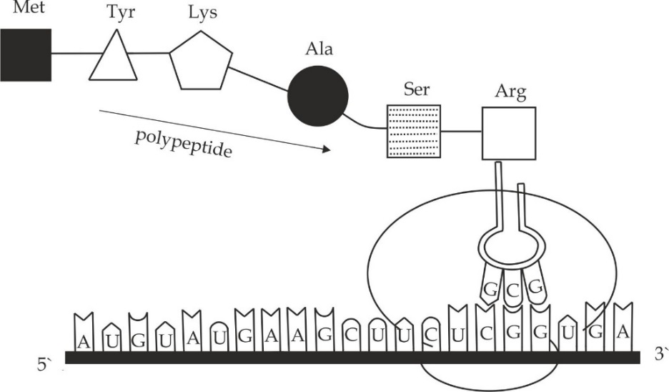

***Figure 1.20*** *The polypeptide chain termination*

SAQ ***1.10***

***NECTA 1998***

* Discuss the main stages involved in the production of a protein (polypeptide chain).

**1.2.4 MENDELIAN PRINCIPLES OF INHERITANCE**

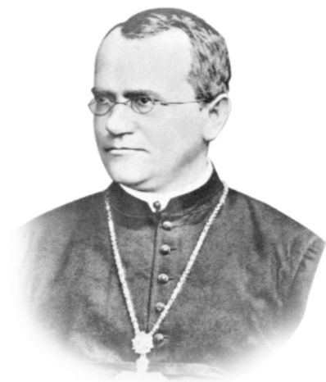

**Introduction of Mendelian Principles of inheritance:**

**Gregory Johan Mendel** (**1822 – 1884**) Figure 1.21 was a teacher and an Austrian monk who made studies of heredity by using garden pea plant, *Pisum sativum*.

In his experiment, Mendel was looking for the Laws that govern the passage of characteristics from one generation to another.

***Figure 1.21*** *Gregor Mendel*

In **1886** his conclusions were published interm of two main laws called “Mendelian Laws of inheritance” which are: The Mendelian first law of inheritance (**Law of segregation**) and The Mendelian second Law of inheritance (**Law of independent Assortment**).

**Why Did Mendel select the garden pea plant** *Pisum sativum***?**

Mendel selected the garden pea plant for his experiments due to the following reasons:

1. The garden pea plant has many contrasting and easily recognizable characteristics
2. The garden pea plants are easy to self or cross – pollinate.
3. The garden pea plant matures relatively fast.
4. The garden pea plants are easy to cultivate.
5. The garden pea plants produce many offspring’s *(seeds)* in each progeny.
6. The hybrids obtained from cross fertilization were fertilize.

**Why was Mendel so successful?**

Mendel was very successful in his experiments because of the following reasons:

1. He paid attention at only one character at a time.
2. He took a quantitative approach to the problem.
3. He took precautions to avoid mistakes committed by earlier workers.
4. He accurately recorded all experiments and the results obtained.
5. He gave himself enough time to collect sufficient data that were statically significant.

**Failure of Mendel**

1. He described only dominance recessive inheritance pattern but not all the time one character is dominant over the other.
2. He described only the diploid sexually reproducing organisms.
3. He did not consider gene interaction such as complementary gene.
4. He did not consider linked genes, i.e. because not all the time gene assort freely.

***SAQ 1.11***

**NECTA 2014**

* Elaborate Mendel’s work in genetics by considering his success and failures.

**Types of Mendelian inheritance**

There are two main types of Mendelian inheritance, namely:

* Monohybrid inheritance (cross)
* Dihybrid inheritance (cross).

**Monohybrid inheritance and the basic monohybrid ratio**

Monohybrid inheritance is a type of inheritance which involves the passage of one pair of contrasting characteristics.Mendels monohybrid inheritance involved flower colour, flower position, stem length, seed shape. Pod shape and pod colour. It is generally inheritance of a single trait.

**Mendel’s experiment on monohybrid inheritance**

In one of his experiments involving monohybrid crosses, Mendel crossed a tall garden pea plant from a pure line to a dwarf garden pea plant also from a pure line. All the products of the *first filial* (F1) *generation* had tall pea plants. However, when the members of this generation were selfed, the resulting members of the *second filial generation* (F2) were a mixture of tall and dwarf pea plants in an approximate ratio of 3: 1.This is the basic monohybrid ratio which is obtained from a cross involving two heterozygous parents.

Genetic representation of the Mendel’s experiment to explain monohybrid inheritance used tall and dwarf pea plants as fully explained in Figure 1.22.

**Assumption:**

**Let T** represent dominant allele for tall pea plant

**Let t** represent recessive allele for dwarf pea plant

1. The cross between a tall plant and a dwarf pea plant, produces tall pea plants in Fi generation. See the following diagram.

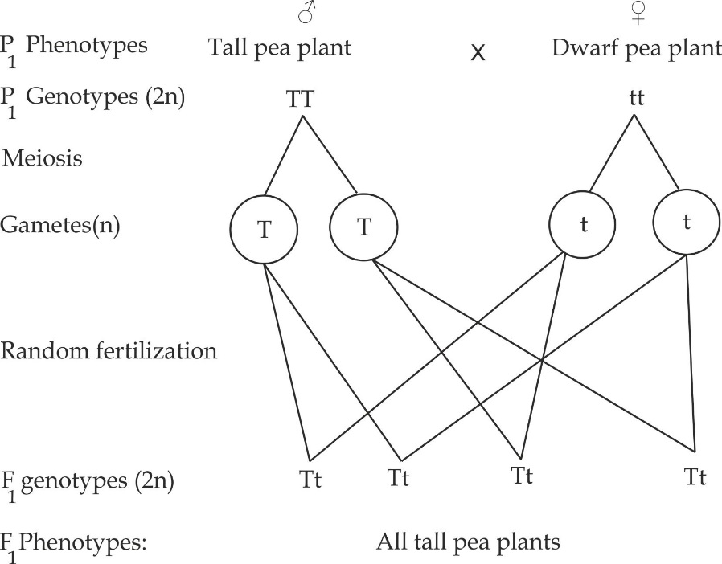

1. Selfing of the F1 members renders the following results in F2 generation:

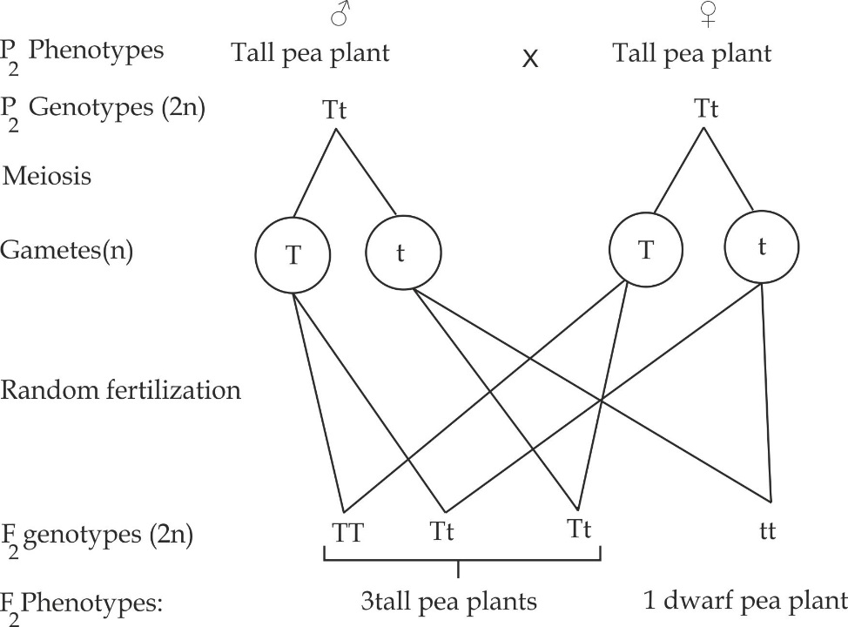

**Figure 1.22** Mendel’s explanation of monohybrid crosses

Thus, from **figure 1.22**, the F2 phenotypic ratio is 3 tall: 1 dwarf, and the genotypic ratio is 1 TT: 2 Tt: 1tt.

**Conclusions from Mendel mono hybrid crosses:**

Mendel’s conclusions from his work on mono hybrid inheritance is explained in terms of the First law of inheritance and is known as the ***Law of segregation*** ***of factors***. This law states that;

“The characteristics of an organism are controlled by internal factors which occur in pairs. Only one of a pair of these factors can be present in a single gamete“

**Meiotic explanation of Mendel’s first Law:**

Although Mendel knew nothing about meiosis process, his first law can be explained by behaviour and movement of chromosomes during meiosis.

* During meiosis I, at anaphase I, homologous chromosome pairs separate from one another, as a result, each haploid gamete receives half of the number of chromosomes present in parental cell.
* The allele also occur in pairs, each allele being located on one of two homologous chromosomes.
* Thus when the chromosomes separate they take their allele with them and therefore each gamete receive only one pair of the allele in a pair in a similar way as it receives only one chromosome as indicated in Figure 1.23.

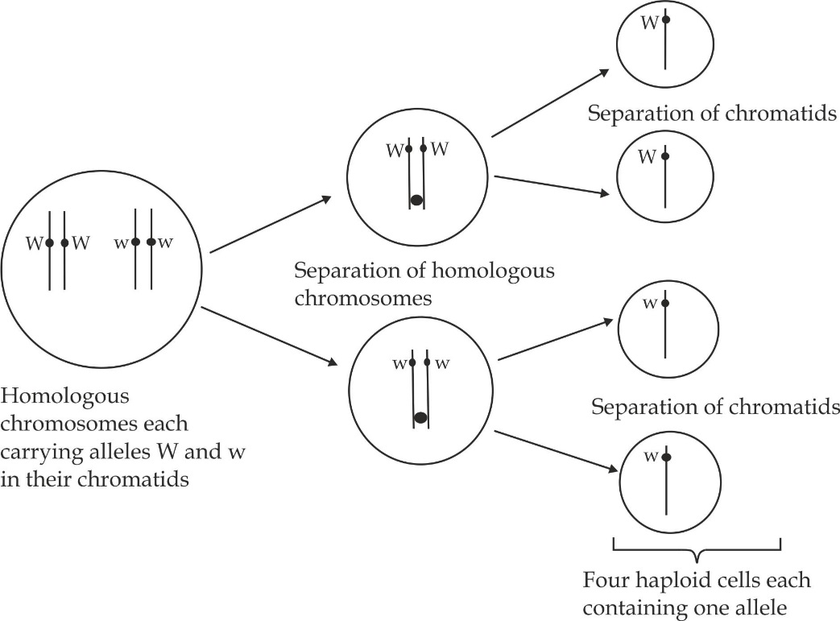

***Figure 1.23*** *Mendel’s principle of segregation of alleles W and w described in terms of homologous chromosomes which occur during meiosis.*

***SAQ 1.12***

***JOINT DAR***

* State Mendel first law of inheritance.
* How does the chromosome behave based on the Mendel First law of inheritance?

**Dihybrid inheritance and the basic dihybrid ratio**

Dihybrid inheritance is a type of inheritance which involves the passage of two pair of contrasting characteristics. For example, if a tall garden pea plant with red flowers is crossed with a short garden pea plant with white flowers, the two characteristics considered here are the height of the plant stem and colour of its flower.

**Mendel’s experiment on dihybrid inheritance**

In one of his experiments involving dihybrid crosses, Mendel crossed pure breeding (homozygous) pea plants having round yellow seeds with pure breeding plants having wrinkled green seeds. All the F1 generation seeds were round yellow. From his previous monohybrid experiments, Mendel knew that these two characteristics (round and yellow) were dominant. The members of the F1 generation were selfed and 556 seeds were collected in the F2 generation, which showing the following proportions; 312 Round yellow seeds;102 Wrinkled yellow seeds;110 Round green seeds and 31 Wrinkled green seeds. These proportions of each phenotype approximated to a ratio of 9:3:3:1.This is known as the basic dihybrid ratio, which is obtained from a cross involving two heterozygous parents.

Genetic representation of the Mendel’s experiment to explain dihybrid cross used round yellow seeds and wrinkled green seeds as fully explained in Figure 1.24.

**Assumptions:**

Rrepresent dominant allele for round seeds**; r** represent recessive allele for wrinkled seeds**; Y** represent dominant allele for yellow seeds**; y** represent recessive allele for green seeds

1. The cross between a homozygous round yellow seeds and a recessive wrinkled seeds, produce all round yellow seeds plants in F1 generation, see the following diagram.

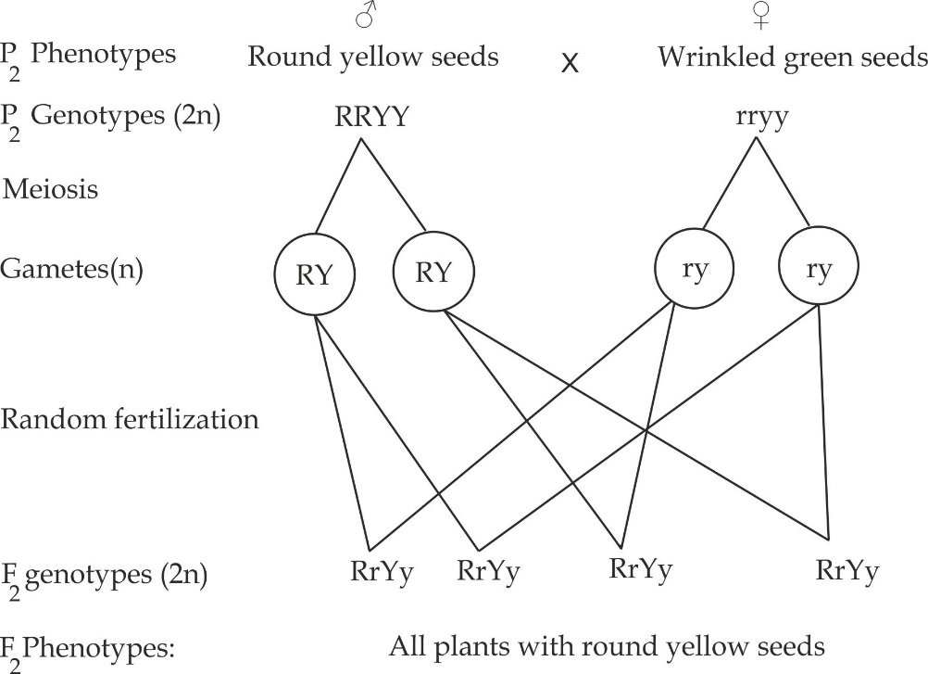

1. When Selfing members of the F1 generation renders the following:

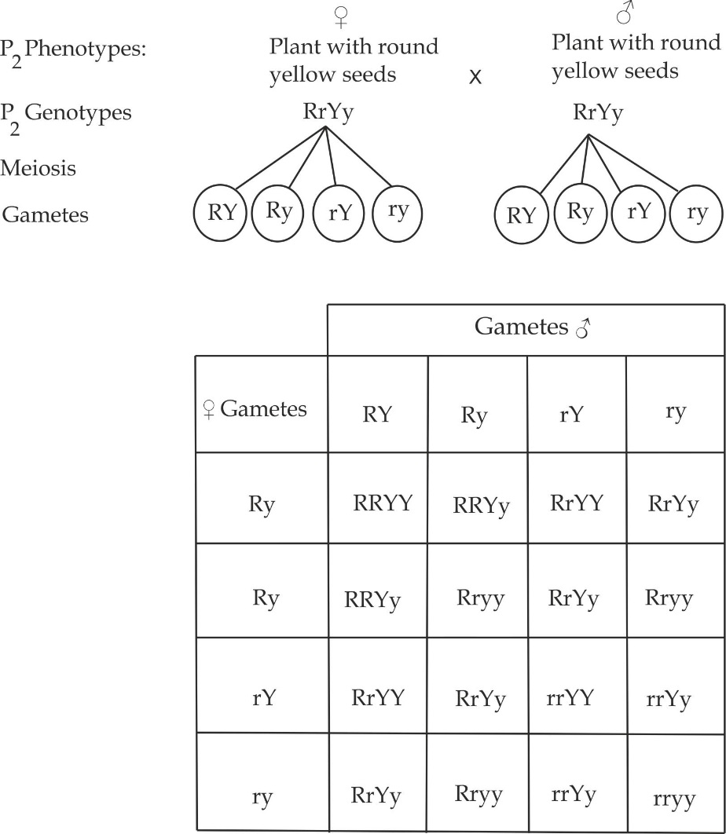

**Figure 1.24** Genetic representation of the dihybrid cross to show a 9:3:3:1 phenotypic ratio in F2 generation using a punnet square.

The above **Figure 1.24** is an example of a dihybrid cross because two characteristics are considered at a time. The punnet square was used to show all possible combinations of gametes to form F2 genotypes, from the punnet square, the phenotypic proportions are; 9 Round yellow seeds; 3 Round green seeds; 3 wrinkled yellow seeds and 1 wrinkled green seeds.

**Conclusions from Mendel mono hybrid crosses:**

Mendel’s conclusions from his work on dihybrid inheritance is explained in terms of the Second Mendelian law of inheritance and is known as the ***Law of independent assortment***. This law states that; each of a pair of contrasted characters may be combined with either of another pair“

**Meiotic explanation of Mendel’s second law:**

Mendel’s second law is explained by meiosis as follows:

* During gamete formation, the distribution of each allele (factors) in the homologous chromosome pair is entire independently of the distribution of alleles of another pair.
* It is therefore random alignment on the equator in metaphase I and their subsequent separation in anaphase II, which leads to a variety of allele in the gamete cells.
* In meiosis, the homologous chromosomes come together (assist), but they arrange themselves on the spindle fibres independently of one another as shown in Figure 1.25.

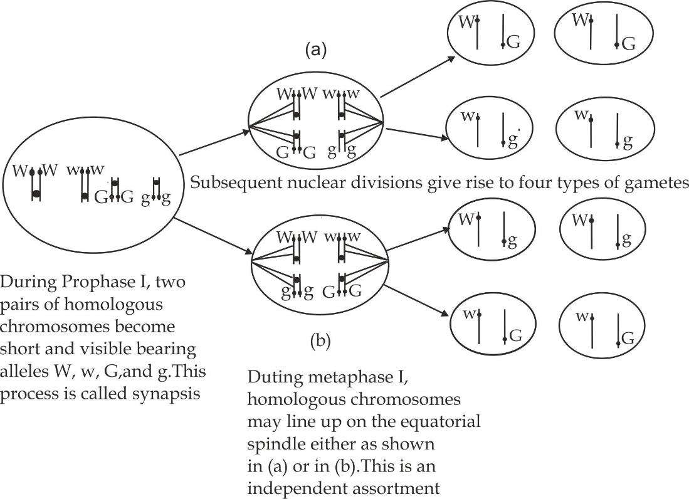

***Figure 1.25*** *Mendel’s principle of independent assortment of factors or alleles described in terms of the separation of homologous chromosomes which occurs during meiosis*

**Common terms used in genetics**

**Gene**

Gene a part of chromosome that determine a particular trait of an individual. Gene are responsible for transferring a hereditary trait to the next generation.

**Allele**

Allele is an alternative form of a gene controlling the same characteristic of an individual. For example **T** is an allele of t where controls tallness and **t** controls shortness.

**Locus**

Locus is the exact position or location of a gene on a chromosome. The plural of the word locus is loci.

**Dominant**

Dominant is a characteristics or a gene that makes the expression of the other gene, i.e. it express itself in the phenotype of an organism regardless of the presence of another gene. It is denoted by capital letters; for example in garden pea tallness (T) is dominant over shortness (t).

**Recessive**

Recessive is a characteristic or gene that does not express itself when a dominant gene is present. It is denoted by small letters of the dominant gene.

**Phenotype**

Phenotype is a physical appearance of an organism. Phenotype include, tall, short, round or brown.

**Genotype**

Genotype is the genetic constitution or genetic makeup of an organism. For example TT, Tt or tt are three different genotypes.

**Homozygous**

Homozygous is a state where the alleles at given locus are similar. For example, TT for tallness or tt for shortness. An individual with similar alleles in a corresponding locus on a pair of homologous chromosome is known as a **homozygote**.

**Heterozygous**

Heterozygous is a state where the alleles at a given locus are different. For example Tt (T for tallness and t for shortness). An individual with different alleles in a corresponding locus on a pair of homologous chromosome is known as a **heterozygote**.

**First filial generation**

First filial generation refers to the offspring’s produced after crossing the parental genotypes. It is abbreviated as F1 generation.

**Second filial generation**

Second filial generation refers to the offspring’s produced after crossing the F1 generation. It is abbreviated as F2 generation.

***SAQ 1.13***

***NECTA 2000***

* Define the following genetic terms:

1. Genotype iii. Homozygous
2. Phenotype iv. Heterozygous

**Worked examples of Mendelian principles of inheritance**

***Worked example 01***

***Necta 2003***

In drosophila Melanogaster, the gene for grey colour (E) is dominant over the gene for ebony colour (e).

1. What would be the offspring genotype be if both parents were heterozygous for body colour?
2. What would be the offspring phenotype of a cross between homozygous grey male flies and heterozygous female flies be?

**Solution:**

1. Consider a cross between two heterozygous grey colour flies parents:

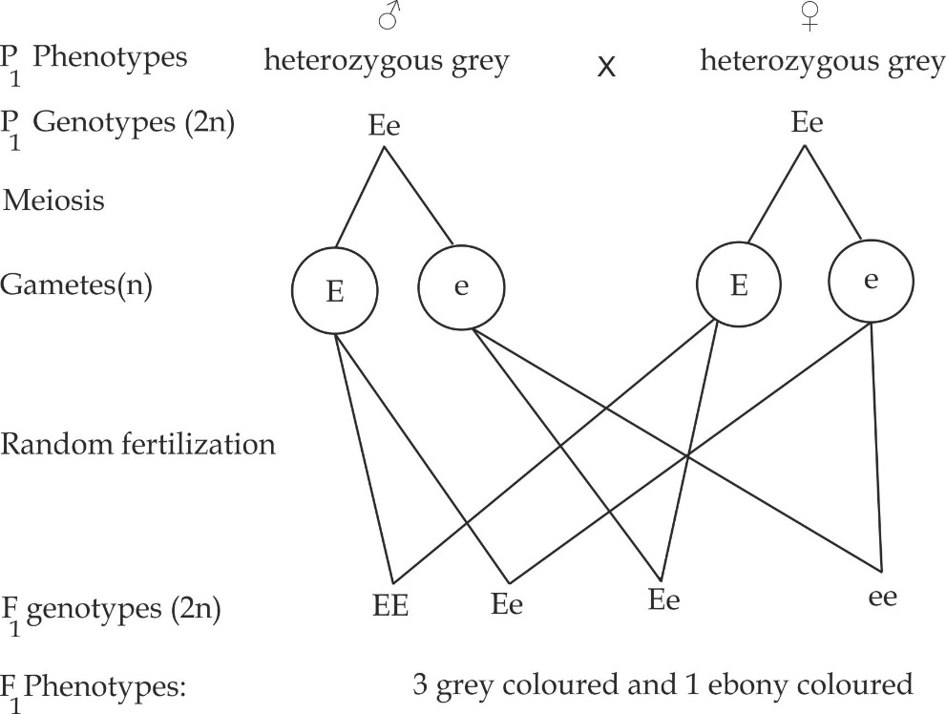

1. Consider a cross between homozygous grey male and heterozygous grey female flies:

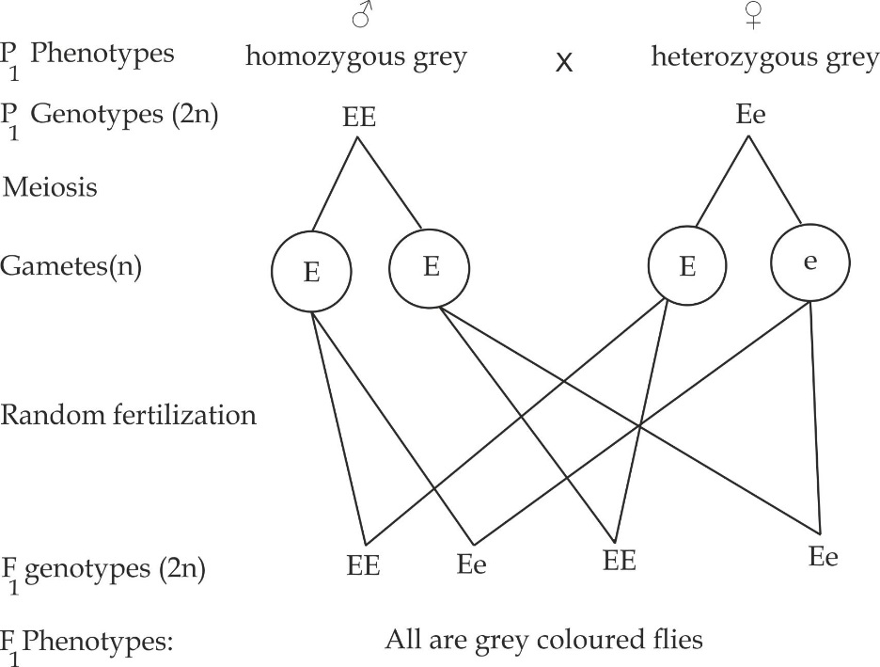

***Worked example 02***

**TAI QUESTION**

If a pure strain of mice with brown coloured fur are allowed to breed with a pure strain of mice with grey coloured fur, they produce offspring with brown coloured fur. If F1 mice are allowed to interbreed, they produce offspring with fur colour in the proportion of three brown – coloured to one grey in F2 generation.

1. Use genetic crosses to explain these results fully.
2. What would be the results of mating a brown coloured heterozygous from the F1 generation with the original grey coloured parent?

**Solution:**

Since all the F1 mice have brown coloured fur, then the gene for brown colour is dominant to the gene for grey colour.

**Assumptions:**

**Let** the allele for the dominant gene is represented by B.

**Let** the allele for the recessive gene is represented by b.

Let brown coloured homozygous alleles be represented by **BB**, the brown heterozygous alleles represented by Bb and the grey recessive alleles by **bb**.

1. The results of a cross between a brown coloured male mice and a grey coloured female mice will be as follows:

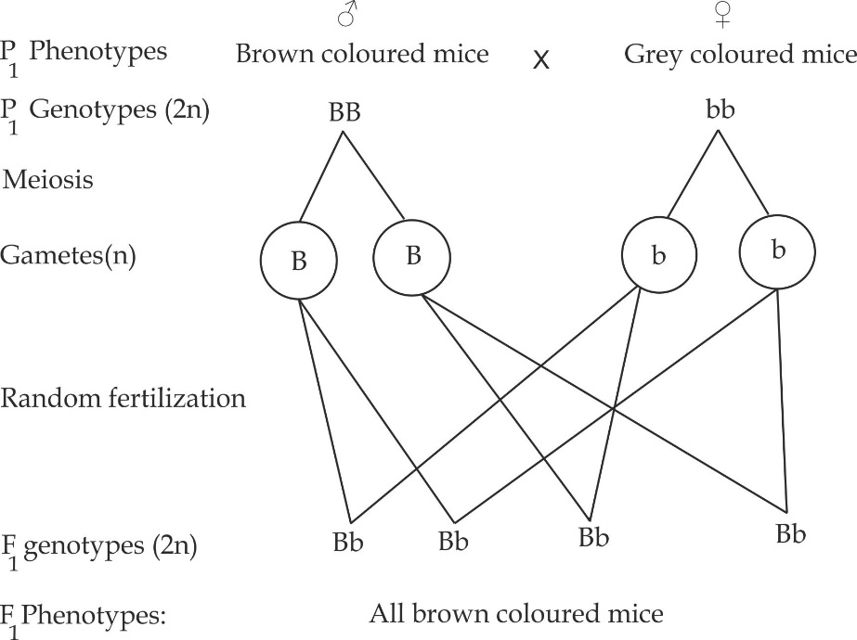

On Selfing of individuals of F1 generation (heterozygous brown mice)

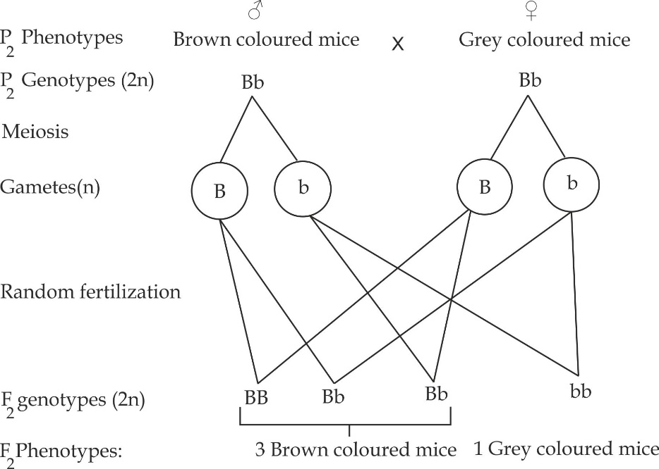

Thus, about ¾ 75% of the offspring in F2 generation will have brown coloured fur because brown colour is dominant over grey colour. The rest 25% of the offspring will have grey coloured fur.

***Worked Example 03***

***COAST MOCK 2003***

In an Orange plant, the gene for red flower is dominant over the gene for white flower.

Give the genotype ratio expected when a homozygous red flowered plant is crossed with white flowered plant and the products of the cross in above are:

1. Crossed among them.
2. ii. Propagated vegetatively.

**Solution:**

1. A cross between homozygous red flowered plants is crossed with white flowered plant.

**Assumptions:**

**Let** the allele for the dominant gene is represented by R.

**Let** the allele for the recessive gene is represented by r.

Let red coloured homozygous alleles be represented by **RR**, the red heterozygous alleles represented by Rr and the white recessive alleles by **rr**.

**CROSS I**

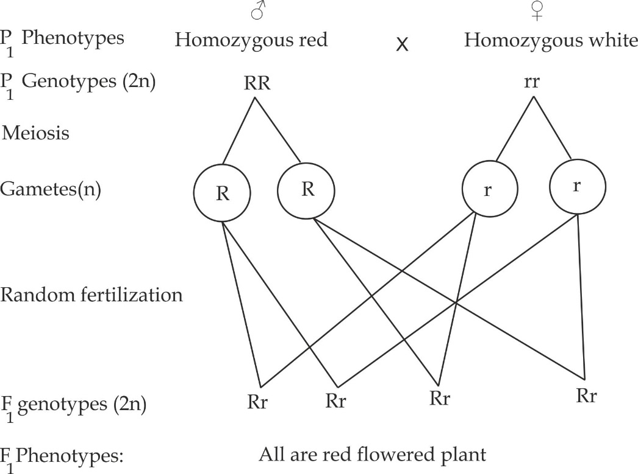

Thus, all offspring in F1 generation will have red coloured flower

On Selfing of individuals of F1 generation (heterozygous red flower)

**CROSS II**

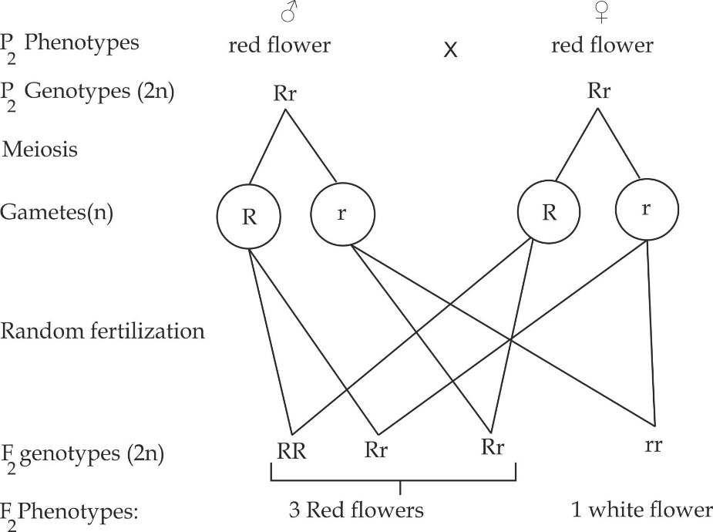

F2 Genotypic ratio is 1RR: 2Rr:1rr

1. Vegetative propagation is the asexual type of reproduction which does not involve any genetic mechanism thus no genotypic ratio is expected.

***Worked Example 04***

***BRIGHT EXAM 2019***

In rodentia, there are two alleles for hair colour, black and white and two alleles for hair length; short and long. In a breeding experiment all the F1 phenotypes produced from a cross between pure breeding long white haired and pure breeding short black haired parents had short black hair.

Explain:

1. Which allele is dominant?
2. The expected of F2 phenotypes.
3. What ratios could be obtained if test cross would carried out.

**Solution:**

1. Since all the F1 mice have short black hair, then the gene for short hair **(S)** is dominant to the gene for long hair **(s)** and gene for black colour **(B)** is dominant over the gene for white colour **(b).**
2. Consider a cross between pure breeding long white haired and pure breeding short black.

**Assumptions:**

**Let** the allele for the dominant short gene is represented by S.

**Let** the allele for the recessive long gene is represented by s.

**Let** the allele for the dominant black gene is represented by B

**Let** the gene for the recessive white gene is represented by b

**CROSS I**

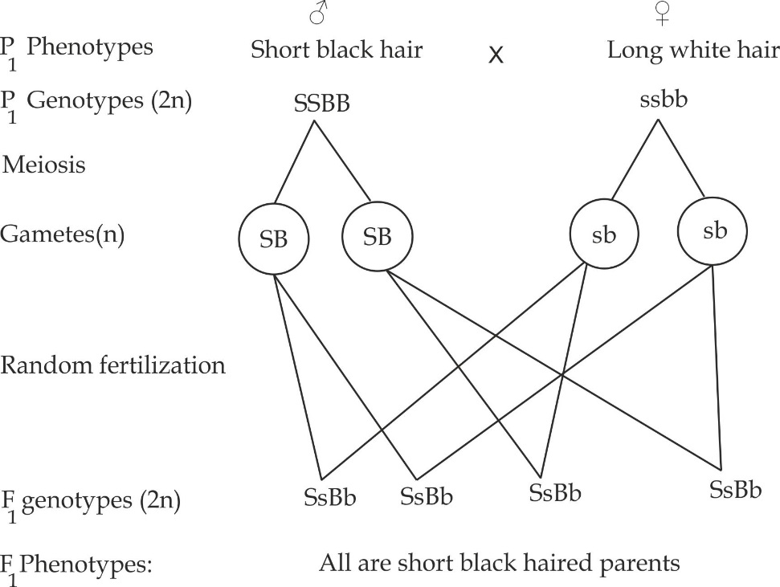

On Selfing of individuals of F1 generation (heterozygous short black)

**CROSS II**

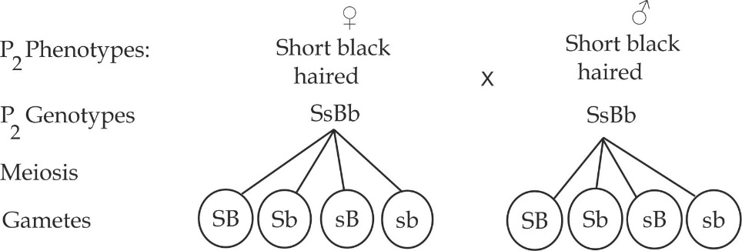

Consider a punnet square table below:

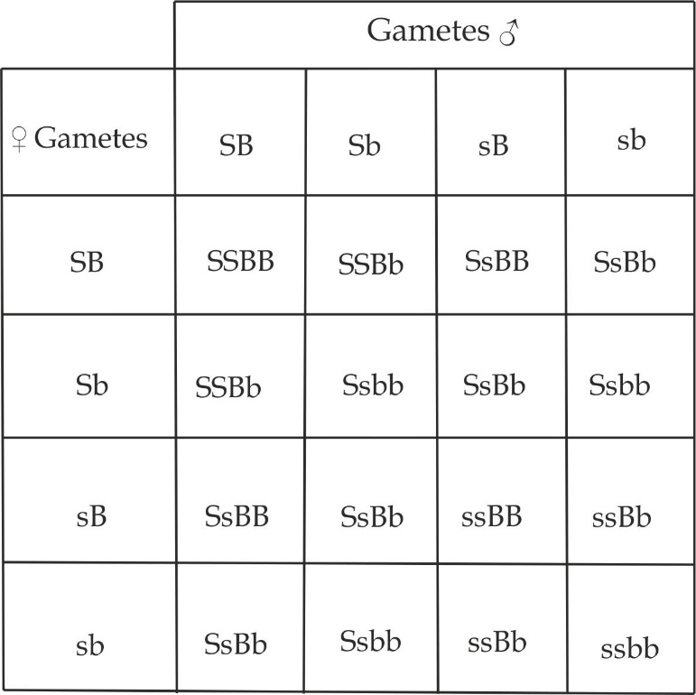

The results of F2 phenotypes are:

9 short black hair mice

3 short white hair mice

3 long black hair mice

1 long white hair mice

1. F2 phenotypic ratio if test cross could be carried out;

F1 offspring (short black hair) Ssbb

Long white hair (ssbb)

**CROSS II**

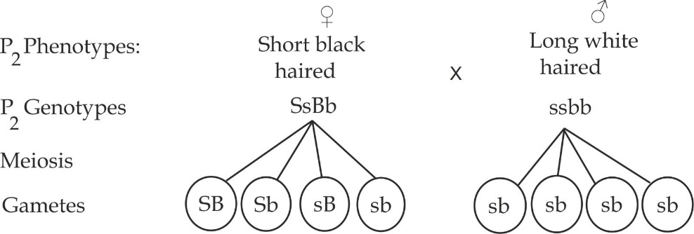

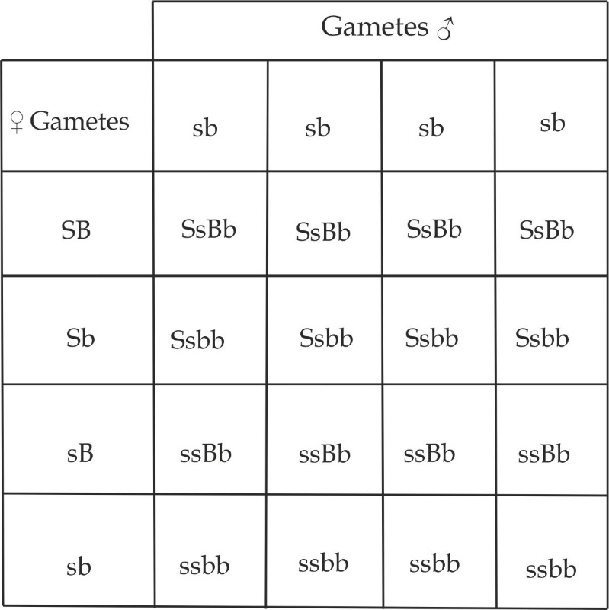

**The results of F2 phenotypes are:**

4 Short black

4 Short white

4 Long black

4 Long white

F2 phenotypic ratio is 4:4:4:4 or 1:1:1:

***Worked Example 05***

***JECAS 2012***

A homozygous purple flowered short stemmed plant was crossed with a homozygous red flowered long stemmed plant and F1 phenotypes had purple flowers and short stem, when the F1 generation was tested crossed with a double homozygous recessive plant the following progeny were produced.

* 52 – purple flower short stem
* 47 – purple flower long stem
* 49 – red flower short stem
* 45 – red flower long stem

1. What are the dominant alleles?
2. What are the probable genotype of the purple flower of short stemmed plant used to produce F1?
3. Using illustration, explain the result of test crossing F1 generation performed in the above experiment?
4. If the purple flowered short stemmed plant obtain as F1 offspring were self-crossed, what would be F2 phenotypes?

**Solution:**

1. Since all the F1 mice have purple short flower, then the gene for short hair **(S)** is dominant to the gene for long stem **(s)** and gene for purple colour **(P)** is dominant over the gene for red colour **(p).**
2. Possible genotype for purple flower short stem is **PPSS.**
3. Across between purple flowered short stem and red flowered long stem

**CROSS I**

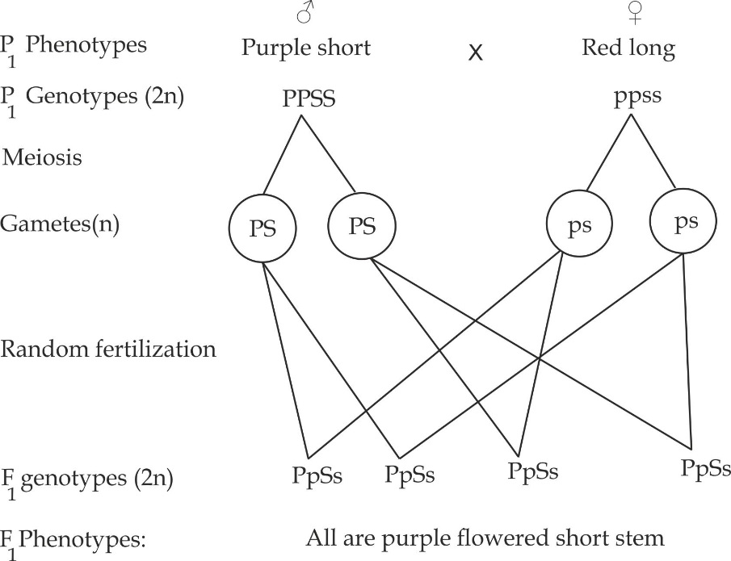

**CROSS II**

(A cross between F1 and red long flower (double homozygous recessive)

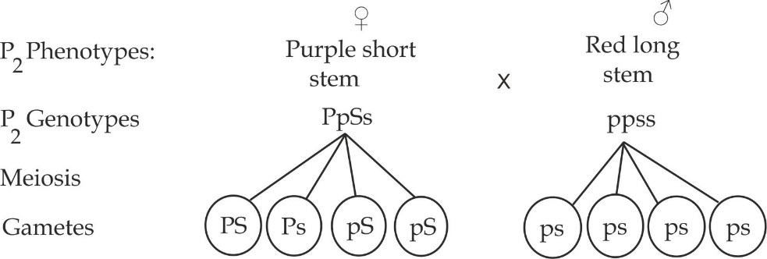

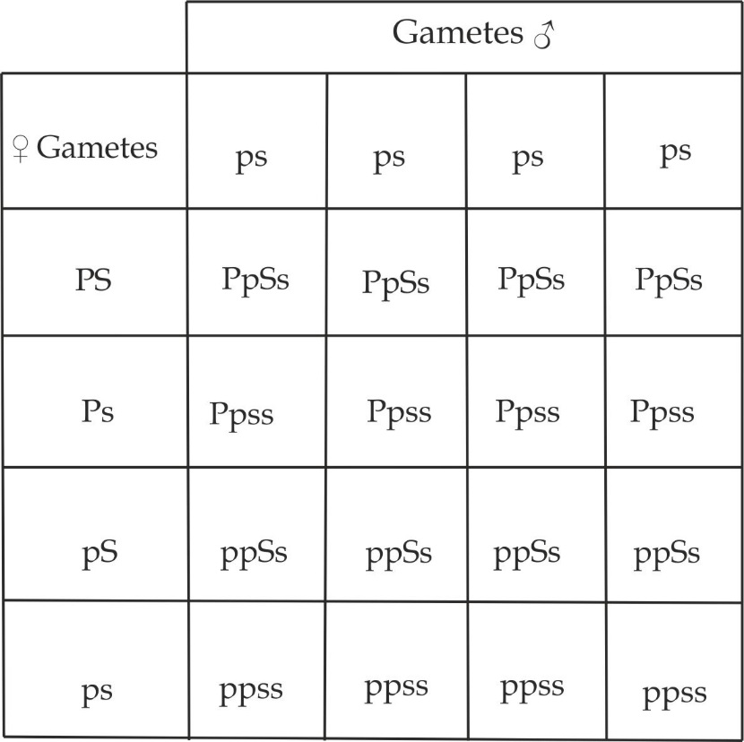

**The results F2 phenotypes are:**

4 purple short

4 purple long

4 white short

4 white long

F2 phenotypic ratio is 4:4:4:4 or 1:1:1:1

1. A cross between F1 individuals obtained in cross I above.

**CROSS II**

**(On Selfing F1 individuals)**

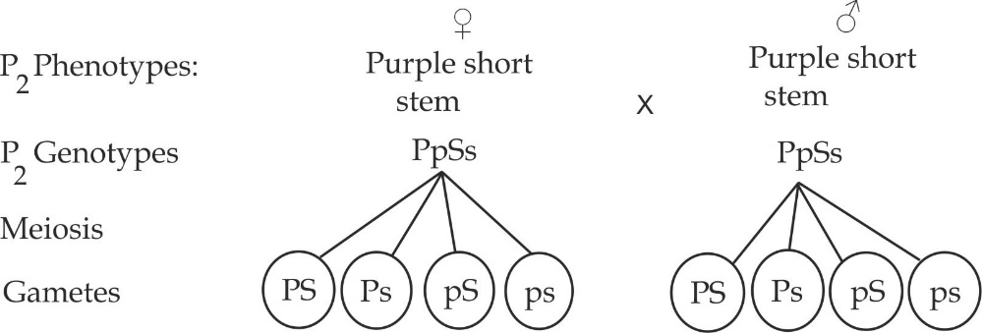

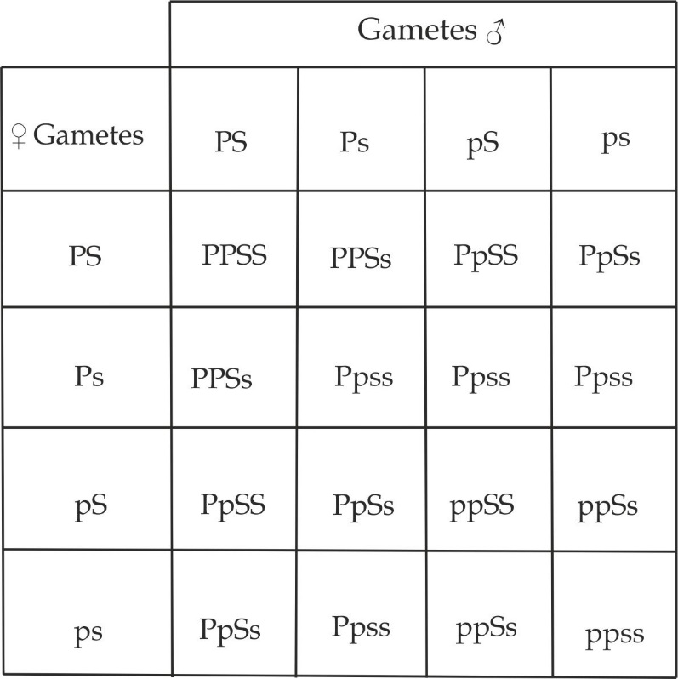

**The F2 phenotypes are:**

9 Purple short stem

3 purple long stem

3 red short

1 red long

F2 phenotypic ratio is 9:3:3:1

***Worked Example 06***

***ACSEE 1983***

In Guinea Pig, Rough coat is dominant over smooth coat, and black coat is dominant over white coat. When a rough black guinea pig was crossed with a rough white guinea pig the offspring obtained were:

* 328 Rough black
* 311 Rough white
* 111 Smooth black
* 110 Smooth white

What were the genotypes of the parents?

**Solution:**

**Assumptions:**

**Let** the allele for the dominant rough gene is represented by R.

**Let** the allele for the recessive smooth gene is represented by r.

**Let** the allele for the dominant black gene is represented by B

**Let** the gene for the recessive white gene is represented by b

In dihybrid cross, each character behaves independently of the other

**Coat texture**:

Rough Smooth

328 + 311 110 + 111

639 221

221 221

3 1

**3: 1**; this is a basic monohybrid ratio obtained from a cross involving two heterozygous individuals. Thus we have, Rr x Rr.

**Coat colour:**

Black White

328 + 111 311 + 110

439 421

421 421

1 1

**1:1**; this is a basic monohybrid ratio obtained from a cross involving heterozygous dominant individual and homozygous recessive individual, thus we have, Bb x bb.

Therefore, the genotypes of the parents are:

Rough black **RrBb** and Rough white **Rrbb.**

***Sample question 07***

***MOROGORO MOCK 2006***

Two form V students Issa and Sophia were eager to put into practise their genetic knowledge, they carried out the following crosses:

CROSS I

Pure breed (homozygous) plant with terminal purple flower was crossed with a homozygous plant with axial white flower.

CROSS II

A plant with Axial purple flower of unknown percentage had crossed with one of the F1 offspring produced the following results:

* 328 Axial purple flowered
* 301 Axial white flowered
* 109 Terminal purple flowered
* 84 Terminal white flowered

Due to their elementary knowledge on genetics, Sophia and Issa failed to interpret their results:

1. Help Sophia and Issa to interpret their result.
2. Identify the genotypes and phenotypes of the plants obtained from CROSS I.
3. What is a phenotypic ratio of plant produced in CROSS II?

**Solution**

1. According to Mendel’s second Law, each character in a dihybrid cross behaves independently:

**Position of flower**

Axial Terminal

328 + 301 109 + 84

624 193

193 193

3 1

3:1; this is monohybrid ratio obtained from a cross involving two heterozygous dominant individuals.3:1 shows that 3 is a value for **axial** (**A**) which is dominant over 1 which is a value for recessive terminal **(a),** from the basic monohybrid ratioabove, this produce Aa (Axial) x Aa (Axial).

**Flower colour**

White Purple

328 + 84 301 + 109

407 410

407 407

1 1

**1: 1**; this is a monohybrid cross obtained after cross involving heterozygous dominant individual and homozygous recessive individual. The ratio 1: cannot be used to identify which character is dominant and which character is recessive. Since from cross I; Axial white flower was from a homozygous plant then white is also a dominant allele **(W)** over the purple colour **(w**), this produce Ww (white) x ww (purple).

1. **Assumptions:**

**Let** the allele for the dominant axial gene is represented by A.

**Let** the allele for the recessive terminal gene is represented by a.

**Let** the allele for the dominant White gene is represented by W.

**Let** the gene for the recessive purple gene is represented by w.

**CROSS I**

Consider a cross between homozygous purple white and homozygous terminal white flower:

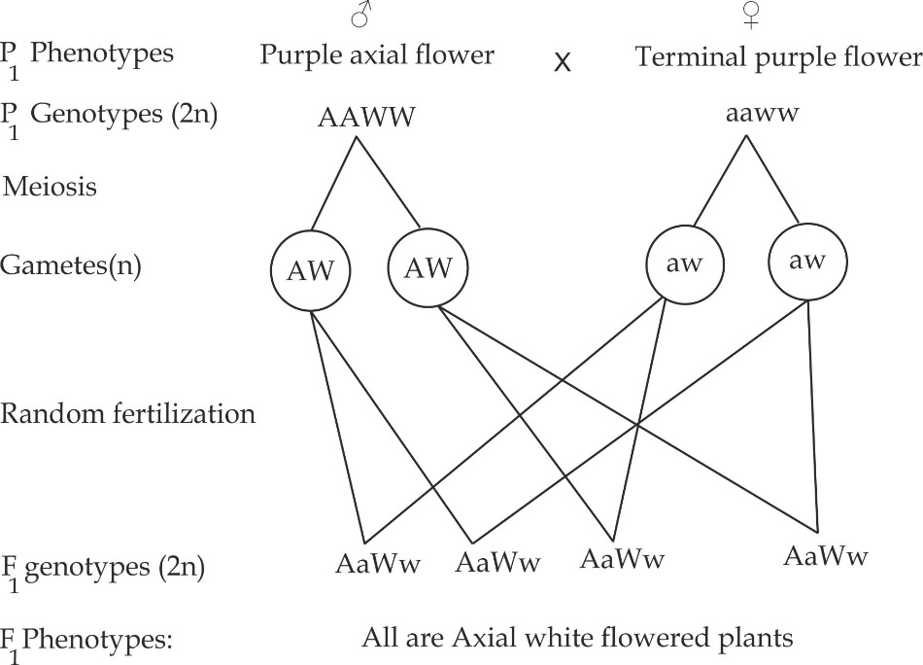

Thus, the genotypes are AaWw, AaWw, AaWw and AaWw

The phenotypes; All are Axial white flowers

1. Consider a cross between F1 individual (AaWw) and Axial purple of unknown percentage interpreted as Aaww.

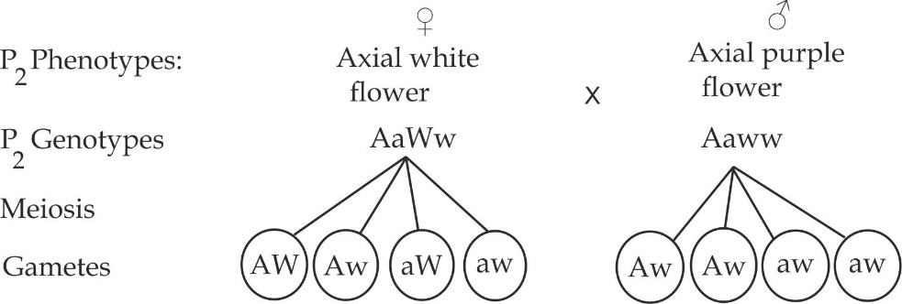

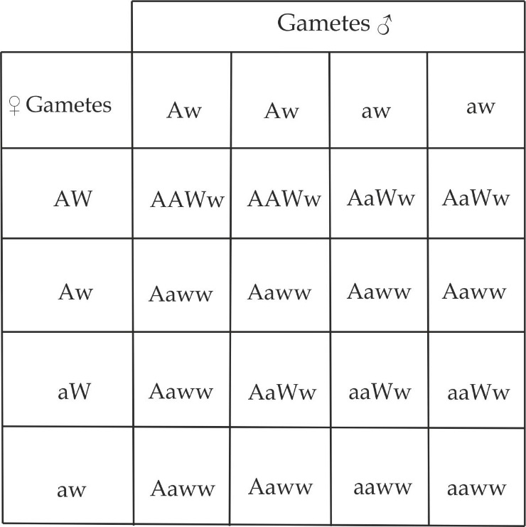

**F2 phenotypes results are:**

6 Axial white flower

6 Axial purple flower

2 Terminal white flower

2 Terminal purple flower

F2 phenotypic ratio is 6:6:2:2 or 3:3:1:1

**1.2.5 TEST CROSS AND BACK CROSS**

**TEST CROSS**

**Test cross** is a genetic cross between a homozygous recessive individual with an individual exhibiting a dominant trait of unknown genotype.

**Application of test cross:**

This is done in order to determine whether that individual is homozygous or heterozygous dominant for that trait. For example, a plant producing red flowers could either be homozygous dominant **(RR)** or heterozygous **(Rr)**. If the genotype of this plant is to be determined accurately, it should be test crossed with a homozygous recessive, for example; In the above case is white flowered plant of the genotype **rr.**

1. If the entire test cross progeny, come out with dominant trait, i.e. red flowered, then the experimental individual is genetically homozygous dominant **RR** as shown in Figure 1.26a.
2. If the test cross progenies are a mixture of dominant and recessive trait, i.e. red and white flowered plants in the approximate ratio of 1:1, then the experimental individual is genotypically heterozygous dominant **Rr** as shown in Figure 1.26b.

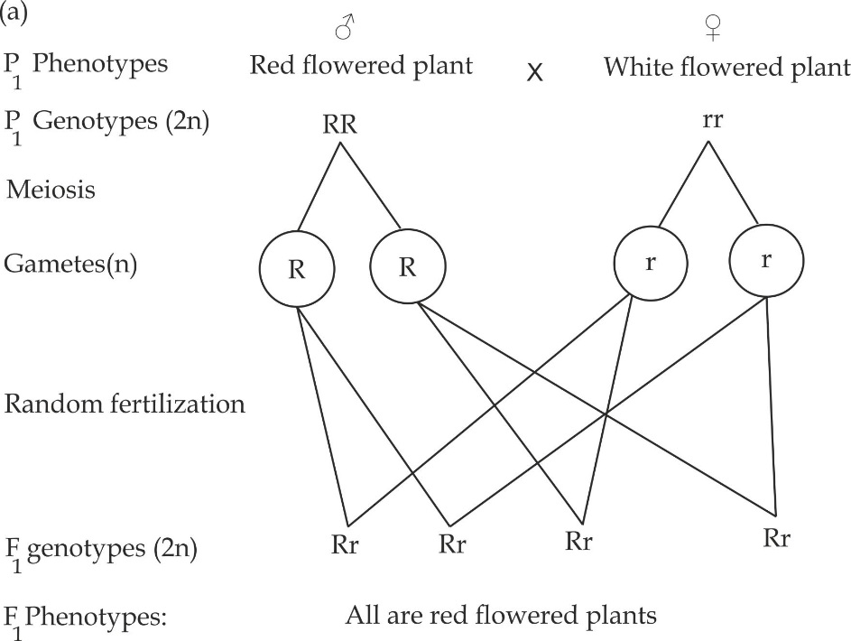

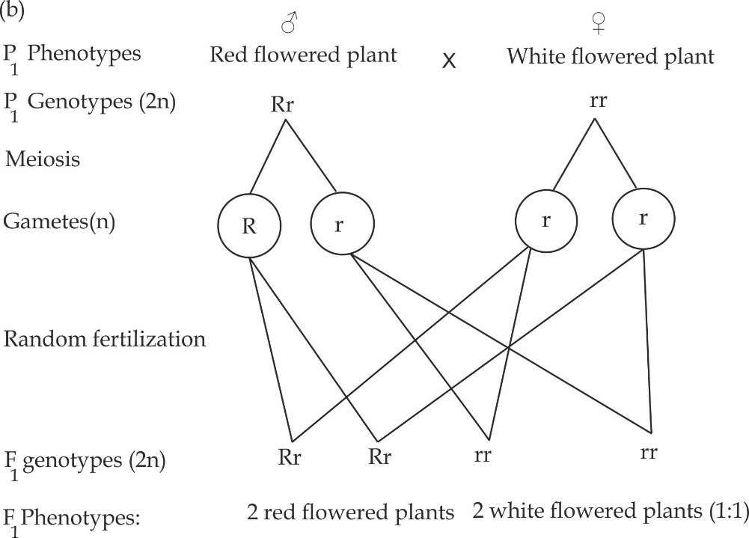

**Figure 1.26** (a) and (b) determination of the genotype of an organism using test cross

***Key points***

* Two plants can be phenotypically similar such that both are red flowered plants but genetically different such RR or Rr.
* It is not possible to use homozygous dominant organism in a test cross experiment because all progenies would have dominant traits which will be difficult to determine the genotype of an organism.

***SAQ 1.14***

***NECTA 1998***

* Why is not possible to use homozygous dominant organism in a test cross experiment to determine the genotype of an organism showing the dominant phenotype.Illustarte your answer fully.

**BACK CROSS**

**Back cross** is a genetic cross between an organism and one of its parent as shown in Figure 1.27.

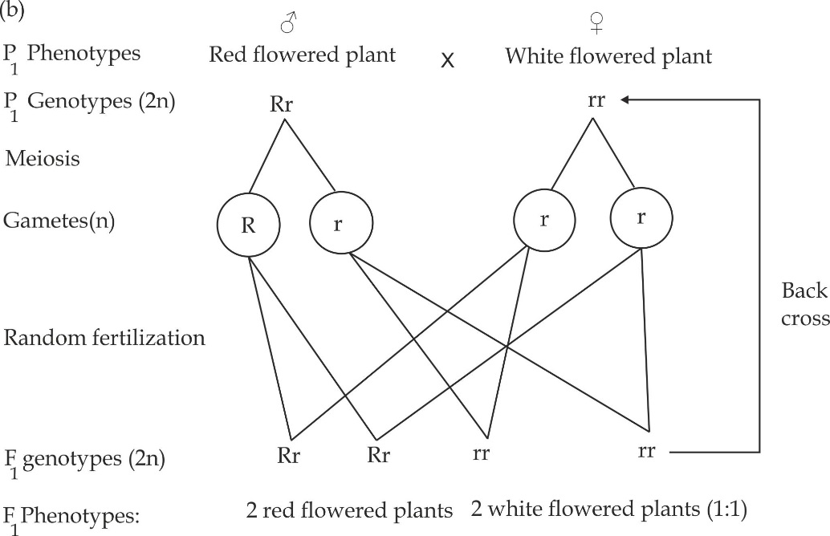

***Figure 1.27*** *illustration showing a back cross*

**Application of back cross:**

This is done in order to extend the generation of plants and animals that have suitable characteristics for economic benefit such as high yield crops, eggs or milk.

***SAQ 1.15***

**JECAS 2015**

* Explain the meaning and application in genetics of the two terms below:

1. Test cross
2. Back cross

1.2.6 **NON MENDELIAN PRINCIPLE OF INHERITANCE**

Non Mendelian inheritance is the pattern of inheritance that is got governed by the Mendelian principle of inhetitance.It has some deviations from the basic Mendelian ratio.

**Types of Non Mendelian inheritance**

Basically there are eight types of non Mendelian inheritance, which include:

* Incomplete dominance
* Codominance
* Lethal genes
* Multiple allelism
* Complimentary genes
* Collaborative genes
* Epistasis
* Polygenic inheritance

***Incomplete dominance – Appearance of a third phenotype***

Incomplete dominance is the pattern of inheritance in which neither of the allele is dominant nor recessive.i.e, two genes blend to produce a new trait. For example; in the common garden flower such as *Antirrhinum* (Dog flower) when red flowered plants are crossed with white flowered plants, the F1 plants have pink flowers. This intermediate form of the trait occurs because neither allele of the pair is completely dominant. Both alleles of the gene produce products, which combine to give a new trait. When pink flowers are selfed the F2 offspring segregate to red, pink and white flowered plants in the ratio 1:2:1.

***Worked example***

***NECTA 1993***

A genetist who was verifying Mendel’s first and second laws of inheritance crossed 45 homozygous red flowered plants with 45 homozygous white flowered plants, the result of the F1 offspring were 530 plants all with pink flowers. He then selfed 530 pink flowered plants and the seeds obtained were planted. The F2 plants with the following phenotypes were obtained:

* 1295 Red flowered plants
* 2570 Pink flowered plants
* 1297 white flowered plants

1. Illustrate using symbols the crosses made and results obtained in the above experiment.
2. What is the name given to the mode of inheritance exhibited by the flowers color in the above described experiment?
3. How do the above observations differ from the Mendel result that lead him to formulate first and second laws of inheritance?
4. Describe the genetically test you would carry out to prove whether or not the pink flower colour in the above experiment is a true deviation from Mendel’s principle of inheritance.

**Solution**

1. Illustration of crosses made by using genetically symbols

**CROSS I**

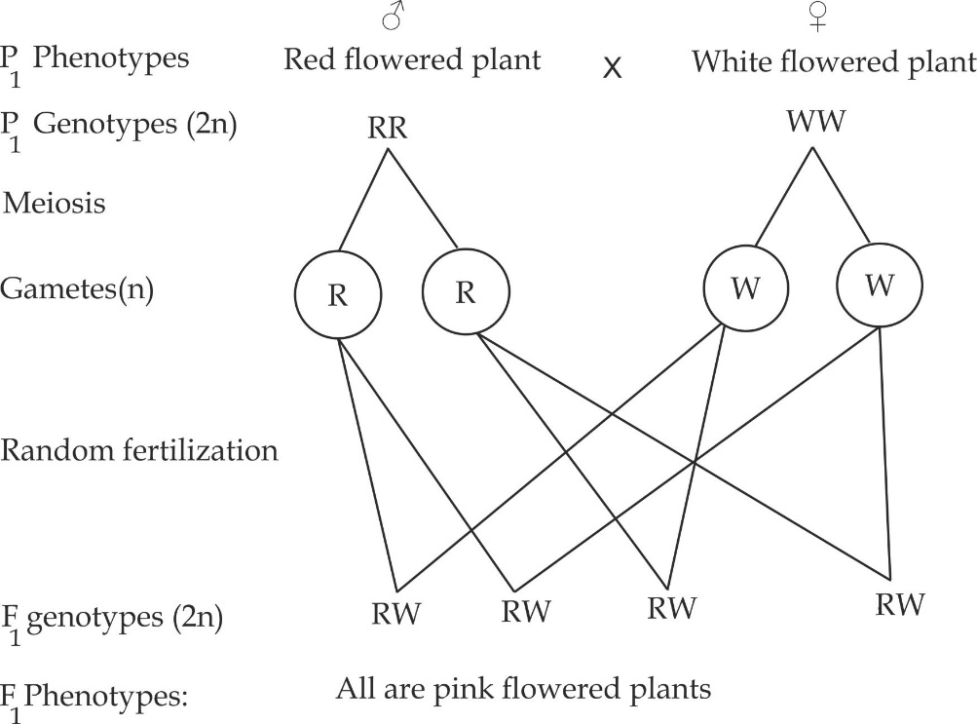

**CROSS II**

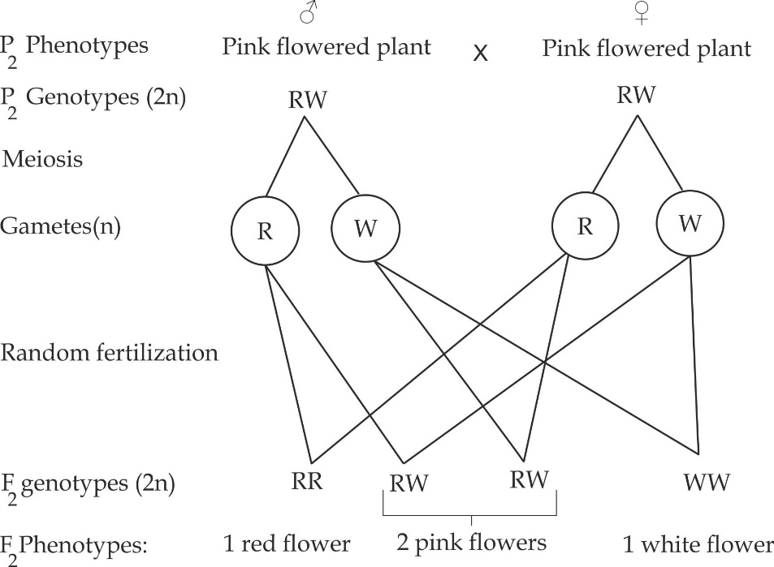

1. The pattern of inheritance is called **incomplete dominance.**
2. The observation differ from Mendelian principle in that; the inheritance of the flower colour does not show the dominance- recessive principle and it F2 phenotypic ratio is 1:2:1 instead of 3:1.
3. The genetic test is back cross in which pink flower plant is crossed with either white or red flowered plant as follows:

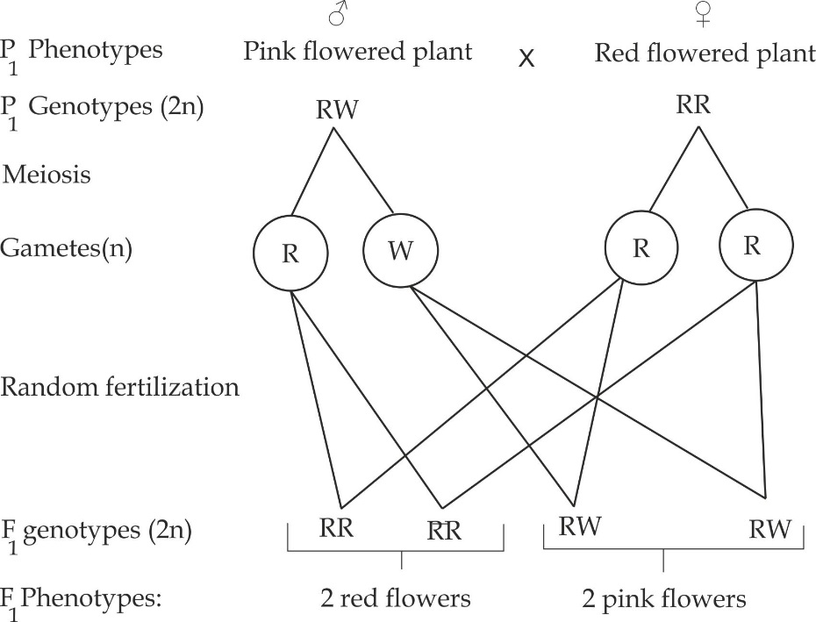

The above result proves that there is no true deviation from Mendel’s principle; because if a true deviation had occurred in the generation then we could expect all offspring to have pink colour again.

***Codominance – Expression of both alleles***

Codominance is the pattern of inheritance in which both alleles are dominant, i.e. two alleles blend to produce an intermediate trait. Examples of alleles which support Codominance are: Black cat (**CBCB**) mate with a ginger cat (**CGCG**) to produce a tortoishell kitten **(CBCG);** Red cow **(CRCR)** mate with a white bull **(CWCW)** to produce a roancattle **(CRCW) and** Black chicken **(CBCB**) mate with a white chicken (**CWCW**) to produce erminette chicken (**CBCW**).

***Worked Example 01***

***DODOMA MOCK 2018***

In cats the genes controlling the coat colour are carried on the **X** chromosomes and are codominant. A black coat female mated with a ginger coat male produced a litter consisting a black male and tortoise shell female kittens.

1. Illustrate the first filial generation.
2. What is the expected F2 phenotypic ratio?

**Solution:**

1. **First filial generation;**

**CROSS I**

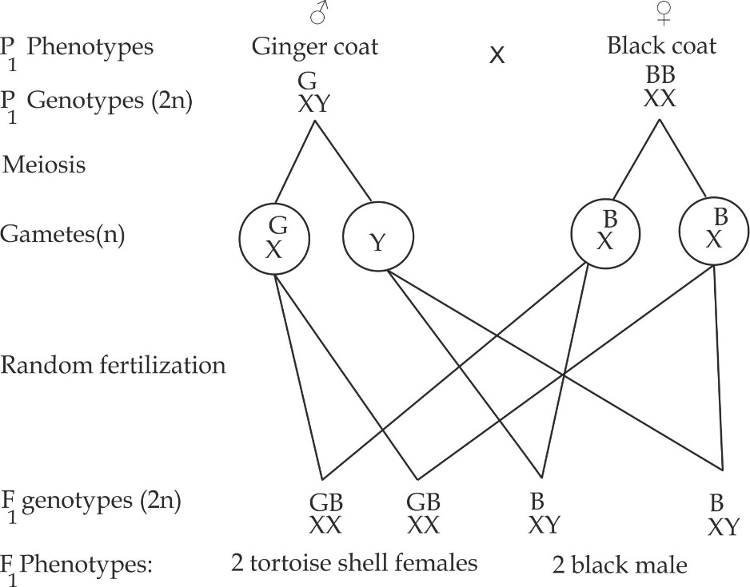

1. **Second filial generation:**

**CROSS II**

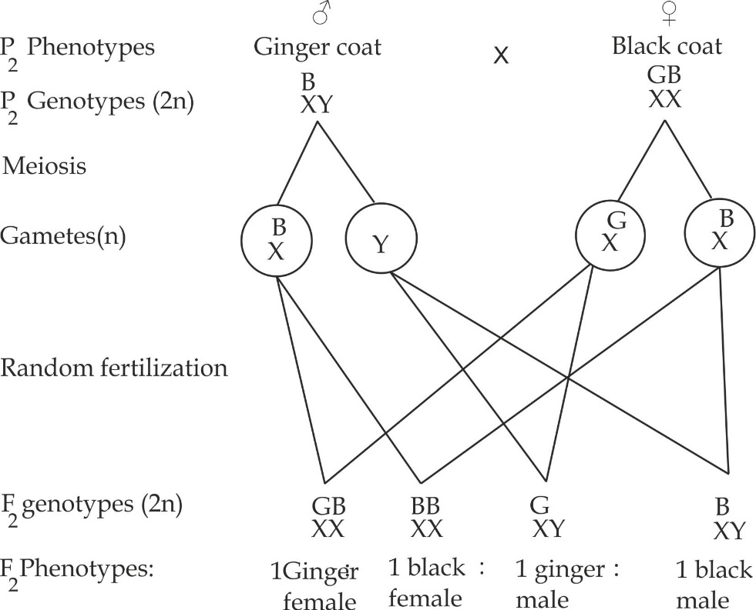

***Worked example – 02***

***TAI QUESTION***

In certain species of chicken, feather colour is controlled by co – dominant genes. The allele for white colour is **W** and for black is **B**. The heterozygous phenotype is known as erminette.

1. What are the genotypes for black, white and erminette chicken?
2. If two erminette chicken were crossed, what is the probability that:
3. They would have a black chick?
4. They would have a white chick?
5. They would have erminette chick?

**Solution:**

1. The genotypes are:

Black chicken is **CBCB.**

White chicken is **CWCW**

Erminette is **CBCW**

1. Consider a cross between two erminette we have: CBCW and CBCW

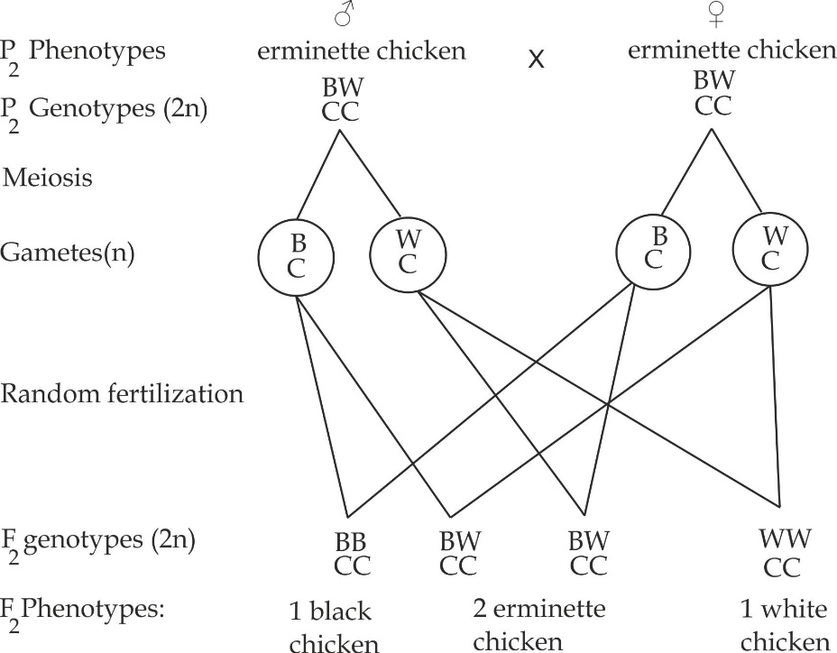

From the above cross:

1. The probability that they would have black is ¼ or 75%.
2. The probability that they would have white chick is ¼ or 75%
3. The probability that they would have erminette chick is ½ or 50%.

***Worked Example -03***

***KAIZIREGE PRE NATIONAL EXAM 2019***

1. In some chickens, the trait for feather colour is controlled by the white gene and black gene. The heterozygous condition of this trait is known as erminette. If these genes were all incomplete dominance genes:
2. Write the genotype for black, white and erminette chickens.
3. If erminette chickens were crossed with black chicken. What is the probability that they would have black chickens, white chickens and erminette chickens?
4. In certain species of cattle, the red coat colour is codominant over the white coat colour. The heterozygous condition is roan (both red and white hairs are produced).Show a cross between two roans coloured cattle. Indicate the genetic ratios.

**Solution:**

1. i. The genotypes are:

Black chicken is **CBCB** Erminette is **CBCW**

White chicken is **CWCW**

1. A cross between black chicken and erminette chicken:

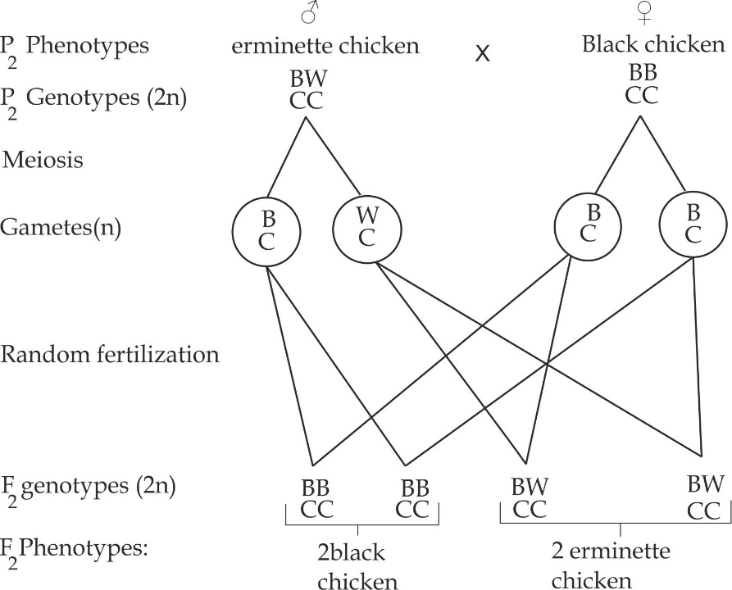

From the above cross the probability that they would have:

Black chick is 50%; white chick is 0% and erminette chick is 50%.

1. Across between two roans cattle

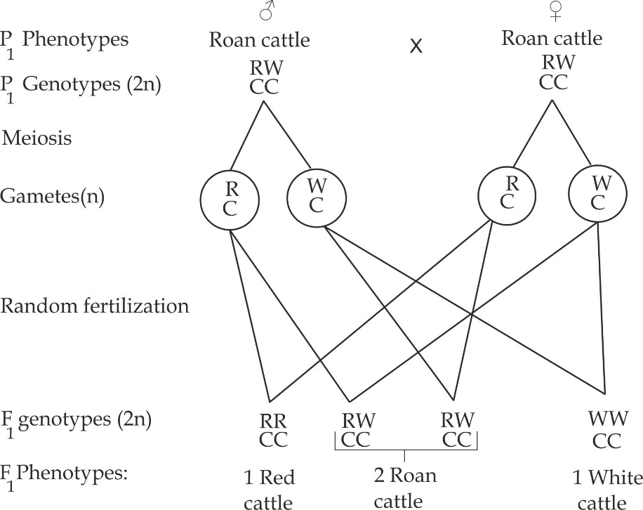

***Lethal genes***

Lethal genes are the alleles that cause death to an organism who bear it when are inherited in homozygous state. In other words, the lethal genes can cause death to an organism before or any time after birth. Examples are yellow coat colour genes in mice and sickle cell genes in human.

1. **Inheritance of yellow fur colour in mice**

In mice, the allele for yellow fur (**Y**) is dominant to the allele for grey (**y**). The homozygous dominant yellow genes (**YY**) are lethal, however the heterozygous yellow mice exist. As a result, a cross between two mice with heterozygous dominant (**Yy**) genotype fails to produce the 3:1 ratio typical of Mendelian monohybrid cross instead produce 1:2:1 as shown in Figure 1.26.

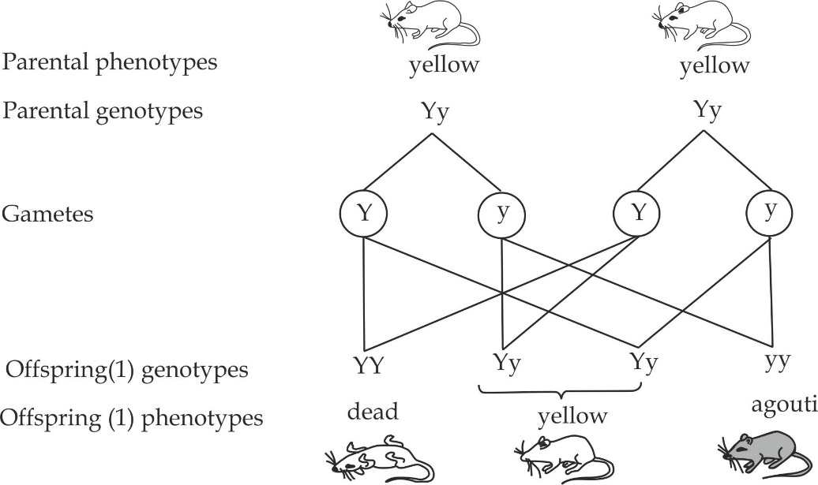

***Figure 1.26*** *Inheritance of fur colour in mice. Mice that are homozygous YY die before birth****.***

1. **Inheritance of sickle cell anaemia**

Sickle cell anaemia is the inheritable disorder caused by the base substitution type of gene mutation in which the amino acid valine is substituted by glutamic acid. This leads to the development of abnormal haemoglobin with sickle or crescent shaped instead of normal biconcave disc shaped. It is inherited by the recessive genes which are represented by HbsHbs carried on the autosomal chromosome. In human, the homozygous recessive allele (HbsHbs) are lethal, homozygous individual is anaemic, the body becomes weak and suffers an early death. However the heterozygous individual (HbAHbS) does not suffer from harmful effect instead a person with such a genotype is advantageous in that, he/she is less likely to suffer from malaria, because malaria parasite multiply in the normal RBCs.This is known as heterozygote advantage.

**Symptoms of sickle cell anaemia**

1. The blocking of blood vessels by sickle RBCs cause joint pain.
2. Poor growth and development.
3. Enlargement of spleen (splenomegaly)
4. Enlargement of liver (Hepatomegaly)
5. Yellowish discoloration of eyes (Jaundice).
6. Body weakness and tiredness.

A cross between two heterozygous dominant individuals **(HbAHbS)** for sickle cell anaemia fails to produce 3:1 ratio typical of Mendelian monohybrid cross instead produce 1:1:1 as shown in Figure 1.27.

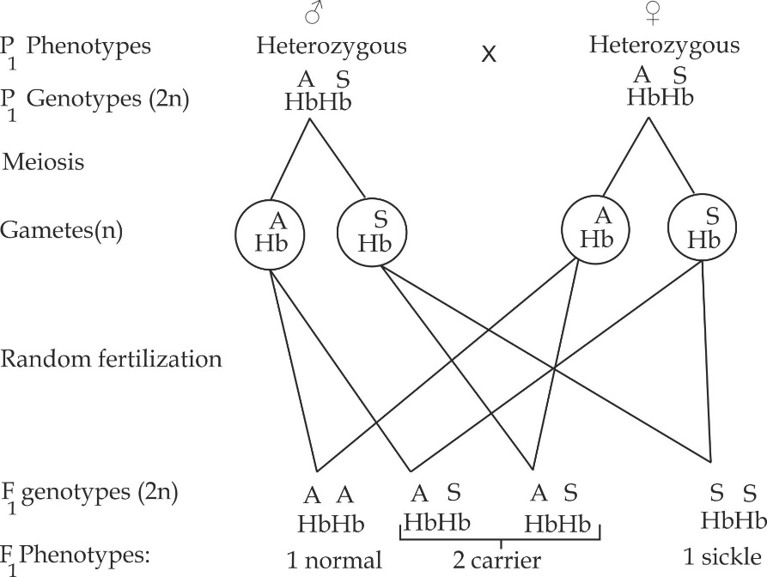

***Figure 1.27*** *Inheritance of sickle cell anaemia in human*

***Multiple allelism***

Multiple allelism is a pattern of inheritance in which three form of genes occupy the same locus but only two of the alleles can control a single trait of an organism. For example, the **ABO** system of blood groups is controlled by three alleles, only two of which are present in an individual. Inheritance of blood groups is controlled by the autosomal gene. The gene locus is usual represented by the symbol **I** (which stands for isohaemagglutinogen) are there are three alleles which are represented by the symbols **A, B** and **O**. The alleles **A** and **B** are equally dominant and **O** is recessive to both. The blood groups arising from the different possible genotypes are summarized in the table 1.5.

**Table 1.5** the phenotype and genotypes in blood groups:

|  |  |
| --- | --- |
| **Blood group (phenotype)** | **Genotypes** |
| **A** | IAIA or IAIO |
| **B** | IBIB or IBIO |
| **AB** | IAIB |
| **O** | **IOIO** |

**Application of the knowledge of blood groups**

* To predict the possible blood groups of children from the parents.
* To settle legal questions relating to paternity.
* As a basis for blood transfussions (*not discussed in A’ level syllabus).*

**To predict the possible blood groups of children from the parents:**

***Worked Example 01***

***Necta 2010***

The A, B and O blood groups in human are controlled by multiple alleles of a single autosomal gene. The gene locus is usually represented by the symbol. There are three alleles represented by: IA, IB and IO. Allele IA and IB are codominant and IO recessive.

1. State all possible genotypes of blood group A and O.
2. If a man of blood group O marries a woman of blood group AB, State the possible blood groups that their children could have.
3. Using the symbols (IA,IB and IO) workout for the possible blood groups of children whose parents are heterozygous, the father for blood group A and the mother for blood group B.

**Solution:**

1. Possible genotypes are:

Blood group A is either IAIA or IAIO.

Blood group O is IOIO.

1. A cross between a man blood group O and woman blood group AB

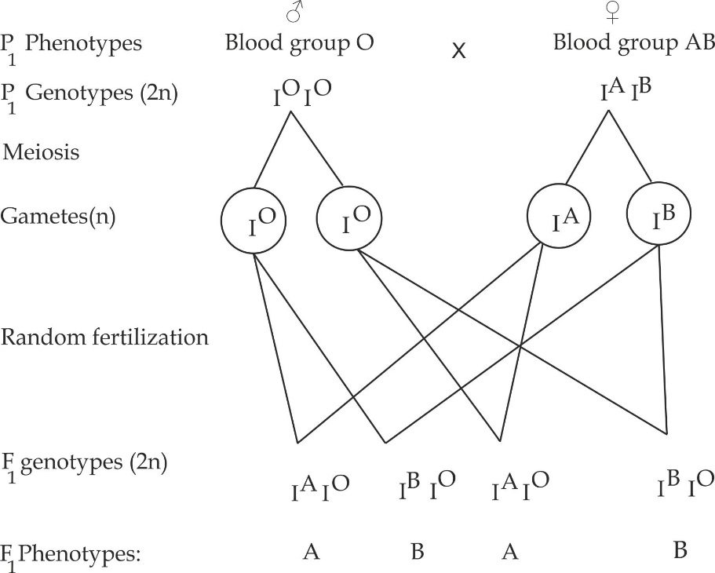

Thus, the possible blood groups of children are blood group A and B.

1. A cross between heterozygous blood group A and heterozygous blood group B.

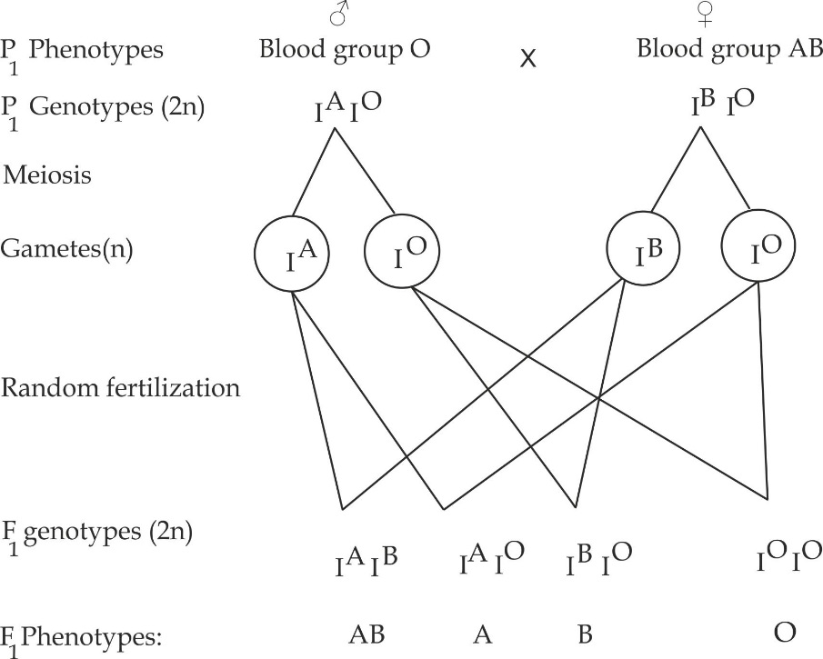

The possible blood group of children are blood group AB, A, B and O.

***Worked example 02***

***NECTA 2014***

A father with blood group A and a mother of blood group B (both are heterozygous) have four children. What is the probability that, the children will have blood group A?

**Solution:**

The genotypes of parents are:

Father is heterozygous A = IAIO

Mother is heterozygous B = IBIO

Consider a cross between heterozygous blood group A and B

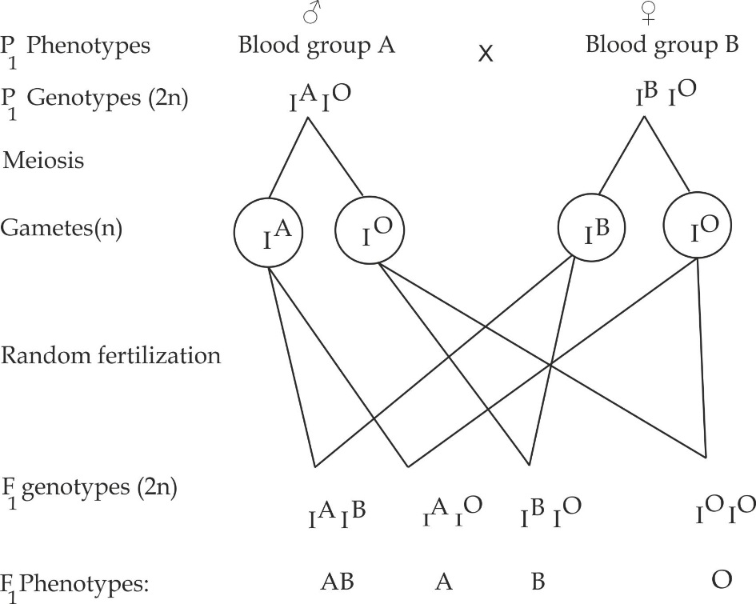

Probability of blood group A children is ¼ or 75%

***Worked Example 03***

***NECTA 2018***

1. State three features of DNA which enable it to:
2. Serve as a store of genetic information.
3. Transmit genetic information accurately.
4. Using appropriate genetic symbols carry out genetic crosses to show the percentage phenotype of blood group of children, whose parents are both heterozygous, the father being blood group A and the mother AB.

What is the probability that the parents will have a child with blood group **O?**

**Solution:**

1. Refer to the nucleic acid.
2. Consider a cross between heterozygous blood group A and B



Blood group A is 75%

Blood group B is 75%

Blood group AB is 75%

Blood group O is 75%

***Worked Example 04***

***Necta 2008***

1. The father is blood group A and the mother blood group B, Explain using appropriate genetic symbols the possible blood group of their children.
2. If these parents get non-identical twins, what is the probability that both twins have blood group A?

**Solution:**

1. The father genotype is either IAIA or IAIO

The mother genotype is either IBIB or IBIO

Due to the above genotypes, there are four pair of parents, consider a cross in each pair.

**CROSS I:** **(**A cross between homozygous blood group A and B)

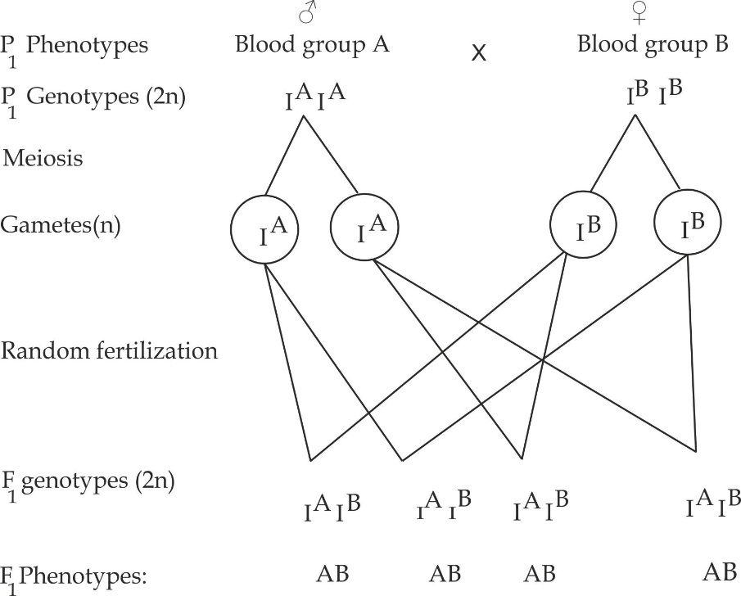

**CROSS II: (**A cross between homozygous group A and heterozygous B)

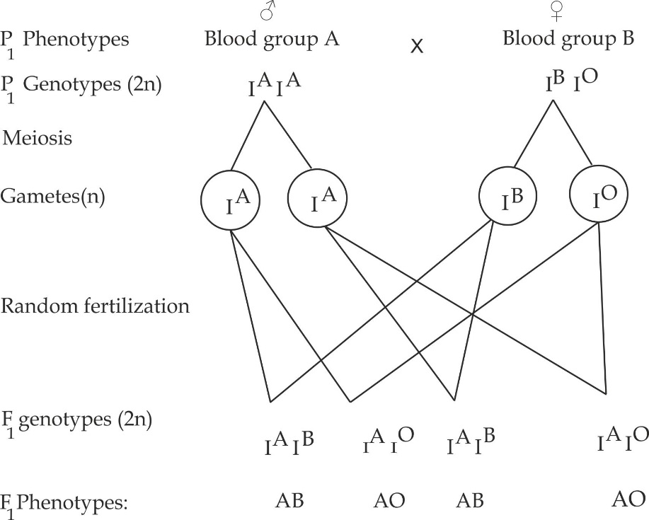

**CROSS III**: (A cross between heterozygous group and homozygous B)

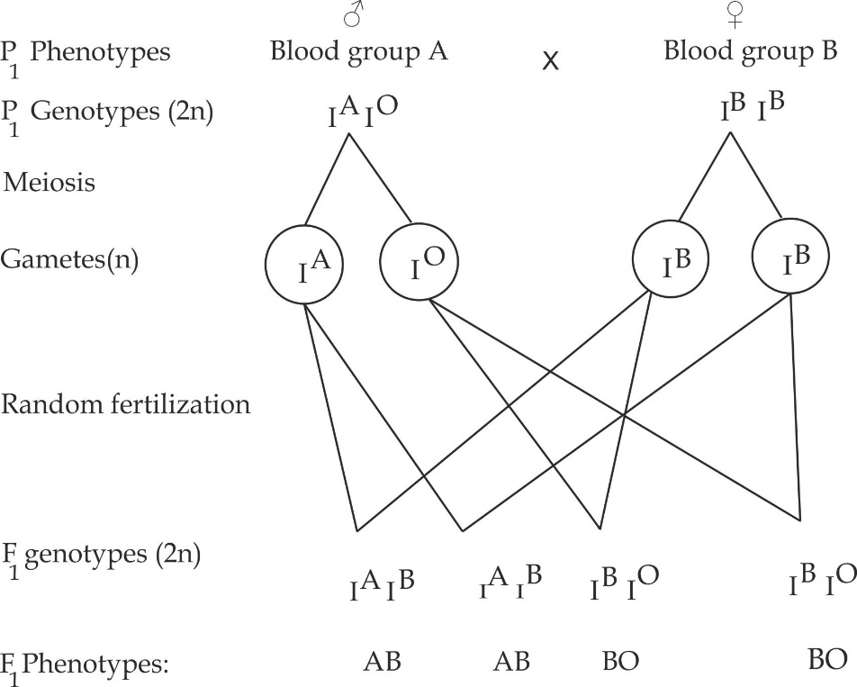

**CROSS IV:** (A cross between heterozygous group A and heterozygous B)

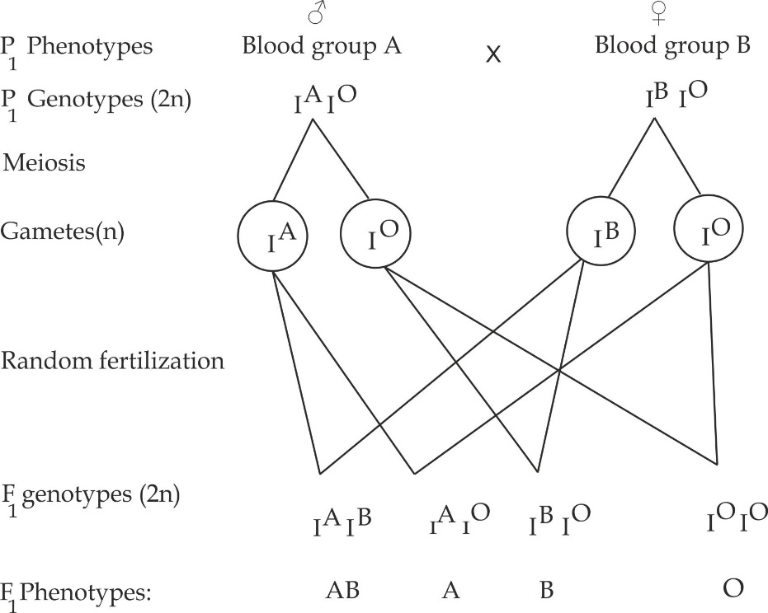

1. Probability of blood group A non-identical twins:

Probability (group A non-identical twins) = P (child A) X P (child A)

For the first cross: 0

For the second cross:2 X 2 = 1

4 4 4

For the third cross:0

For the fourth cross: 1 X 1 = 1

4 4 16

Total probability = 0 + 1 + 1 + 0 = **5**

4 16 **16**

**To settle legal questions relating to paternity:**

An interesting aspects relating of blood groups to paternity can result in the offspring that differs from both parents. This is seen for example, when mating takes place between individual with blood groups A and B, both being heterozygous for their blood groups, resulting into children with blood group O.

***Worked example 01***

***KILAKALA MID TERM 2010***

Anna is a woman married to John, these couples once had a child Kitto who one day discovered that his parents were in bad terms. John is claiming that Kitto is an illegitimate child but Anna is opposing the case. Blood tests revealed that John is of blood group A and Kitto is of blood group O. Anna’s mother blood type is B and Anna’s father blood group AB, using this information above.

1. Suggest the possible genotypes for Anna and show how you deduce the genotypes.
2. Show clearly whether Kitto is or he is not an illegitimate child of the family.

**Solution:**

1. To find the genotypes for Anna

Now considering genotypes for Anna’s parents we have:

Mother: Blood group B whose possible genotypes are IBIB or IBIO.

Father: Blood group AB whose possible genotype is IAIB.

Since Kitto is blood group O then his genotype is of no doubt IOIO this implies that the genotype for Anna should have an allele IO. But for Anna to have an allele IO then Anna’s mother should bear the allele IO, thus the genotype should be IBIO.

1. Legitimacy of Kitto will depend on John’s genotype.

If John is homozygous for his blood group, then for sure, Kitto is illegitimate child of the family because no blood group O will appear in F1 generation but If John is heterozygous for his blood group (IAIO), then Kitto is not a legitimacy child since blood group O will appear in F1 generation as shown below.

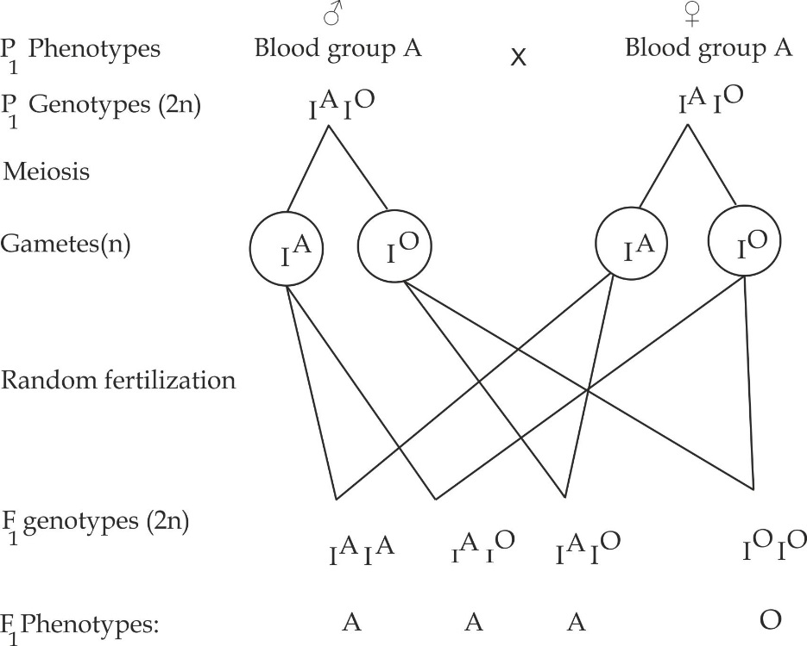

***Worked example 02***

***ST MATHEW HIGH SCHOOL 2011***

Two newly born babies were accidentary mixed up in hospital. Blood test revealed the following:

Baby 1 – Blood type O

Baby 2 – Blood type A

Mr. Tolo – Blood type B

Mrs. Tolo – Blood type B

Mr Bonge – Blood type A

Mrs. Bonge – Blood type AB

Using these information alone, determine which baby belongs to which parent.

**Solution:**

Since baby 1 is blood group O then his genotype is of no doubt contain allele IOIO, Mr and Mrs Tolo have a chance to have a baby of blood group O since their genotypes bear allele IO .

Consider a cross between Mr Tolo IBIO and Mrs Tolo IBIO

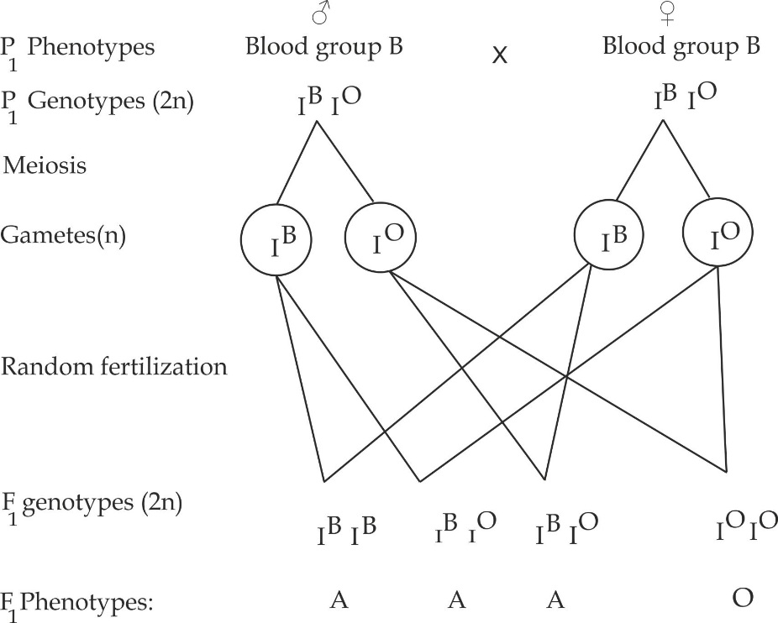

Mr and Mr Bonge have no chance to have a child with blood group O, thus the child 2 belongs to Mr and Mr Bonge.

**Complimentary genes**

These are genes which are mutually dependent neither of them produce a given phenotype in the absence of other.i.e, the two genes interact together to produce a dominant phenotypic trait. Example of complimentary genes are seen in the control of purple colour in sweet pea plants. Purple colour is produced only when a dominant allele **C** is complimented by a dominant allele **P**.This means that the purple colour of the flowers is determined by two dominant genes **C** and **P**.One gene, **C** controls the synthesis of raw materials that are necessary for the formation of purple colour while the other gene **P**, controls the conversion of the raw materials into a purple pigments. Thus, having either **P** or **C** alone is not enough to produce a purple pigment. However, in the absence of either of these genes, the flowers are white.

***Worked example 01***

***EZEB NOV 2013***

1. What does it mean by the term complementary genes?
2. In sweet potatoes, the purple colour of flower is controlled by two dominant genes C and P, when one of these is absence the flowers are white. If dihybrid pure cross between purple and white flowered plants was conducted. Find out the F1 and F2 individuals.

**Solution:**

1. The genotypes are: CCPP (Pure purple) and ccpp (pure white)

CROSS I

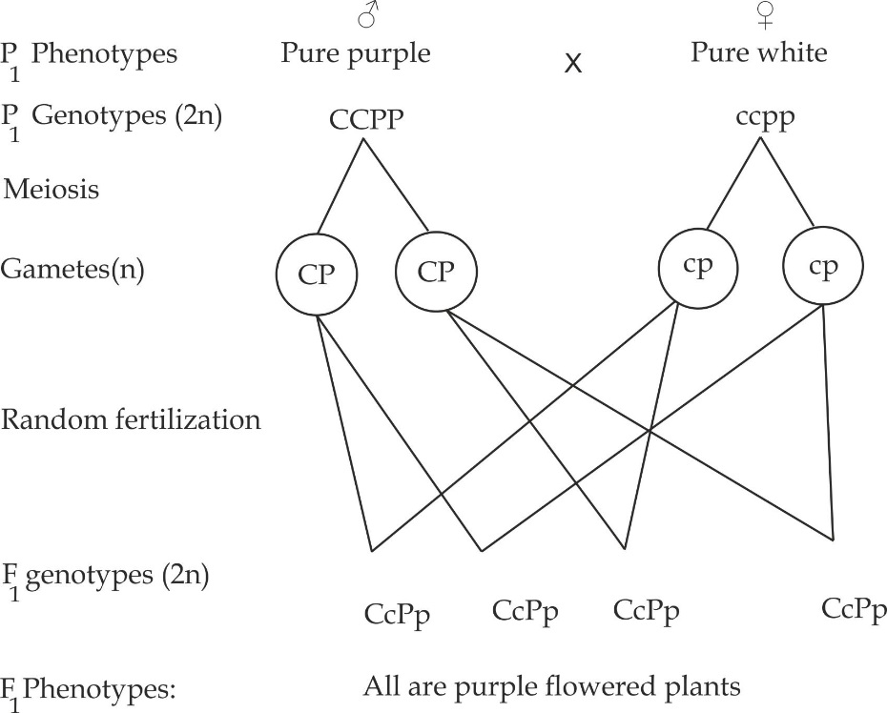

CROSS II

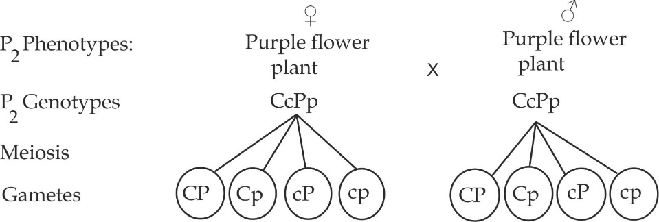

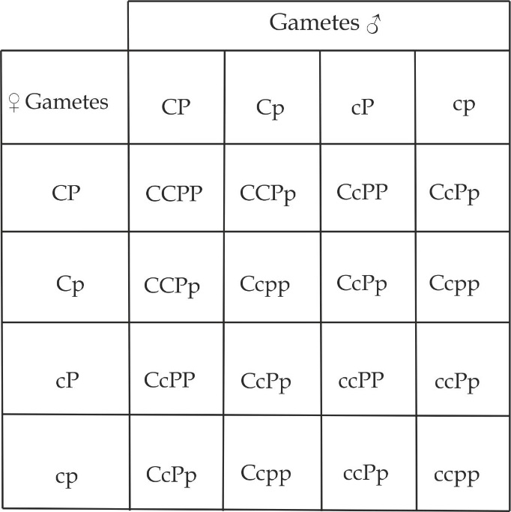

F2 phenotypes are:

9 purple flowers

7 white flowers

***Worked Example 02***

***TAI QUESTION***

A certain kind of flower is used because of a red pigment that requires two different genes. Gene A encodes an enzyme which catalyses the conversion of colourless molecule **X** into a second colourless molecule **Y**. The enzyme encoded by gene **B** catalyses conversion of molecule **Y** into a red pigment molecule **Z**.Both enzymes must working in order to make red pigment as shown in the following diagram.

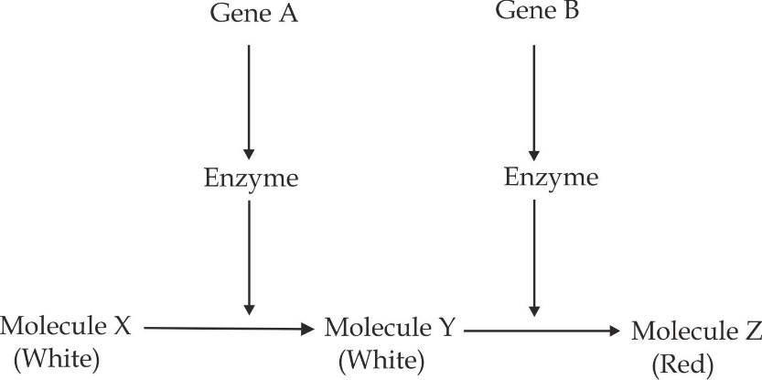

A pure – breeding white – flowered plant that produces no functional enzyme **A** or **B** is crossed with a pure breeding red flowered plant. Predict the phenotypes and the ratios of the F2 offspring.

**Solution:**

The genotypes are:

Pure red flowered plant (AABB)

Pure white flowered plant (aabb).

**CROSS I**

A cross between a pure red flower and a pure white flower

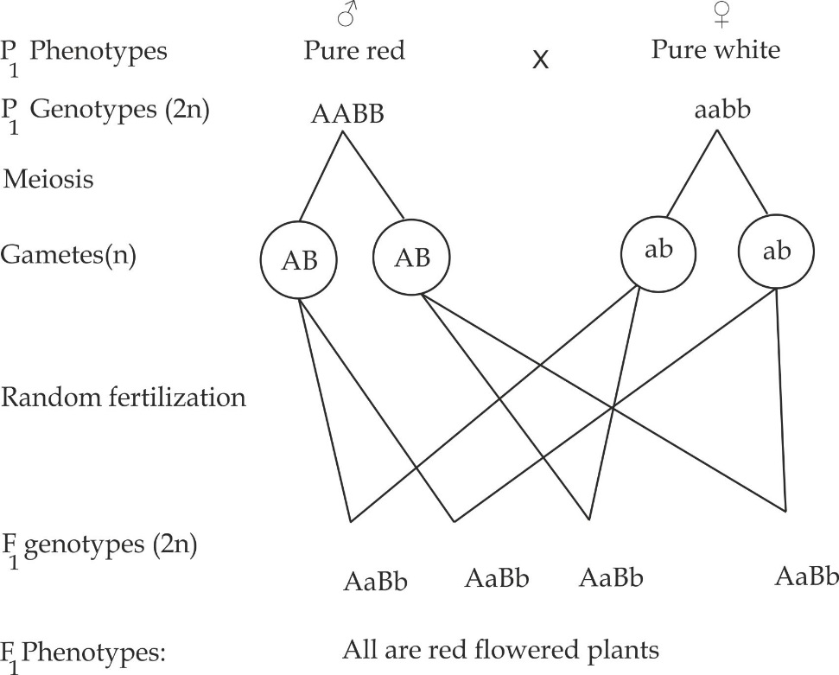

**CROSS II**

(On Selfing F1 red flowered plants)

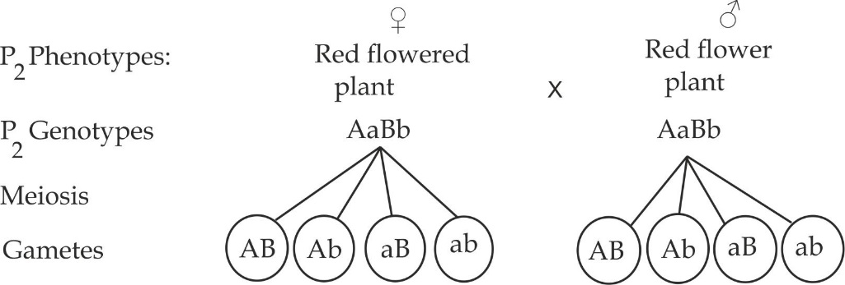

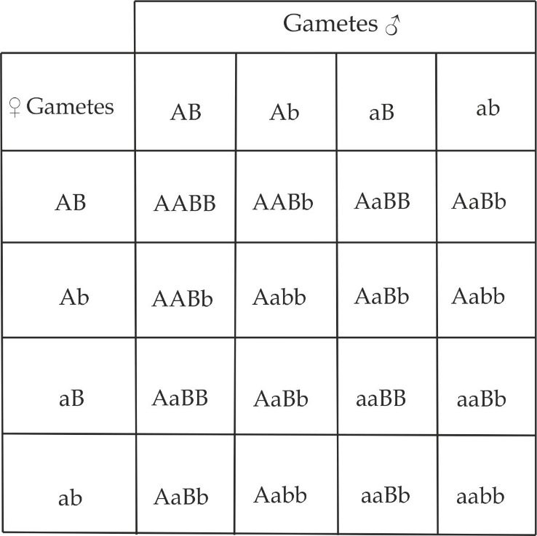

**F2 phenotypes are**:

9 red flowered plants

7 white flowered plants

***Collaborative genes***

These are two genes which interact to produce a single characteristic that could not be produced by either of the two genes alone. Example of this gene interaction is the control of a comb form in chicken. In this case, one gene **R** produces a rose comb whereas its recessive allele **r** produces a single comb. Another gene **P** produces a pea comb and its recessive allele **p** produces a single comb. When **P** and **R** interact, they collaborate to produce a walnut comb, which neither of the two genes could produce alone as shown in Figure 1.27.

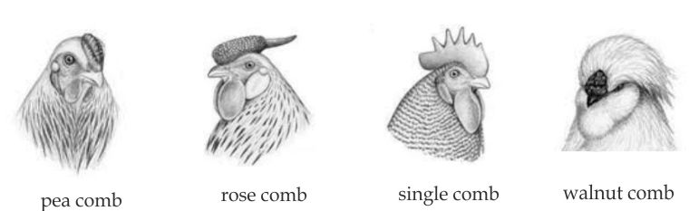

***Figure 1.27*** *comb shapes in chicken*

The phenotypes of comb shapes have the following possible genotypes as shown in Table 1.6.

**Table 1.6** The possible phenotypes and genotypes of comb shapes

|  |  |
| --- | --- |
| **Phenotypes** | **Possible genotypes** |
| Pea comb | rrPP, rrPp |
| Rose comb | RRpp, Rrpp |
| Single comb | rrpp |
| Walnut comb | RRPP, RrPp, RrPP, RRPp |

***Worked Example 01***

**LAKE ZONE MOCK 2018**

In the fowl, the genotype rrpp gives single comb, R – P gives walnut comb, rrP – gives pea comb, and R-pp gives rose comb.

1. What comb types will appear in F1 and in F2 in what proportions, if single – combed birds are crossed with birds of a true breeding walnut combined strain?
2. Explain the type of inheritance shown by comb shape in fowls.

**Solution**

1. A cross between single comb birds and pure walnut comb

**CROSS I**

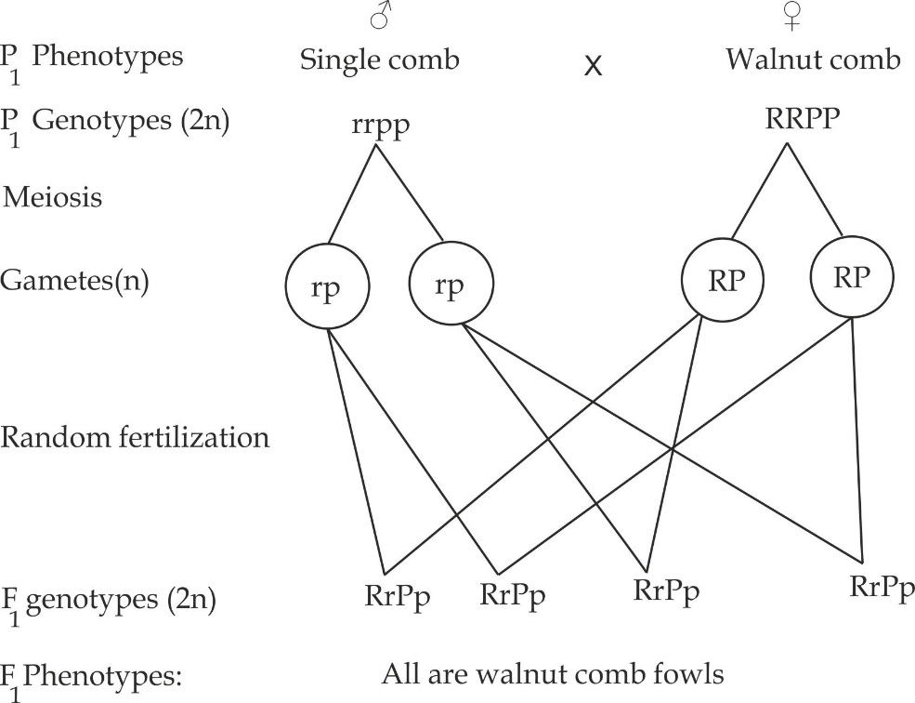

**CROSS II**

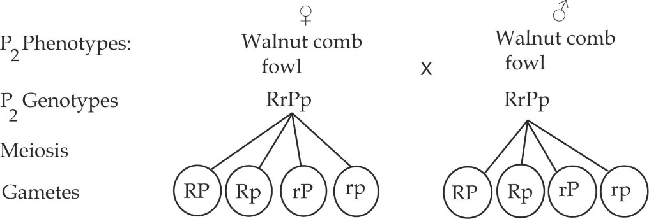

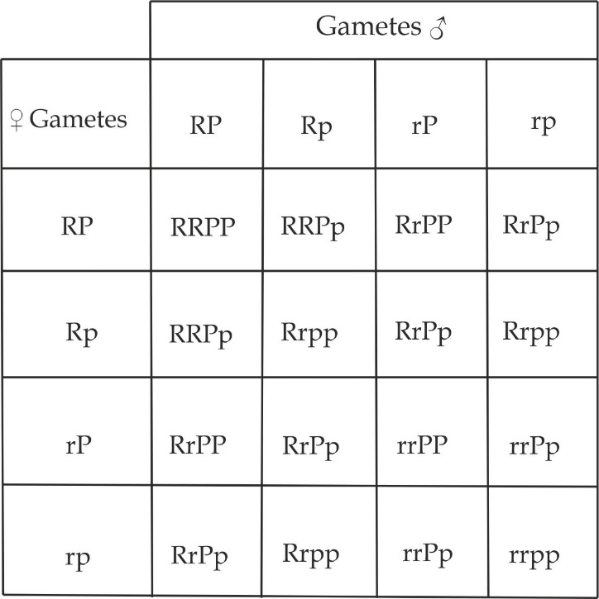

**F2 phenotypes are:**

9 walnut combed fowls

3 Rose combed fowls

3 Pea combed fowls

1 single combed fowl

1. From the table above, the F2 phenotypic ratio is 9:3:3:1.This shows that, the F2 phenotypic ratio of 9:3:3:1 is not altered in this case, the only modification of mendelian genetics is that in the F2 generation there is an emergency of new phenotypes such as rose and pea comb forms which are neither seen in Pi generation nor in F1 generation, so this is collaborative type of non mendelian gene interaction.

***Epistasis***

This is a form of gene interaction in which an allele at one locus totally inhibits the expression of another allele at a second locus which contribute to a single phenotype. Usually, the gene supressing the other is called ″ **Epistatic**“, while the one masked is called “**hypostatic**“.Epistatic genes are also known as inhibiting genes because of their ability to mask the effect of other genes.

**Types of epistasis gene interaction**

There are two types of epistasis gene interaction which are dominant epistasis and recessive epistasis.

**Dominant epistasis – 12: 3: 1**

It is a type of epistasis in which dominant allele of one gene may hide the effect of dominant allele of another gene. Examples are and inheritance of Plumuge colour in Leghorn, inheritance of fruit colour in summer squash and inheritance of seed coat in maize or oat. The mechanism of action is shown in Figure 1.28

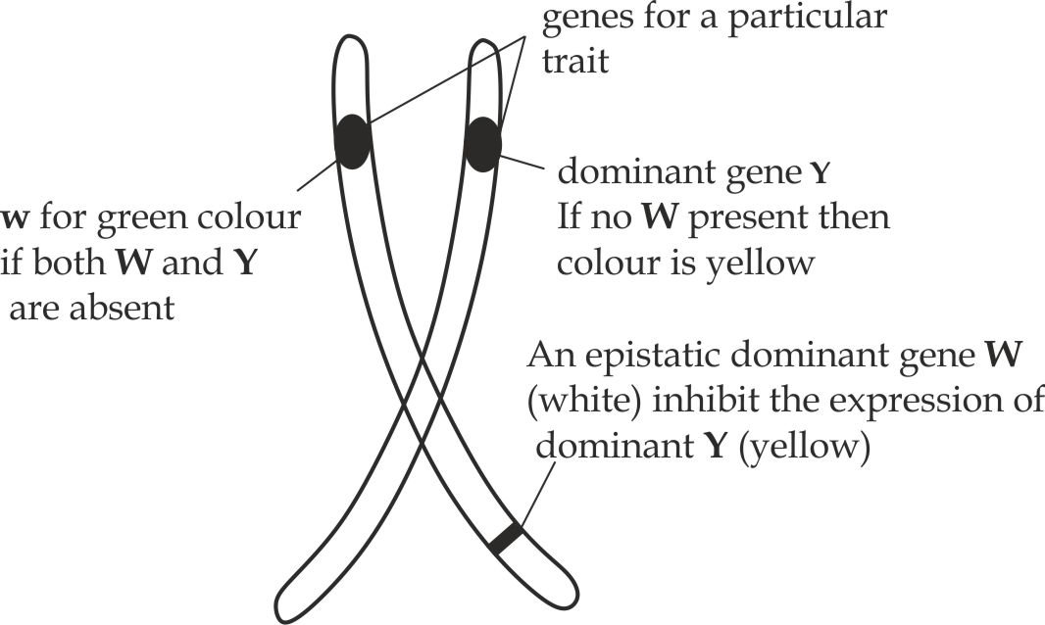

***Figure 1.28*** *The Mechanism of action of dominant Epistatic gene*

***Worked Example – 01***

**KILIMANJARO MOCK 2016**

In white leghorn fowl, Plumuge colour is controlled by two sets of genes, including the following:

**W** (white) dominant over w (colourful),

**B** (black) dominant over **b** (brown).

The heterozygous F1 genotype **WwBb** is white. Account for this type of gene interaction and show the phenotypic ratio of the F2 generation.

**Solution**

Since both dominant alleles **W**, which is white and **B**, black are present in the heterozygous F1 genotype and the phenotype is white, it may be said that the alleles show an Epistatic interaction where the white represents the Epistatic gene.

Consider a cross between two white colour leghorn fowls

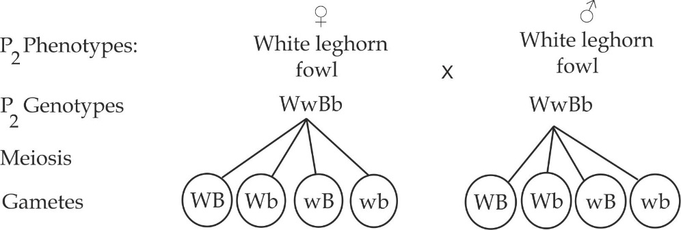

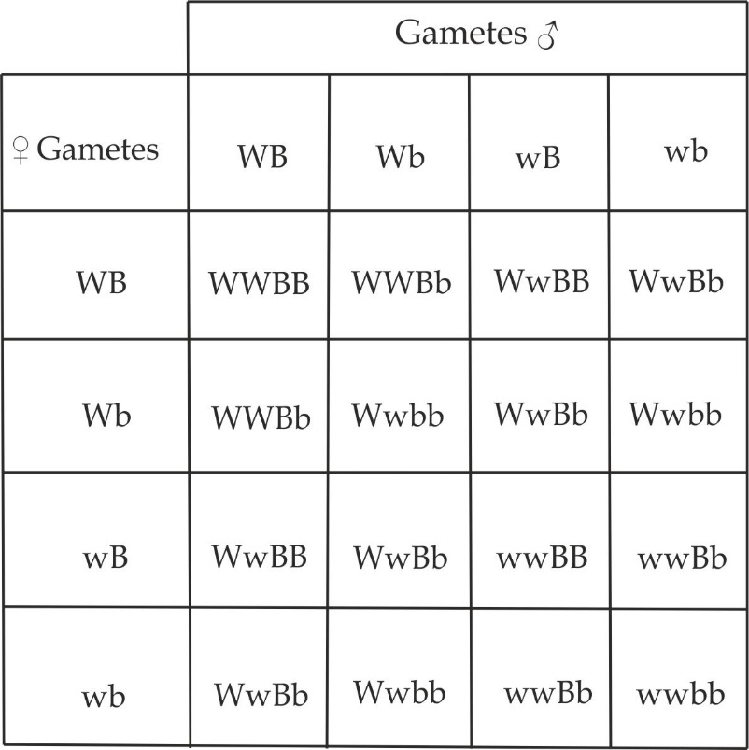

**F2 phenotypes are:**

12 white leghorn fowl

3 Black leghorn fowl

1 brown leghorn fowl

Therefore the F2 phenotypic ratio is **12:3:1**

***Worked Example 2***

**ST ANNIE MARIE 2013**

In summer squashes, there are three common fruit color, white, yellow and green. White color is caused by a dominant gene (W) that is Epistatic over any other combinations. In crosses between yellow and green, yellow is found to be dominant; due to a dominant allele (Y) that is not linked to W. A homozygous white squash plant that carries the dominant allele (WWYY) is crossed with a green squash plant (wwyy).

1. What is the genotype and phenotype of the F1 progeny?
2. What is the phenotypic ratio of the F2 progeny?

**Solution:**

**CROSS I**

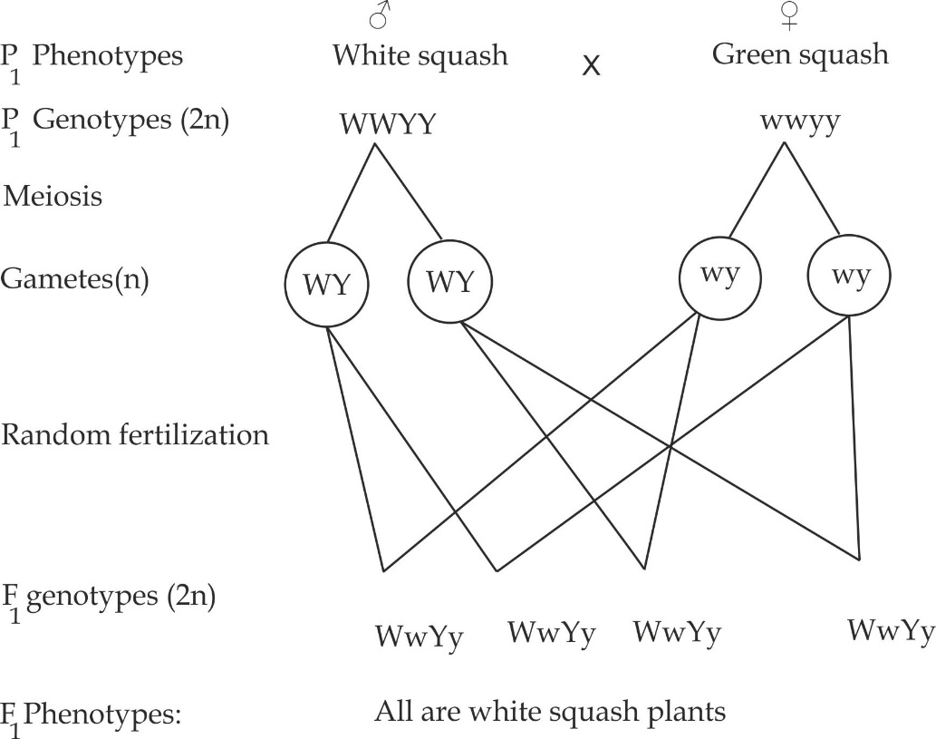

**CROSS II**

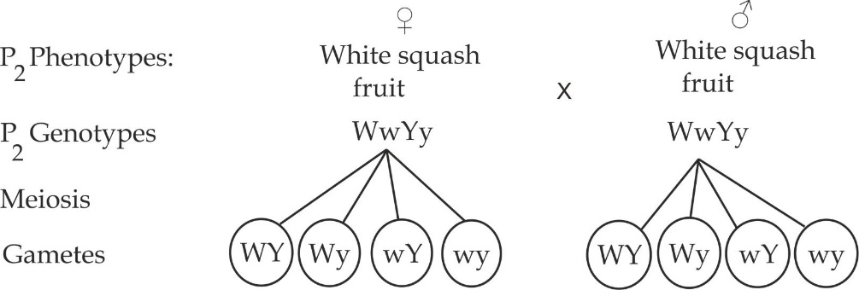

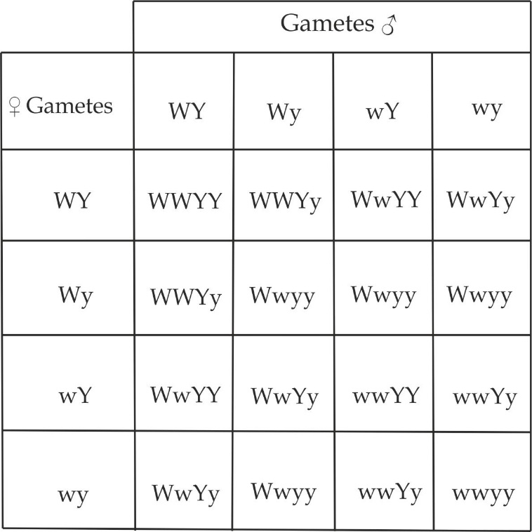

**F2 phenotypes are:**

12 white squash fruits

3 Black squash fruits

1 green squash fruits

***Worked example 03***

**DAR MOCK 2017**

In maize, the grains are covered by tough testa. In a cross between pure line varieties of maize one with black – testa covered grains, the other with white – testa covered grains, the F1 offspring all had back – testa covered grains. On allowing the F1 plants to fertilize by self-reproduction, gave rise to an F2 generation with phenotypes ex – pressed below:

Black – test covered grains 836

Grey – test covered grains 212

White – testa covered grains 72

Account for the F2 generation results.

**Solution:**

Given ratio: Black: Grey: White

836 212 72

72 72 72

13 : 3 : 1

The above shown phenotypic ratio of Epistatic gene interaction.

Let **B** be an allele for black colour.

**A** be an allele foe grey colour

**B** be an allele for white colour

**A** be an allele for colured pigment

Parental genotypes are:

**BBAA** is black testa covered grain

**Bbaa** is white testa covered grain

Now Consider a cross between black testa covered grain and white testa covered grain

**CROSS I**

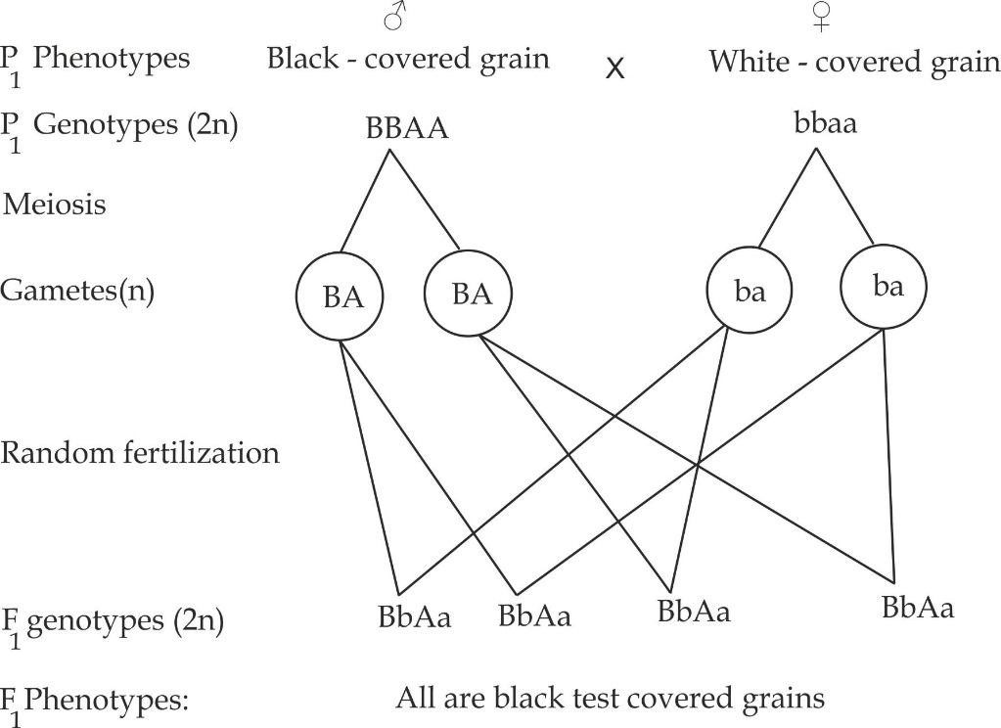

**CROSS II**

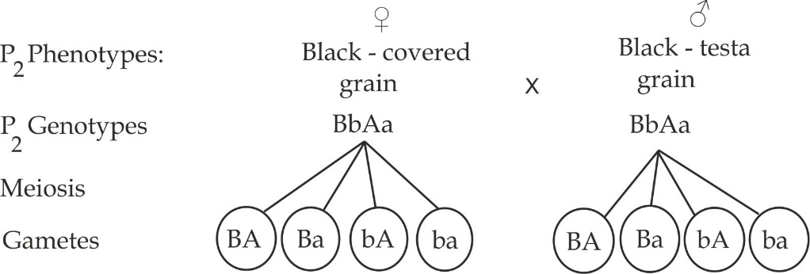

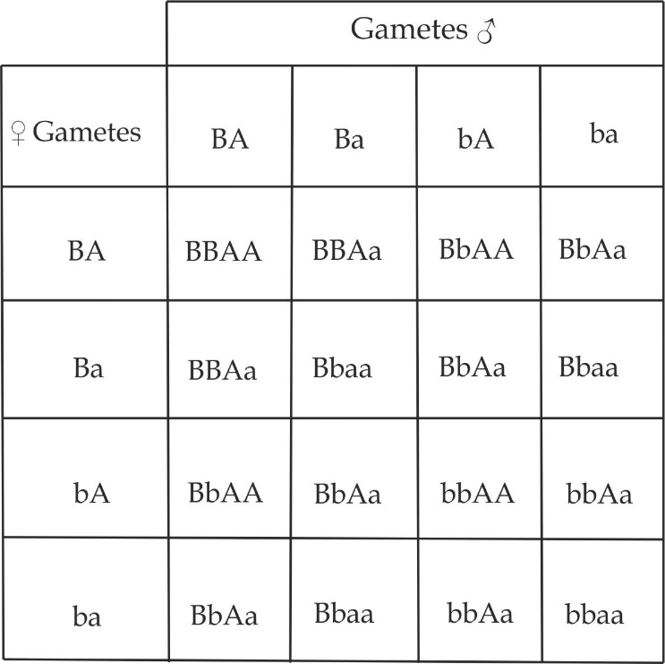

**F2 phenotypes are:**

Black – testa covered grains are 12

Grey testa covered grains are 3

White testa covered grain is 1

Therefore, the F2 phenotypic ratio is 12:3:1

**Recessive epistasis - 9:3:4**

It is a type of epistasis in which recessive allele of one gene may hide the effect of dominant allele of another gene. Inheritance of body colour in mice; **C** and **c** are found in the same locus; **cc** is Epistatic recessive genes which inhibits the expression of **A** or **a** to produce albino mice.**C** in the absence of **A** the colour of mice is black whereas if C and A both are present the colour of the mice is Agouti.

**Phenotype Genotypes**

White/albino AAcc, Aacc, aacc

Black CCaa, CCaa

Agouti/ greyish CCAA, CcAA, CCAa, CcAa

***Worked example 1***

**MZUMBE GAUGING 2008**

In mice, the wild body colour is known as agouti (greyish) and is controlled by a gene A which is hypostatic to recessive allele c.The dominant allele C in the presence of allele a gives coloured (black) mice. In the presence of dominant allele C, A gives rise to agouti. So, CCaa will be coloured and ccAA will be albino. Account for F2 generation results if CCAA (agouti/greyish) mice crossed with ccaa (white) mice.

**CROSS I**

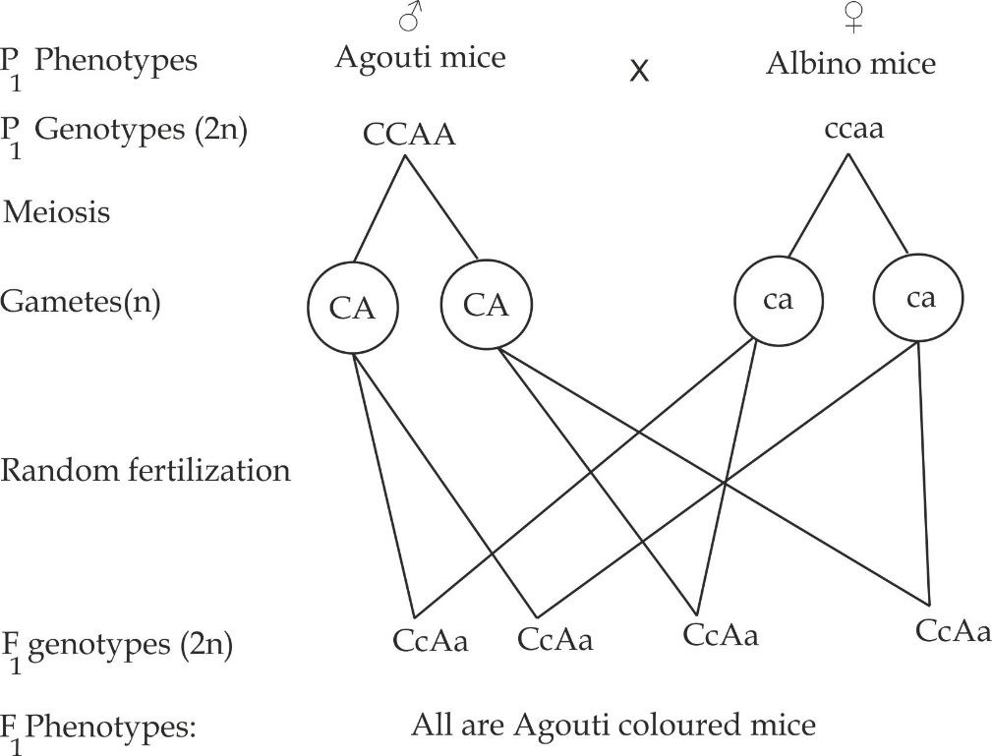

**CROSS II**

(On Selfing black coloured mice)

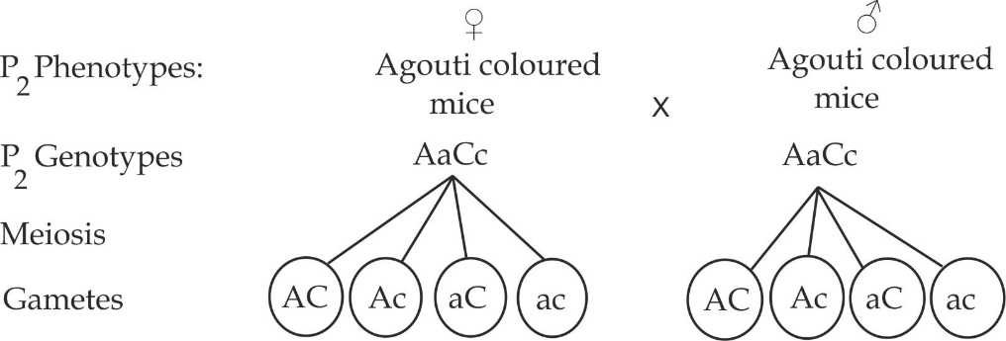

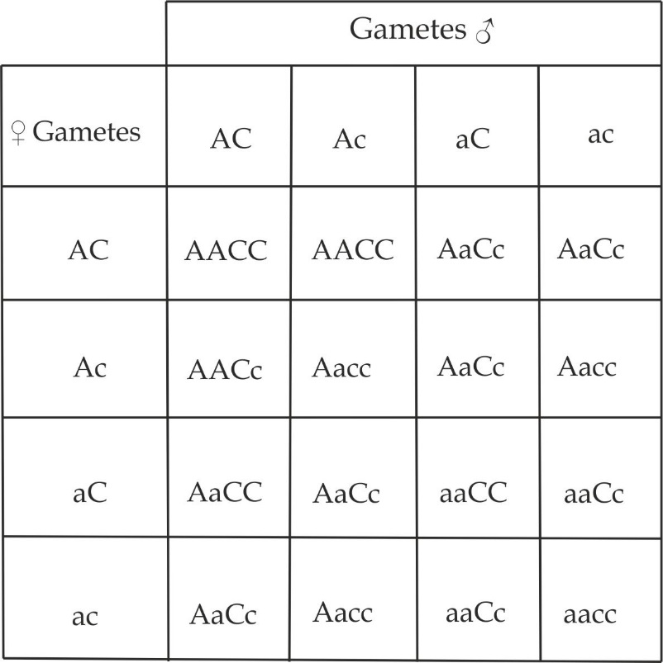

**F2 phenotypes are:**

9 Agouti colored mice

4 Albino coloured mice

3 black coloured mice

***Polygenic inheritance***

Polygenic inheritance is a form of gene interaction which occurs when one characteristics is controlled by many different genes. It is also termed as multiple factor gene interaction or multiple factor gene inheritance. These genes form a special gene complex known as a polygenic system. It is additive effect of several genes in a single phenotypic characteristic. These genes form a special gene complex known as polygenic system.Oftern, the gene alone is too small to make any significant impression on the phenotype, but their combined effect will make the phenotype more conspicuous. Examples of human polygenic inheritance are height, skin and eye colours.

**Inheritance of skin colour in human**

The skin colour in human is controlled by two pairs of allele on two different loci, the presence of 4 dominant alleles produce black colour skin (AABB), 4 recessive alleles produce white skin (aabb), any 3 dominant alleles produce dark skin (AABb,AaBB), any 2 dominant alleles produce medium skin (AAbb, aaBB,AaBb,) and any 1 dominant gene produce black skin (A orB).

***Worked Example 01***

**NECTA 2004**

Assume that in man the difference in skin colour between black and white is due to two pairs of alleles which are AABB for black and aabb for white, and that any three of the colour producing alleles produce dark skin, any two alleles produce medium skin and any one allele produces light skin. Using appropriate genetic symbols show how you will determine the skin colour of the offspring from:

1. A white woman and a black man.
2. Two individuals who are genetically like the F1 offspring in 8(a) above.

**Solution:**

1. A cross between a white woman and black man

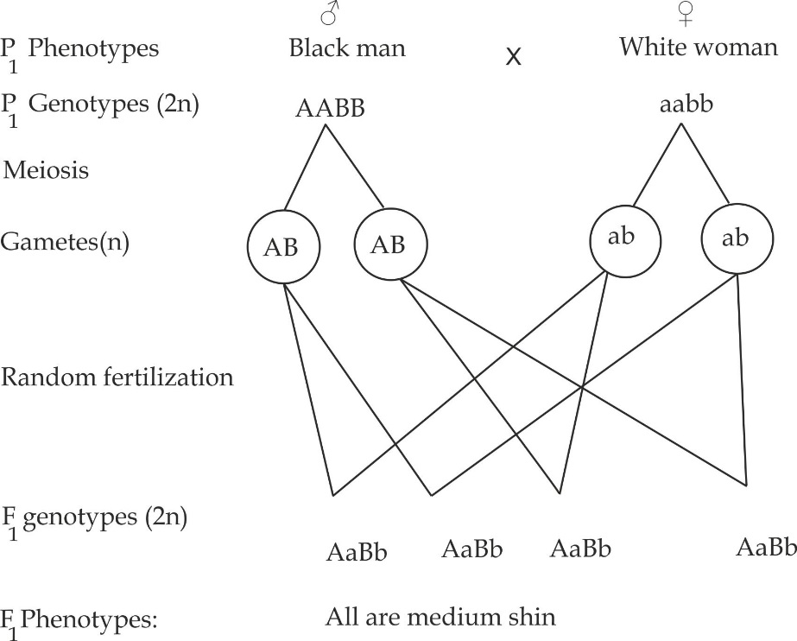

**CROSS II**

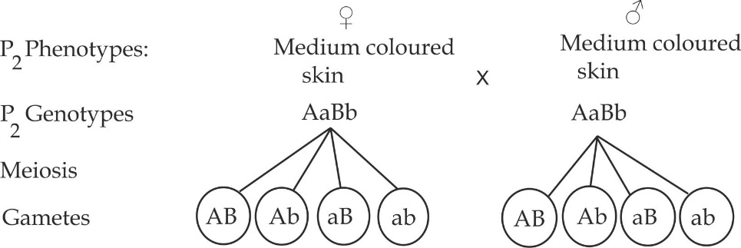

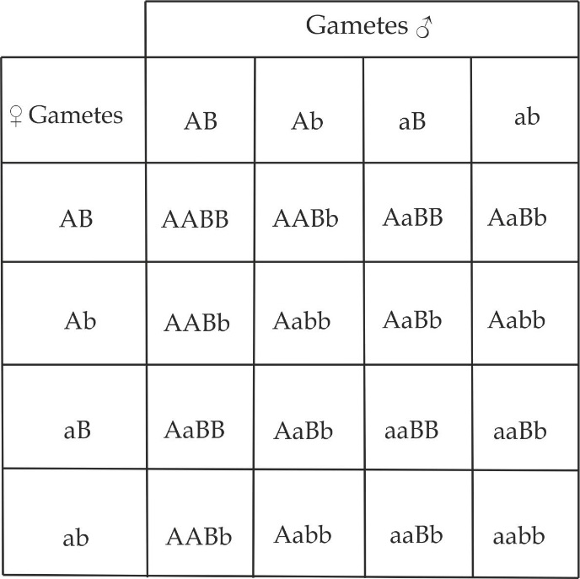

**F2 phenotypes are:**

6 medium skin colour

5 light skin colour

5 dark skin colour

**1.2.7 LINKAGE**

Linkage is a location of two or more genes of different characteristics on the same chromosome. For example in human, the gene for ear size, ability to roll the tongue and eye colour; such genes are said to be **linked** Figure 1.28**,** this result in their transmitted together.

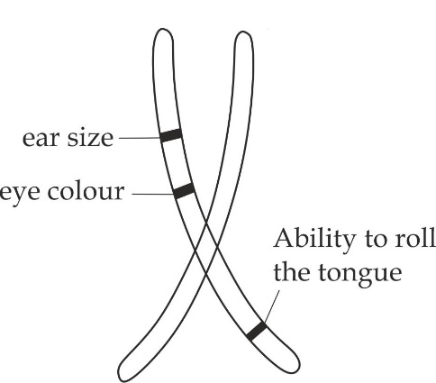

***Figure 1.28*** *Linked genes in human*

**Types of linkage**

There are two types of linkage which are sex linkage and autosomal linkage.

***Sex linkage***

**Sex linkage** is the carrying of genes on the sex chromosome. These genes are linked on the X chromosome, this is because Y chromosome is very small in size, hence cannot bear any gene. The characteristics that are controlled by genes carried on the sex chromosomes are called **sex linked traits**. In humans, two well – known sex – linked characteristics include haemophilia and red – green colour blindness.

**Sex determination**

Sex determination is a genetical system that determines the development of sexual characteristics in organisms. In many species of plants and animals including human, sex of the offspring is determined by sex chromosomes carrying corresponding gene alleles in the male and female gametes. Thus, male and female organisms have different alleles that define their sexual morphology. In human; **X** chromosome fuses with **Y** chromosome to produce a male whereas **X** chromosome fuses with **X** chromosome produce a female. In birds, butterflies, and fishes **X** chromosome fuses with **Y** chromosome to produce a female wherea**s X** chromosome fuses with **X** – chromosome to produce a male as shown in figure 1.5.

**Table 1.5** Differences between X- chromosome and Y- chromosome

|  |  |
| --- | --- |
| **Y chromosome** | **X chromosome** |
| It determines maleness | It determines femaleness |
| It is smaller in size | It is larger in size |
| It does not bear extra genes | It bears extra genes |
| It occurs in heterozygous state such as XY | It occurs in either heterozygous XY or homozygous state or XX |

***SAQ 1.16***

***NECTA 2002***

* Give two main differences between the X and Y chromosome of human.

**Haemophilia**

This is a sex – linked genetic disorder in which blood delays or fails to clot caused by the deficiency of blood clotting factor IX or VII.The haemophiliac people experience prolonged bleeding during injury, surgery or tooth uproot. In severe cases, haemophilia may result in bleeding of internal organs such as brain, joints, and muscles. Haemophilia is an X – chromosome linked disorder and for this reason, males are commonly affected while females are usually carriers of the trait.

**Mode of inheritance**

This is sex- linked defect is caused by a recessive gene allele **h** carried on the sex (**X**) chromosome. The normal dominant allele is **H**, and the possible genotypes, therefore, are as follows:

**Table 1.7** the possible phenotype and genotypes of haemophilia

|  |  |
| --- | --- |
| **Genotype** | **Phenotype** |
| XHXH | Normal female |
| XHXh | Normal carrier female |
| XhXh | Haemophiliac female |
| XHY | Normal male |
| XhY | Haemophiliac male |

**Red green colour blindness**

This is X linked genetic disorder in which an individual fails to distinguish red from green colour.

**Mode of inheritance**

This is sex – linked defect is caused by a recessive gene allele **b** carried on the sex (**X**) chromosome, and it is inherited in a similar way as haemophilia. The normal dominant is **B** represents the allele for normal sight and **b** represents the allele for colour blindness in table 1.8.

**Table 1.8** the possible genotype and phenotypes of red colour blindness

|  |  |
| --- | --- |
| **Genotype** | **Phenotype** |
| XBXB | Normal female |
| XBXb | Normal carrier female |
| XbXb | Colour blind female |
| XbY | Colour blind male |
| XBY | Normal male |

***Autosomal linkage***

Autosomal linkage is the carrying of genes on the autosomal chromosomes. The characteristics that are controlled by genes carried on the autosomal chromosomes are called **autosomal linked traits**. In humans, one well – known autosomal – linked characteristics is albinism.

**Albinism**

Albinism is the inheritable disorder due to the absence of pigmentation called melanin in human.

**Mode of inheritance**

This is autosomal- linked defect is caused by a recessive gene allele **a** carried on the autosomal chromosome. The normal dominant allele is **A**, and the possible genotypes, therefore, are as follows in table 1.9:

**Table 1.9** the possible genotype and phenotypes of albinism

|  |  |
| --- | --- |
| **Genotype** | **Phenotype** |
| AA | Normal |
| Aa | Normal carrier |
| aa | Albino |

**Comparison between sex linkage and autosomal linkage**:

* Both are Linkage genetic disorder.
* Both involve genes that are carried on the chromosome
* Both are controlled by the recessive genes.
* Both obey Mendelian principles of inheritance.

**Table 1.10** Differences between sex linkage and autosomal linkage

|  |  |
| --- | --- |
| **Sex linkage** | **Autosomal linkage** |
| It is common in male rather than female | It is common for both male and female in a population |
| The effects are not observed externally | The effects are observed are usual externally |
| Examples are haemophilia and colour blindness | Example is albinism |

***SAQ 1.17***

***EASTERN ZONE MOCK 2009***

* How is the inheritance of albinism similar and yet different from that of haemophilia.
* How is the sex genetically determined in birds and humans?

**Worked examples of linkage disorders**

***Worked example 01***

1. A woman has four (4) sons one of whom is haemophiliac suggest the genotypes of the woman and her husband.
2. Show whether it is possible for the couple in (a) above to have a haemophiliac daughter.

**Solution:**

1. For the woman and her husband to have one son who is haemophiliac the genotypes should be: **XHXh** for woman and **XHY** for husband.
2. It is not possible for the above couples to have a haemophiliac daughter as shown below:

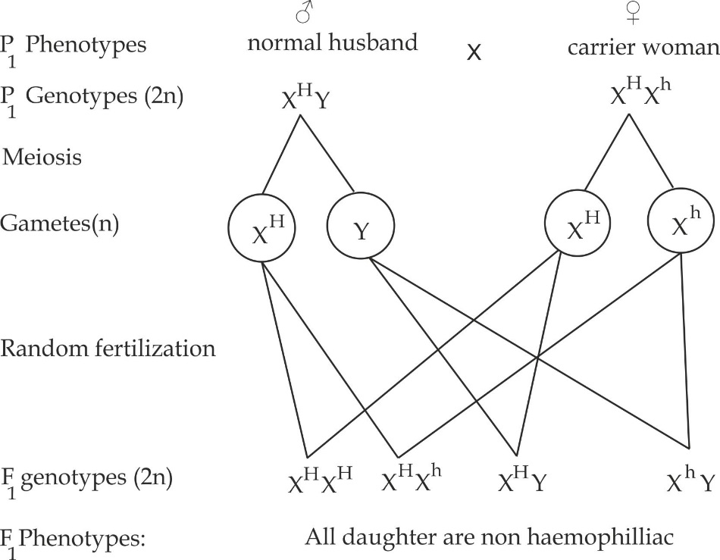

***Worked example 2***

**JECAS DAR 2017**

If a man marries a carrier haemophiliac woman:

1. Show the probability of the couple having haemophiliac children.
2. Deduce the probability of having haemophiliac son.
3. What is the chance for the couple to have haemophiliac daughter? Explain your answer.

**Solution:**

The genotypes of parents are:

Normal Man is **XHY** and carrier woman is **XHXh**.

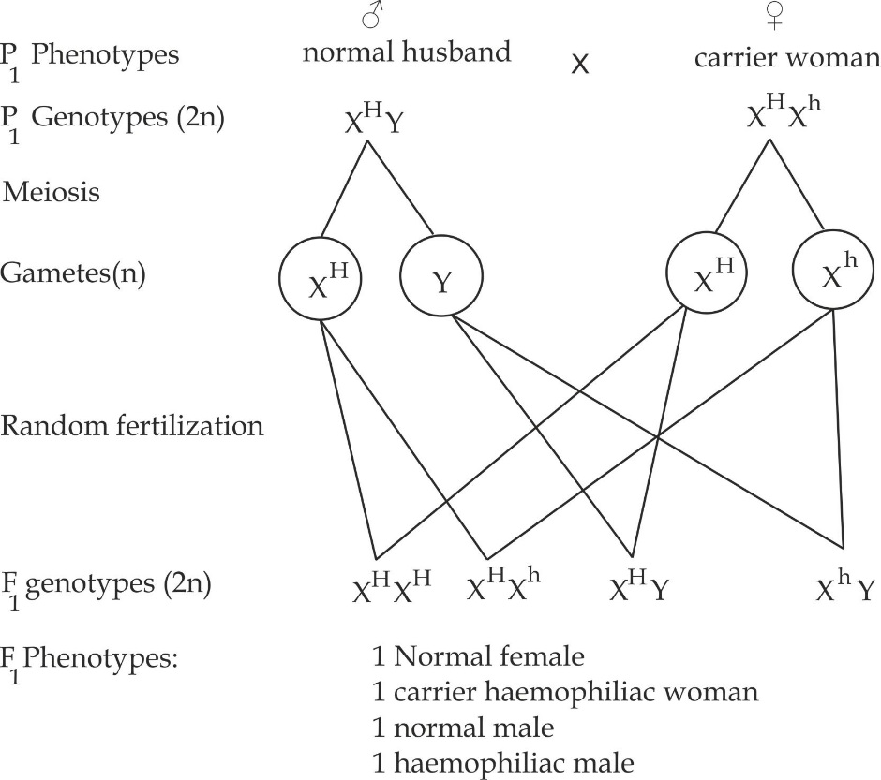

1. Probability of haemophiliac children = number of haemophiliac children

Total number of children

= 1 x 100% = **25%**

4

1. Probability of haemophiliac son **=** number of haemophiliac sons

Total number of sons

= 1 x 100% = **50%**

2

1. It is not possible for the above couples to have a haemophiliac daughter, in order to have haemophiliac daughter both couples should bear an allele for haemophilia.

***Worked example 03***

**MOCK SOUTHERN ZONE 2021**

Mrs Mpenza has two haemophiliac sons and two normal sons, what is her genotype and that of her husband with respect to this gene. Explain your answer.

**Solution:**

This means the ratio of haemophiliac to normal sons 1:1. By this ratio the genotype of Mrs Mpenza is XHXh (carrier) while that of her husband is XHY (normal) because of the following cross:

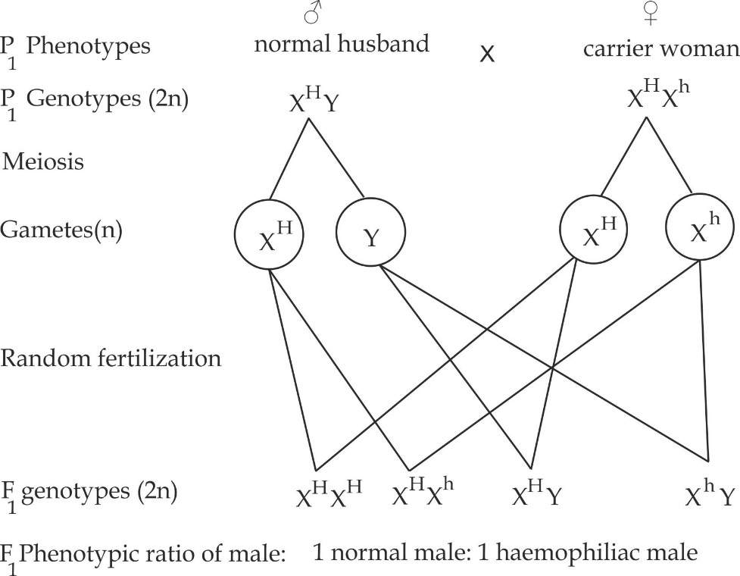

***Worked Example 04***

**Necta 2004**

A girl of normal vision whose father was color blind marries a man of normal vision whose father was also a color blind. Using the genetic symbols show clearly in terms of probability, the type of vision expected in their children.

**Solution**

**To find the genotype of a girl:**

Usual a girl receives one **X** from a father and another **X** from a mother.

**To find the genotype of a man**:

Usual a man receives **Y** chromosome from a father and **X** from a mother.

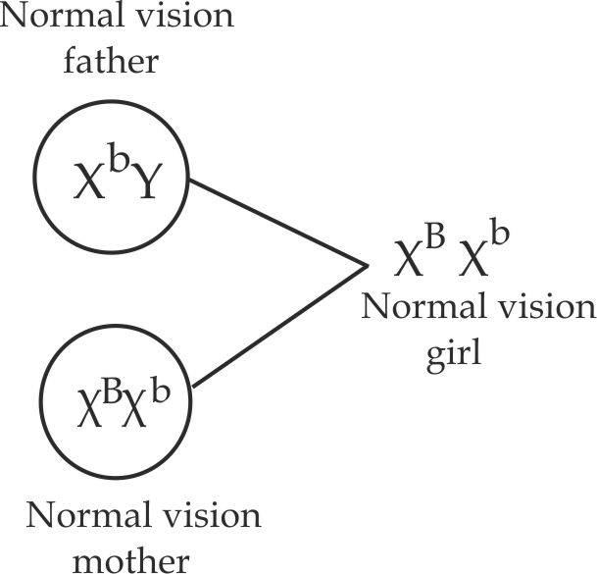

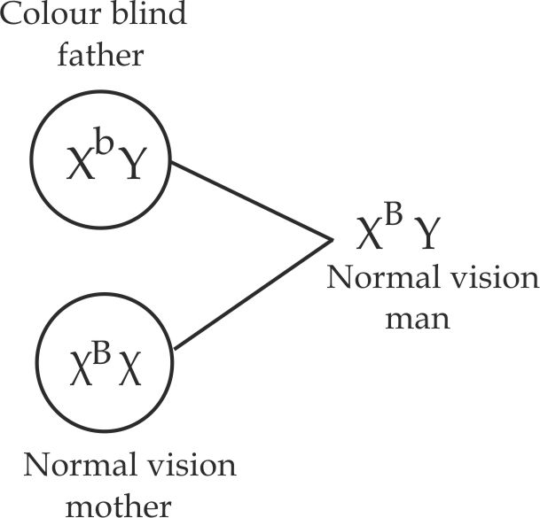

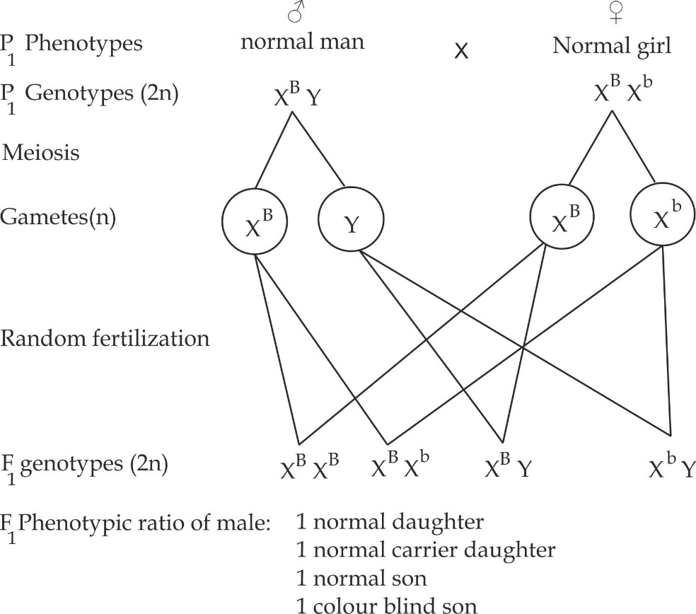

Probability of colour blind children = 1 X 100% = **25%**

4

Probability of normal children = 3 X 100% = **75%**

4

***Worked example 05***

**NECTA 1999**

Albinism in human being is caused by a recessive gene which is transmitted in Mendelian fashion. A couple which phenotypically normal for skin colour has four children. The first three have normal skin and the fourth is an albino.

1. What are the genotypes of the parents?
2. What is the probability that the fifth child will be an albino?
3. One of the first three children marries a normal woman. What predictions can you make regarding the skin of their first child?
4. The albino child marries a normal skinned widow who had an albino child in her first marriage. What is the probability of this couple to produce a normal skinned child?

**Solution:**

Let **A** – represent normal gene for skin and **a** represent albino allele.

For phenotypically normal parents to have an albino child among four children, they both must be heterozygous.

1. Proof by crossing:

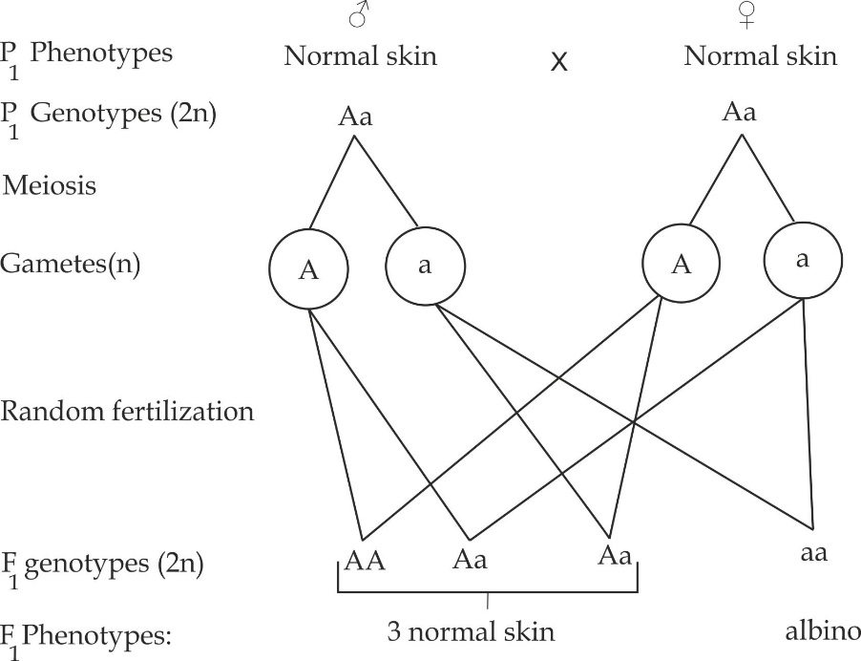

1. From the above illustration; the probability that the fifth child will be an albino is 25%.
2. The genotypes of the first three children are AA, Aa and Aa. The genotypes for a normal skinned woman is either AA or Aa.

**Case 1:** First child (AA) crossed with homozygous woman (AA):

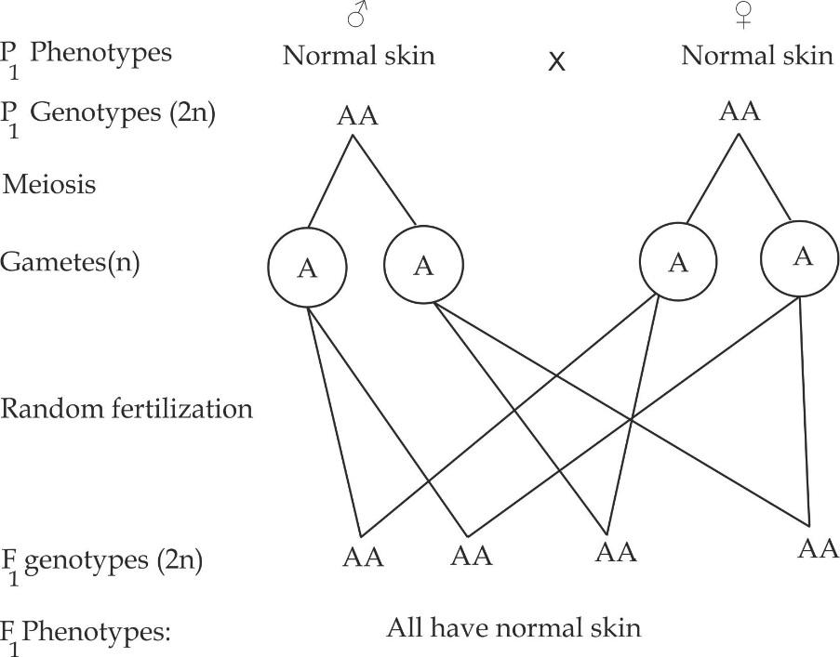

**Case 2:** First child (AA) crossed with heterozygous woman (Aa)

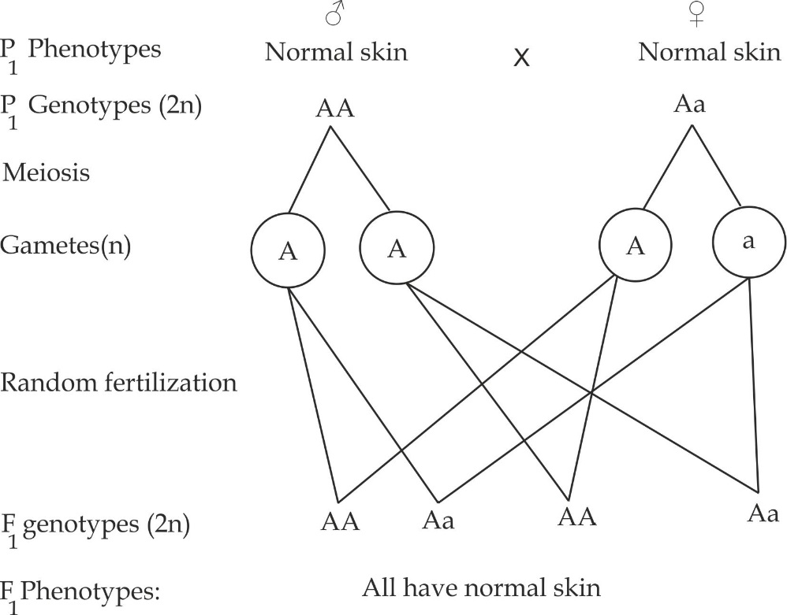

**Case 3: 2and or 3rd** child (Aa) crossed with homozygous woman (AA)

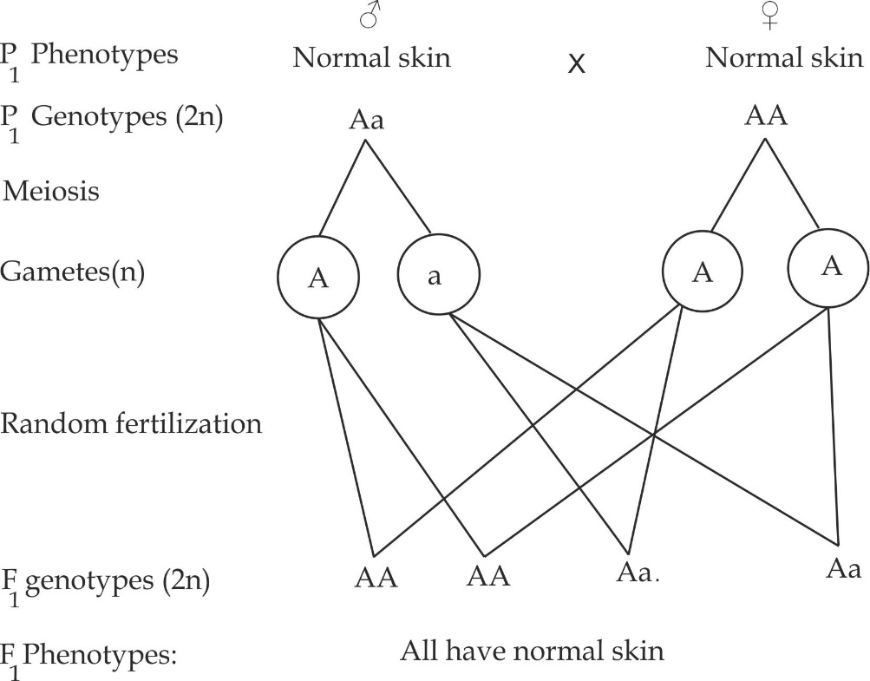

**Case 4:** 2and or 3rd child (Aa) crossed with heterozygous (Aa)

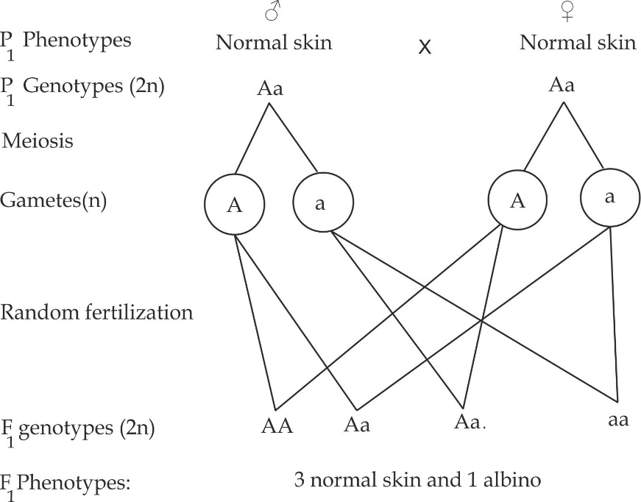

**From above crossing (i) and (iv)**

If the first three children married a normal woman all offspring become normal and only one albino.

1. A cross between an albino child (aa) and normal skinned widow who had an albino child (Aa).

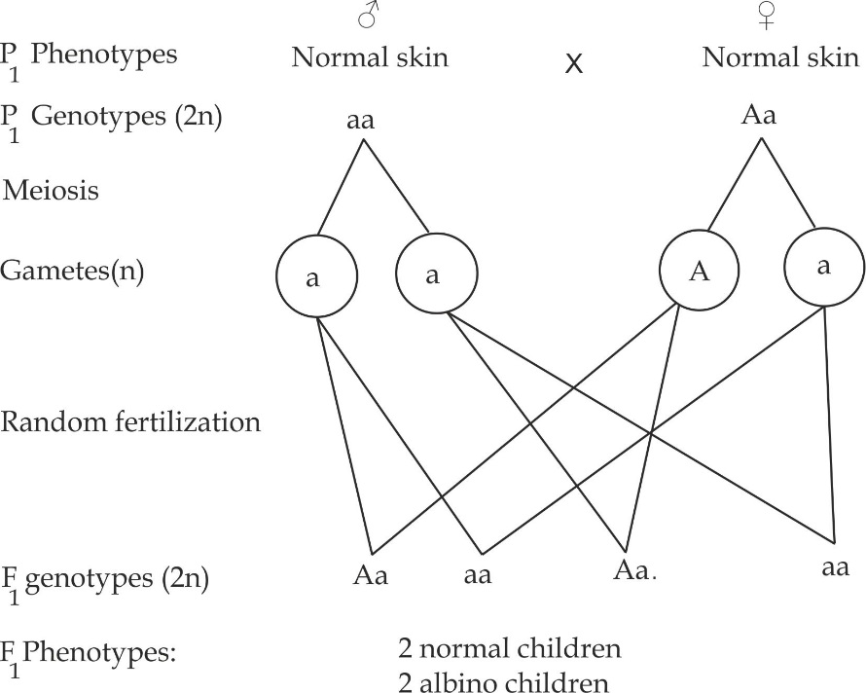

Probability of normal children = number of normal children

Total number of children

= 1 x 100% = 50%

2

Therefore the probability to produce a normal skinned children is 50%

**1.2.8 PEDIGREE ANALYSIS**

Pedigree analysis referred to as a family tree or genetic chart which shows the inheritance of a given genetic trait from one generation to another.

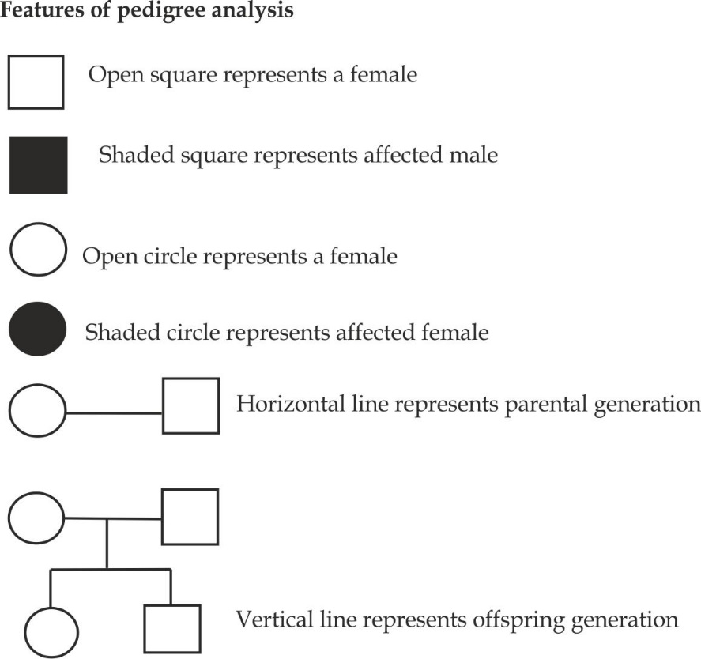

**Importance of pedigree Analysis**

1. It used to identify some forms of inheritance linkage disorders in a given family such as haemophilia and colour blindness.
2. It helps to understand the genotypes of an individual for the trait under investigation.
3. It is used to predict the risk of disease in future offspring in a family which help in genetic cancelling to the parents who have possibilities of carry diseases to their children.

**DR G MBASHI’S TRICK TO UNDERSTAND PEDIGREE ANALYSIS:**

**Trick one:** To find if pedigree is controlled by a dominant or recessive gene:

For the **dominant gene**, affected parents must have affected child.

For **recessive gene**, unaffected parents may have affected child.

**Trick two**: To find if pedigree is sex – linked or autosomal linked:

For **sex – linked**, males are more affected than females.

For autosomal linked, both males and females are equal affected.

**Trick three:** This works in sex linked pedigree:

For a daughter to be affected both parents must have affected gene

For a son to be affected a mother should have affected gene.

**Worked examples of pedigree analysis**

***Worked example 01***

**NECTA 1991**

Study the pedigree shown below, circles represent females, squares represent males, open figures represent the normal phenotypes and shaded figures represent colour blindness.

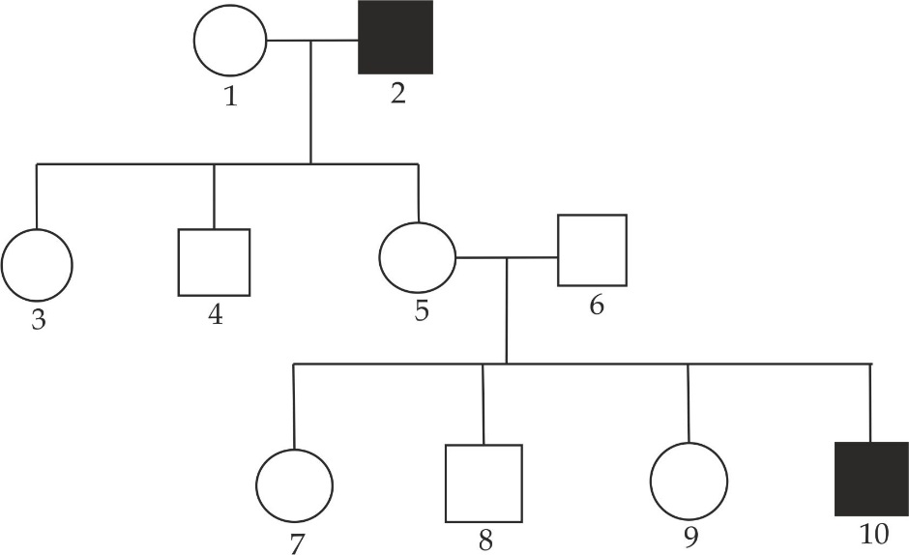

1. What is the possible genotype for 1?
2. What are the probable genotypes for 5 and 8?
3. If 7 marries a normal man, what are the chances that she will have a colour blind son?

**Solution**

1. Let gene for colour blind be “**b ″** then the possible genotype for 1 is XBXB.
2. The probable genotypes are:

5 = **XBXb**

6 = **XBY**

1. A cross between a normal carrier 7 (XBXb) and a normal man 5 (XBY)

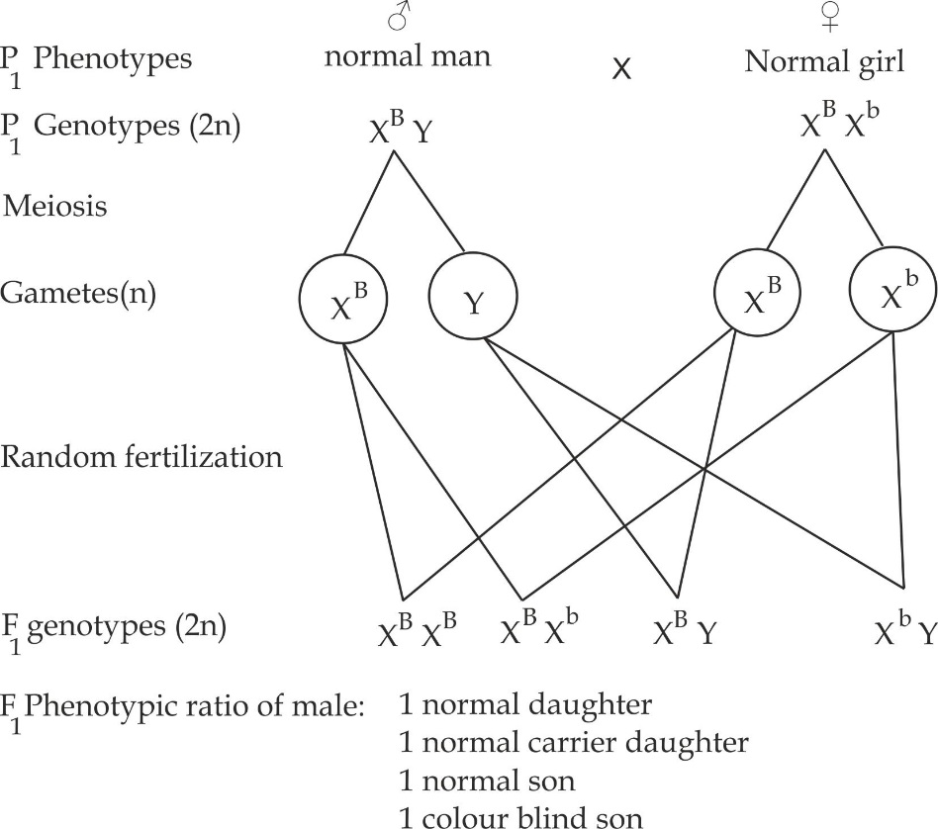

The probability of colour blind son = number of colour blind sons

Total number of sons

= 1 X 100% = 50%

2

Therefore, the probability of colour blind sons is **50%**

***Worked example 02***

**NECTA 2010**

Define:

1. Sex linkage
2. Autosomal linkage
3. The diagram below shows part of family tree (pedigree) where some of the people have haemophilia. Circles represent female, square represents male, open figures represent the normal phenotypes, shaded figure represent haemophiliac. Study the pedigree shown below and answer the questions which follow carefully.

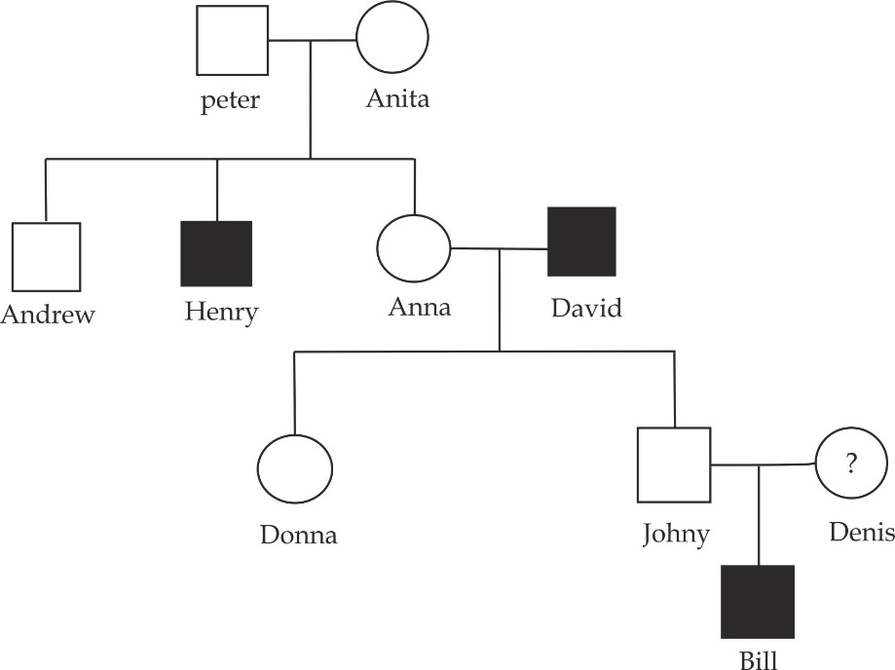

1. i. Show the possible genotype of Denise.

Give the evidence from the genetic diagram to support your answer.

1. Peter and Anita have three children, Andrew the first born, Henry second and Anna third; when could genetic counselling have been given to help Peter and Anita?
2. Explain the useful information which peter and Anita could have been given.

**Solution:**

1. i. Since Bill is a haemophiliac male, he must have acquired his Xh from

a female parent, Denise. However it is unlikely for Denise to be haemophiliac homozygous XhXh since haemophiliac female cannot survive after puberty because of recessive blood loss during the first menstruation. Thus, most probably genotype for Denise is XHXh.

1. Genetic counselling could have been given after the birth of the second born (Henry) who was haemophiliac or after Peter and Anita considered to have children especially if there was a family history of haemophiliac in Anita’s side.
2. Useful information’s in genetic counselling includes:

* To educate family on the meaning and mode of transimittion of the haemophilia.
* To educate family on the Probability of haemophilia recurring in the family.
* To advise family on how to cope with a genetic disorder such as haemophilia.

***Worked example 03***

**NECTA 2006**

Carefully study the pedigree given below showing the inheritance of a certain trait.

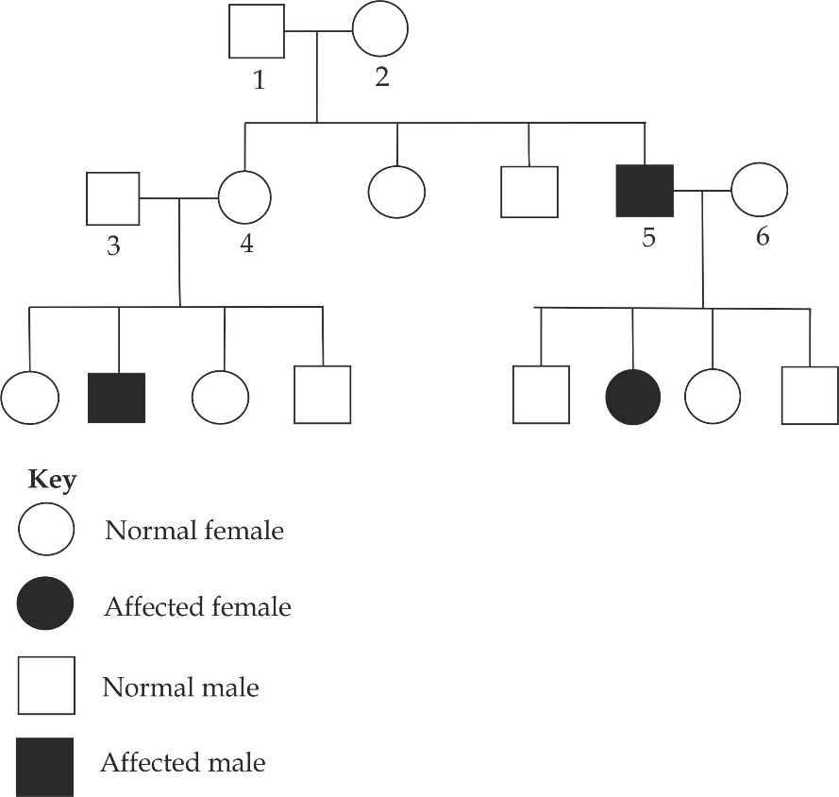

1. Determine the genotypes and phenotypes of individuals numbered 1, 2,3,4,5 and 6.
2. What type of inheritance is displayed in the pedigree above?
3. Suggest two human traits transmitted in a manner similar to the pedigree above.
4. What is the nature of the gene controlling the trait being investigated in the pedigree?

**Solution:**

1. The genotypes and phenotypes are:

|  |  |  |
| --- | --- | --- |
| **Individual** | **Genotype** | **Phenotype** |
| 1 | XNY | Normal male |
| 2 | XNXn | Normal female |
| 3 | XNY | Normal male |
| 4 | XNXn | Normal female |
| 5 | XnY | Affected male |
| 6 | XNXn | Normal female |

1. Sex linked disorder.
2. Other traits transmitted as pedigree above are haemophilia and colour blindness.
3. The nature of the gene is recessive gene located on the X chromosome.

***Worked example 04***

**PRE NECTA SOUTHERN ZONE 2021**

Haemophilia and colour blindness are inherited recessive condition in human, figure 3 show generation of the family in which these conditions are inherited.

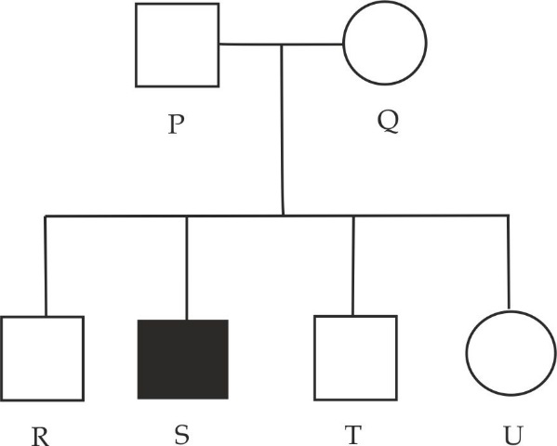

1. Using the symbol **H**- for normal clotting, **h** for haemophiliac, **B** for normal vision and **b** for colour blind. State the allele present in the following individual P, Q, R, S, T and U.
2. Explain why it is unlikely that any daughter of father R would suffer from haemophilia or colour blindness.
3. Suggest how the genotype S has arisen.

**Solution:**

1. Allele present in the following individuals are:

P = H and B

Q = H, h and B, b

R = H and B

S = h and b

T = H and B

U = H, H and B, B or H, h and B, b or H, h and BB or HH and B, b.

1. It is usual unlikely that any daughter of father **R** would suffer from the haemophiliac or colour blindness as such daughter would have inherit one recessive allele on the X chromosome from him and one recessive allele on the X chromosome from the mother for each condition. Therefore R would have to marry a woman who is carrier of both recessive allele which is highly unlikely.
2. The genotype **S** arose from crossing over occurring during prophase I of meiosis I in the chromosome of the mother Therefore an exchange of allele occurred that put the allele **H** and **b** on the same **X** chromosomes.

***Worked example 05***

**TAHOSSA DAR 2014**

Examine the pattern of inheritance of PKU (phenylketonuria) shown below:

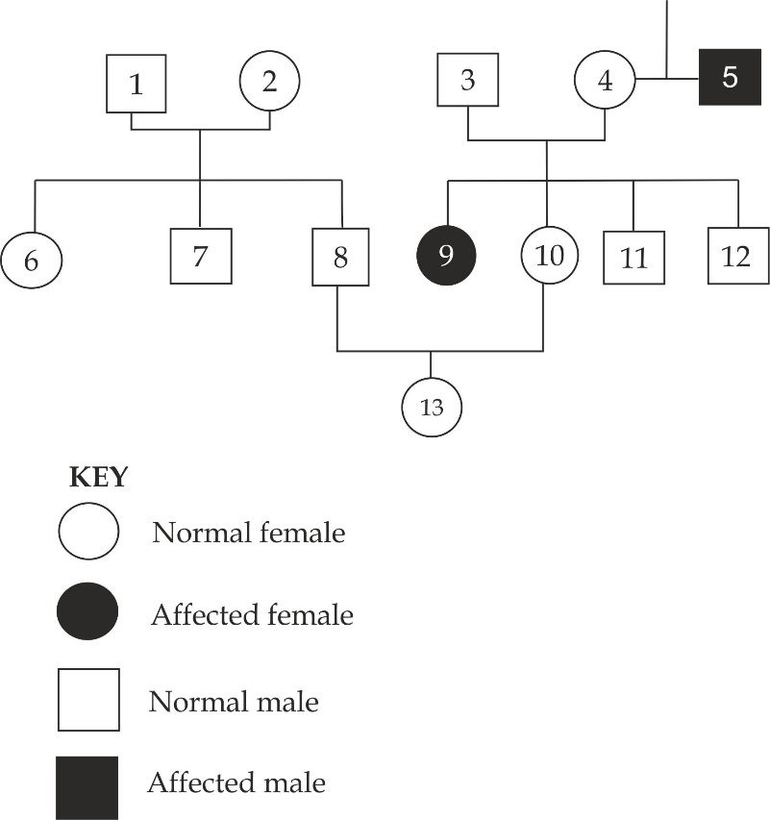

1. What evidence is there that PKU is controlled by a recessive gene?
2. What evidence is there PKU is not sex linked?
3. Which individuals are definitely carriers (heterozygous) based on the evidence available?
4. Which other individuals could be carriers?
5. In real situation the individuals numbered 10,11 and 12 may well wish to know if they were carriers since their sisters suffers from PKU.If one of them asked you what were their chances of being a carrier, what would you reply.

**Solution**

1. Unaffected parents 3 and 4 have affected child number 9.
2. The males and females are equal affected in a population.i.e. One male (5) to one female (9).
3. The individual numbered 3 and 4.
4. Individual 11 and 12.
5. Let the gene for PKU be ″**b“**

Consider a cross between individual 3 (Bb) and 4 (Bb)

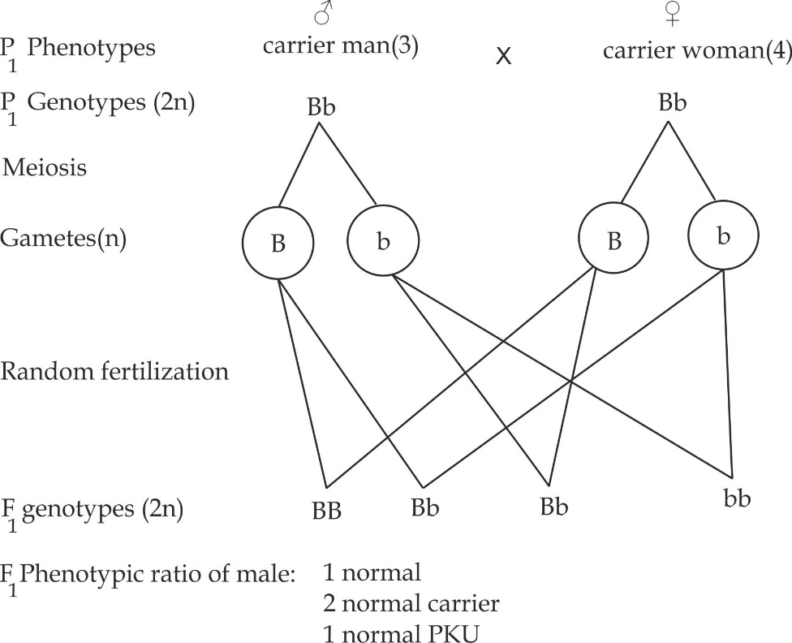

Probability of carrier PKU = number of carrier PKU

Total number of children

= 2 X 100% = 50%

4

Therefore, the probability of carrier PKU is **50%**

***Worked example 06***

**NECTA 2005**

Pituitary dwarfism is an inherited condition in human in which the affected individuals have very short limbs. The allele for pituitary dwarfism is recessive to the allele for normal limbs, and its locus is situated on the X – chromosomes, the pedigree below shows part of an affected family.

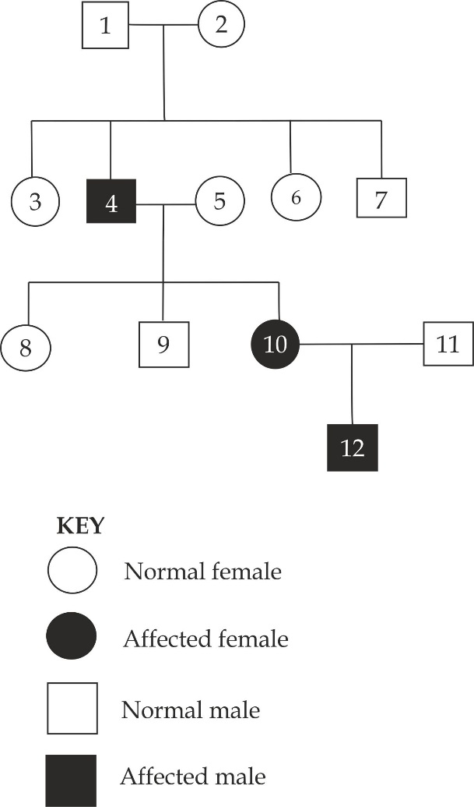

1. Identify and explain two pieces of evidences from the pedigree above, which show that the allele for pituitary dwarfism is recessive to the allele for normal limbs.
2. Explain why the genotype of individual 10 must be a carrier. Illustrate your answer.
3. Explain why the genotype of individual 11 must be normal.
4. Since the son of individual 10 and 11 showed pituitary dwarfism. The couple consulted a genetic counsellor before the woman become pregnant again. What prediction would have been made about the probability of the couples have child showing pituitary dwarfism? Illustrate your answer.

**Solution:**

1. Evidence 1; from the cross between the individual 1 and 2, the affected parents produce affected child (dwarf) 4. This shows that the allele (short limb) is suppressed by the dominant allele (normal limb) from occurring in other individuals.

Evidence 2; from the cross between individual 4 and 5, one of the offspring female is affected which represents individual 10.The other female offspring is a carrier who proves that the allele for pituitary dwarfism is recessive to the allele for normal limbs.

1. A cross between individual 4 and 5 to show that individual 10 must be carrier.

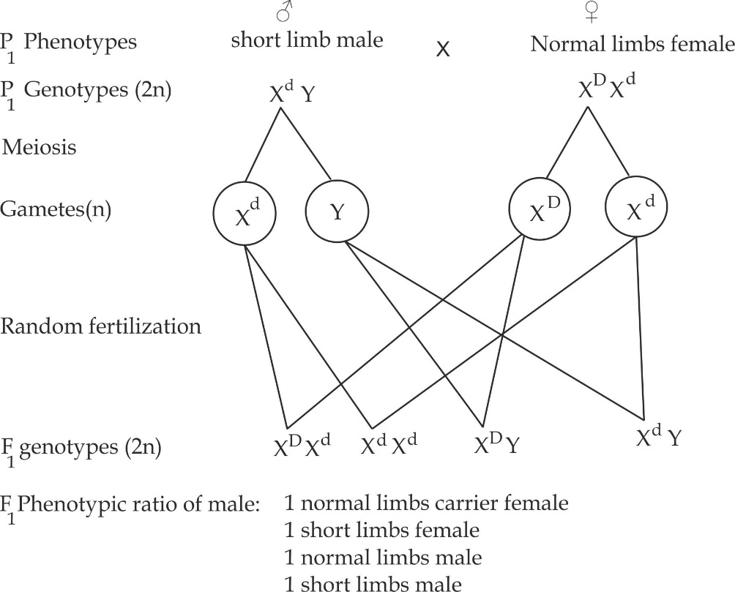

From the illustration above it shows that one of the female offspring is a carrier which represents individual 10.

1. The genotype of individual 11 must be normal. This is because the male offspring always inherits defects genes from the mother (individual 10) who is a carrier.
2. In summary the cross between 10 and 11 produces:

1 normal female

1 normal carrier female

1 dwarf male

1 normal male

Probability of pituitary dwarfism = number of pituitary dwarfism

Total number of individuals

= 1X 100% = 25%

4

**1.2.9 GENETIC ENGINEERING (GE)**

Genetic engineering or genetic modification is the process by which DNA is transferred from one organism (human) to another organism (bacteria) to create a new gene recombination with desirable characteristics. Genetic engineering is also referred to as recombinant DNA technology because it is made possible by combining fragments of DNA from different organisms, when gene transfer occurs, the resulting organism is called a transgenic organism or a genetically modified organism (GMO).

**Procedure in genetic engineering**

The process of gene cloning involves various steps as shown in Figure 1.29.

* The target gene is isolated and cut out using a restriction enzyme.
* Opening up of a bacterial plasmid by using restriction enzyme.
* Binding of the target gene into the plasmid by using DNA ligase.
* Insertion of the altered plasmid into the bacteria.
* Duplication (cloning) of the altered plasmid.
* Extraction and purification of genes.

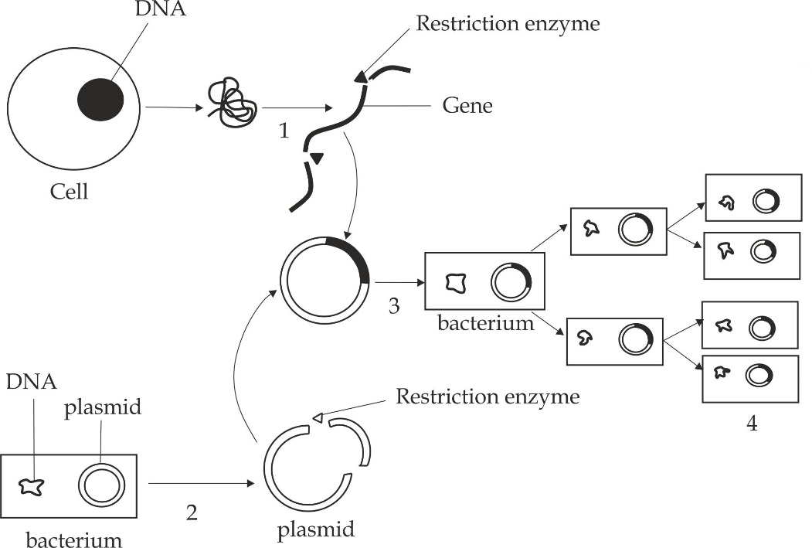

***Figure 1.29*** *The process of genetic engineering and gene cloning*

***SAQ 1.18***

***LYAMUNGO TERMINAL EXAM 2019***

* Briefly explain the stages of genetic engineering in bacteria.

**Merits of genetic engineering**

Genetic engineering has a number of advantages in various sectors include:

1. **In medical values**
2. It is used to synthesize insulin hormone needed by diabetes patient shown in Figure 1.30.
3. It is used to synthesize growth hormone needed by dwarfism.
4. It is used to synthesize clotting factors such as factor VII used to treat patient suffer from the haemophiliac.
5. It is used to produce vaccines from the viruses.
6. **In agriculture values**
7. It improves the quality of the animal products such as meat, milk, and eggs.
8. It improves the quality of the plant products such as size and taste of fruits.
9. It is used to synthesize plants resistance to diseases.
10. It is used to increase the yield of food crops.
11. **In forensic medicine**

Investigating common crime cases such as a rape, settling paternity, and detecting inherited disease by using DNA finger printing. Some DNA fingerprints shown in figure 1.31 from the *criminal investigation (a murder case),* you can see at once which suspects are unlikely to have committed the crime by matching up the dark bands. The DNA profiles of seven murder suspects and a blood stain from the crime scene.

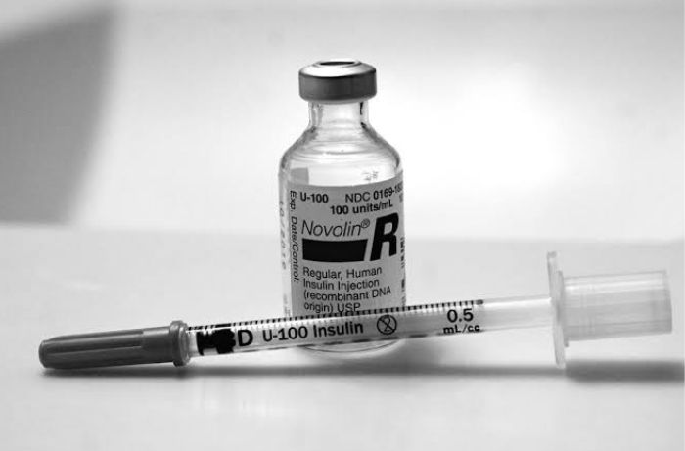

***Figure 1.30*** *human insulin used in the treatment of diabetic mellitus produced by recombinant DNA technology, using E.Coli.*

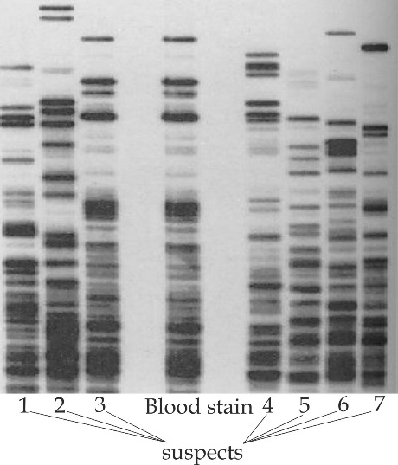

***Figure 1.31*** *DNA profile*

1. **In biological welfare**

Microorganisms that cause diseases are cloned by genetic engineering and thrown into the territory of the enemy, infections of these bacteria cause death within few days.

**Demerits of genetic engineering**

1. It is very expensive technique.
2. It leads to the development of super weeds that are resistant to herbicides.
3. Biological weapons are harmful to human.
4. The use of biological modified organism to human consumption may lead to harmful effects such cancer.
5. It may lead to disappearance of local varieties of crops.
6. It is against the compromises issues on ethics and morality.

***SAQ 1.19***

***JECAS 2012***

* What are the biological significances of genetic engineering?
  1. **VARIATION**

Variation is the differences between individuals of the same species. In other words, variation is the possession of characteristics that are different among members of a species.

In this part the following aspects should be discussed:

* Types of variation
* Causes of variation
* The concept of mutation
* Common genetic disorders

**1.3.1 TYPES OF VARIATION**

There are two main types of variations namely continuousand discontinuous variation**.**

1. **Continuous variation**

This type of variation shows intermediate forms of characteristics, from one extreme end to the other. It has no clear – cut differences and this gives rise to intermediate between two extremes**.** It is also known as quantitative variation and it is controlled by many genes. Example of continuous variations in human beings include weight, height as shown in Figure 1.32, skin and intelligence (1Q).

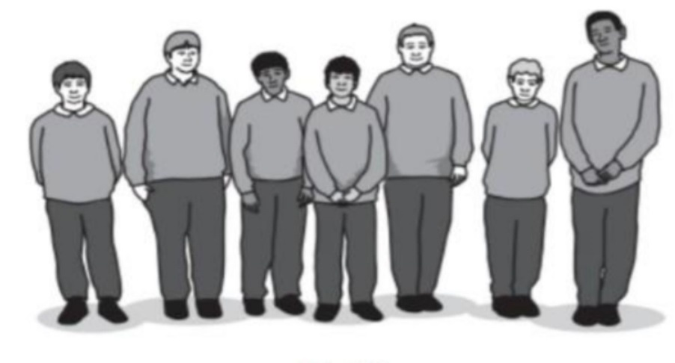

***Figure 1.32*** *Continuous variation in height of the form six students*

1. **Discontinues variation**

This type of variation which shows no intermediate forms, that is, there is a clear cut distinction form of characteristics. Example of discontinues variations in human beings include tongue rolling as shown in Figure 1.33 (where one is either tongue roller or non-tongue roller), sex (one is either male or female) ear lobes (where one is either free ear lobe or attached ear lobe) and the ABO blood group system where one can only have blood group A, B, AB and 0.

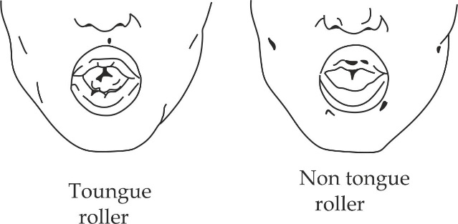

***Figure 1.33*** *a tongue roller and non-tongue roller*

***SAQ 1.20***

***NECTA 1999***

* Categorizes the following list of human traits into continuous and discontinuous variation:
* Tongue rolling
* Height
* Intelligence
* Blood groups

**1.3.2 CAUSES OF VARIATION**

The causes of variation can be divided into two main parts: Genetic factors and environmental factors.

1. **Genetic factors**

These factors affect the sex cells hence can be transmitted from one generation to other.i.e, they can be inherited.

1. **Mutation**

Mutation is a sudden and permanent changes in the genetic makeup which are then passed on from one generation to another as the result produce offspring that differ from parents.

1. **Crossing over**

The crossing over among homologous chromosomes during prophase I of meiosis resulting into new gene recombination hence variation.

1. **Independent assortment of homologous chromosomes**

Random distribution of chromosomes on the equator during metaphase I of meiosis and subsequently segregation, forming different gametes with different chromosomes which are capable of producing different offspring after fertilization.

1. **Random fertilization**

Random fertilization causes the genes from different parents to mix resulting into variation.

1. **Environmental factors**

Environmental conditions mainly influence and cause continuous variation. For example water, temperature, food, light, and diseases, such variations are produced in the body (somatic) cells and not in the sex cells hence cannot be inherited.

***SAQ 1.21***

***DAR MOCK 2016***

* Briefly explain how variation caused by environment differ from those caused by mutation.

**1.3.3 THE CONCEPT OF MUTATION**

Mutation is a sudden and permanent changes in the genetic makeup of organism. The mutations that occur in somatic (body) cells are not passed from generation to the next. The mutations which occur in the formation of gametes can be inherited. These mutations produce sudden and distinct differences between individuals, hence, the basis of genetic variations.

**Causes of mutations**

The substances that cause mutations are called mutagens or mutagenic agents and they affect either the chemical structure of genes or a gross structure of chromosomes. An organism, which has undergone mutation is called mutant.

The mutagens include the following:

1. Energetic radiations such as X –rays and ultraviolet lights.
2. High energy particles such as α – particles, β – particles and cosmic rays.
3. Chemicals such as mustard gas, cosmetics, formaldehyde and tobacco.
4. Viruses that generates tumours in animals, such as human papilloma viruses (HPV) that causes cervical cancer in women.

**Effects of mutations**

The results of mutations to living organisms may be beneficial or detrimental. Advantageous mutations lead to genetic variation, which is necessary for organisms to adapt to the constantly changing environment which increase the survival chance. Hence, mutations can be a means of evolution such as antibiotic resistance bacteria. Harmful (disadvantageous) mutations result into genetic disorders such as sickle cell anaemia downs syndrome and some mutation are lethal such as cancer which result into death to living organisms.

***SAQ 1.22***

***PRE NATIONAL DAR 2019***

* Write short notes on mutation based on the following criteria:

1. Causes and effects
2. Types of mutation

**Types of mutation**

There are two types of mutation. These are gene mutation and chromosome mutation.

***Gene mutation***

Gene mutation is a type of mutation due to change in the base sequence in a nucleotide of the DNA.That is; a change in the structure of DNA that occurs at a single locus on a chromosome. Gene mutation is also referred to as point mutation. There are five types of gene mutation namely **deletion**, **insertion**, **duplication, invertion** and **substitution**.

1. **Deletion**

This is a gene mutation occurs when a portion of the nucleotide sequence is left out (removed).

1. I**nsertion (addition)**

This is a gene mutation which occurs when a new nucleotide is inserted in the DNA sequence.

1. **Duplication**

This is a gene mutation which occurs when a portion of the nucleotide sequence chain becomes repeated.

1. **Invertion**

This is a gene mutation which occurs when a portion of the nucleotide become inverted.

1. **Substitution**

This is a gene mutation which occurs when one portion of the nucleotide is replaced by another which has different organic base. Substitution of a nucleotide in a DNA will affect a single amino acid in the same protein.

***SAQ 1.23***

**BAUBAU SEC SCHOOL**

* A piece of DNA has the following base sequence AAT, TCG, CGA, TCC. State the change (type of mutation) that has taken place in each of the following variants:

1. ATT, CGC, GAT, TCC
2. AAT, TCG, AGC, TTC
3. AAC, TCG, CGA, TTC

***Chromosomal mutation***

Chromosome mutation is a type of mutation due to the change in number or structure of the chromosome. This type of mutation, which is also known as chromosome aberration produces effects that are easily noticed in mutant organisms.

**Types of chromosome mutation**

Chromosome mutation may result from either of the following types:

* Structural chromosomal mutation
* Numerical chromosomal mutation

1. **Structural chromosomal mutation**

It is a type of chromosome mutation due to the change in structure of the chromosome, but the total number of chromosomes remain constant. This may result from either of the following as illustrated in Figure 1.34.

1. **Deletion**

Deletion occurs when a part of chromosome breaks off. The genes within the part of the break off are lost in the chromosomes as a result it may lead to a significant effect on the organism.

1. **Duplication**

Duplication occurs when a part of chromosome is doubled, resulting in the repetition of a gene sequence. This type of mutation results from unequal crossing over between misaligned chromosomes.

1. **Invertion**

Invertion occurs when a part of chromosome breaks off and rotates through 180º before it re-joins the chromosome. The sequence of genes on this portion is therefore reversed and may alter the phenotype.

1. **Translocation**

Translocation occurs when a portion of chromosome breaks off and become attached to another chromosome. This type of chromosome mutation also produce position effect in the phenotype.

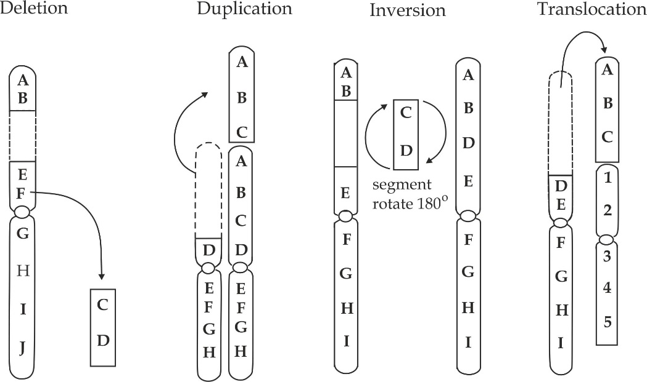

***Figure 1.34*** *Illustration of four types of chromosome mutation*

1. **Numerical chromosome mutation**

It is a type of chromosome mutation due to the change in total number of chromosomes. The changes in the number of chromosomes are usually the result of errors during meiosis. These changes may involve a loss or gain of single chromosomes, a condition called **aneuploidy** or an increase of the entire haploid sets of chromosomes, a condition called **euploidy** or **polyploidy**.

**Aneuploidy**

This is a condition in which half of the daughter cells produced have an extra chromosome, for example, n + 1 or 2n + 1 (*Trisomy*) and the other half have a chromosome missing, n – 1 or 2n -1 (*Monosomy*).Aneuploidy can arise from the failure of a pairs of chromosomes to separate during meiosis I or meiosis II which may lead to the formation of gamete cells containing either more or less than normal number of chromosomes. This condition is called non-disjunction as shown in Figure 1.35.The fusion of either of these gametes with a normal haploid gamete produces a zygote with less than the diploid number of chromosomes in which the zygote may not develop. However, those with extra chromosome may develop although the organisms resulting from these zygotes have a number of abnormalities.

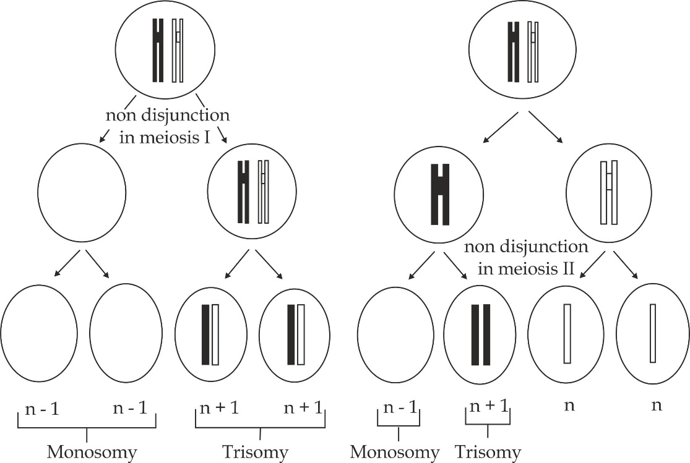

***Figure 1.36*** *illustration of non-disjunction of meiosis I and meiosis II*

**1.3.4 COMMON GENETIC DISORDERS**

In human beings, the genetic disorders resulting from the non-disjunction of chromosomes during meiosis I or meiosis II include Downs’s syndrome, Klinifelters syndrome and Turners syndrome.

***Downs syndrome***

Downs syndrome or mongolism is a genetic disorder that occurs when chromosome 21 fails to segregate during meiosis, thus the gamete produced possesses 24 chromosomes. For this reason; it is also known as **Trisomy** **21**.The fusion of this gamete with a normal one having 23 chromosomes, resulting in the offspring having 47 (2n + 1) chromosomes. On disjunction in the case of downs syndrome seems to occur during the production of ova rather than sperm. Its incidence is related to the age of the mother and therefore, the chances of having Downs’s syndrome child increase as the mother’s age increases, especially above 40 years.

**Symptoms of Downs’s syndrome**

Down syndrome has the following symptoms as shown in Figure 1.37.

* Severe mental retardation, i.e. they have low intelligent quotient (IQ).
* They have a flat, broad face.
* Upward slanting eyes.
* Flat nasal bridge.
* Epicanthic fold.
* Short stature and relatively small skull due to poor skeletal development.
* They have protruding tongue.
* They have poor immune system and hence risks of infection.
* Short life expectancy.

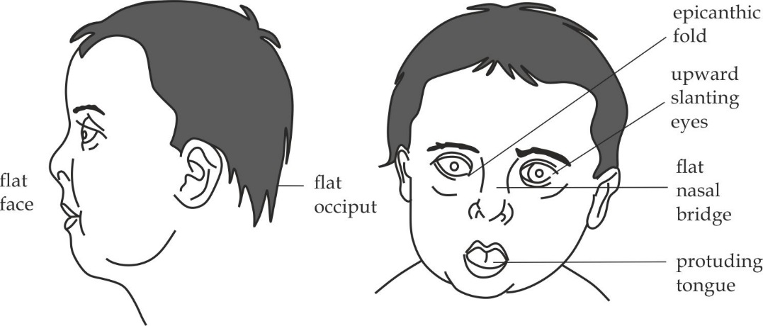

***Figure 1.37*** *Downs’s syndrome*

***Klinifelters syndrome***

This is a non-disjunction of the sex chromosomes, which may occur in meiosis during spermatogenesis in male parents or oogenesis in female parents. This genetic disorder is due to extra X chromosome and the genotype is **XXY** instead of normal XY.The number of chromosomes is, therefore, 47 (2n + 1) instead of 46 (2n).

**Symptoms of Klinifelters syndrome**

The Klinifelters syndrome victim is phonotypical a male, but the presence of an extra X chromosome may result in the development of the following femine features as shown in Figure 1.38 a.

* The person is sterile, sperms are never produced although he can erect.
* He is taller than average.
* Breast may develop.
* Testes are very small.
* Has little facial hair.
* High pitched voice.
* Low intelligence.

**Treatment:**

Male hormones can be given, breast then returns to normal size and condition is diagnosed only after puberty.

***Turner’s syndrome***

This genetic disorder is due to a missing **X** chromosome in females. The genotype is, therefore, **XO** instead of normal **XX** and the number of chromosome is 45 (2n -1) instead of 46 (2n).Turners syndrome can arise as a result of non-disjunction during meiosis.

**Symptoms of Turners syndrome**

The Turners syndrome victim is phonotypical a female, but the absence of X chromosome may result in the development of the following male features as shown in Figure 1.38 b:

* Infertility – ovaries never mature and small uterus.
* Short stature.
* Broad chest with widely spread nipples.
* Under developed breast.
* Lack of secondary sexual characteristics.

**Treatment:**

Female sex hormones can be given to make her develop breast and have periods, though, this does not cure infertility.

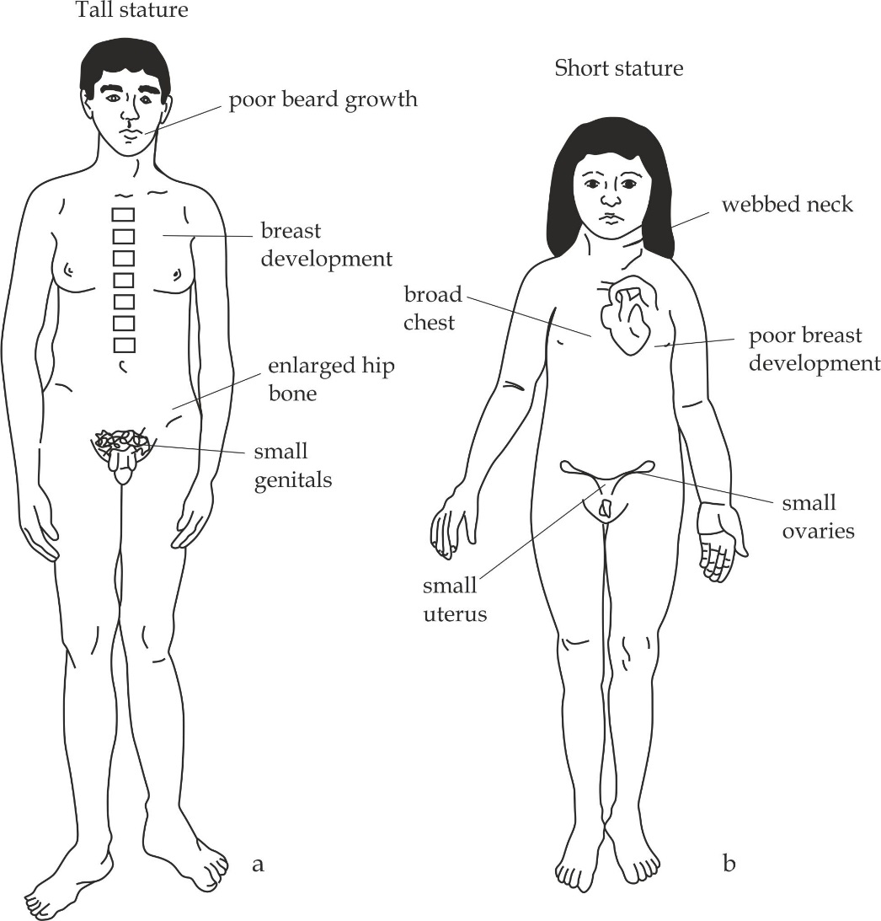

***Figure 1.38*** *sex chromosome genetic disorders in human. (a) Klinifelters syndrome, (b) Turners syndrome.*

***SAQ 1.24***

***DAR MOCK 2017***

* Describe the following conditions of chromosomal mutation:

1. Trisomy
2. Monosomy

* Name three genetic disorders involving whole chromosomes in human and explain how they are brought about.